February 3, 2020

Dear Families,

We hope everyone had a great week! We have begun our Mid-Year Assessments. Students are being assessed by their teachers in reading using Fountas and Pinnell Running Records. Students are also taking their I-ready 2nd diagnostic to see progress they have made so far in math and reading. Students in all grades are showing incredible growth.

Upcoming Events

- Parent Association Movie Night: February 1st
- The February SLT meeting has been rescheduled. It is now on February 26th
- February 12,13: Valentine’s Sale
- February 13: School Tour 9am
- February 17-21: School Closed for Midwinter Recess

Big Announcement

We are proud to announce that PS 24 has officially engaged in a partnership with the NYPCC (New York Psychotherapy and Counseling Center). A special thank you to one of our parents, Jason Guardado for assisting in bringing this important partnership to our community. This partnership will allow us to better support our entire community with many different health needs. More info to follow.
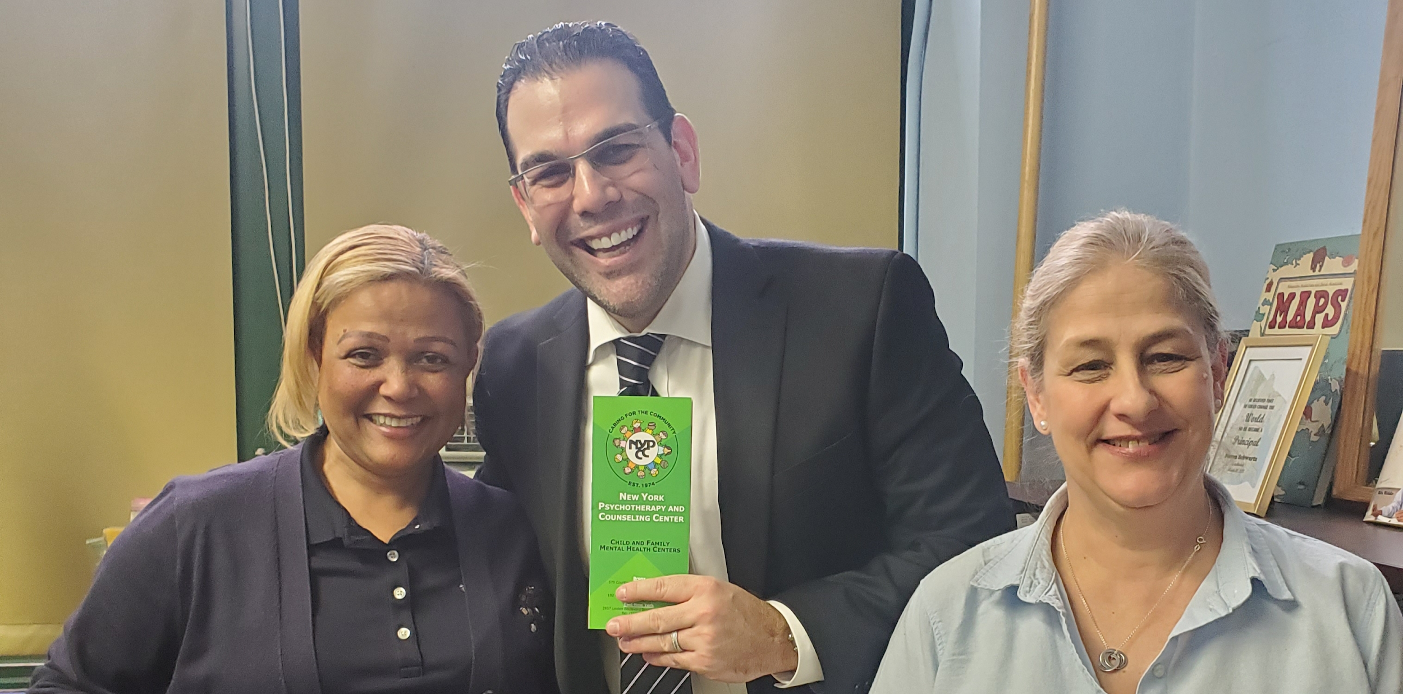
If you have any questions or concerns please email the administration or parent coordinator directly at: sschwartz@schools.nyc.gov, namster@schools.nyc.gov, aparedes@schools.nyc.gov or fbyrne@schools.nyc.gov

We look forward to a great week! Thank you for your support and please remember to ask your children about all of the exciting things they are learning at school every day.

Sincerely,
P.S. 24 Administration

