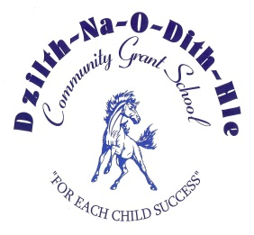
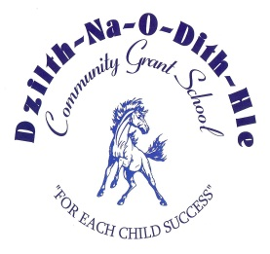
Dzilth-Na-O-Dith-Hle Community Grant School
35 Road 7585 Box 5003
Bloomfield, New Mexico 87413
Telephone: (505) 960-8928 ᵜ Fax: (505) 960-8929

Thank you for your interest in Dzilth-Na-O-Dith-Hle Community Grant School (DCGS). Procedures are outlined below to assist you in the application process.

- APPLICATION FORM
• The application form must be fully completed, even if a resume is submitted.
- Complete names, mailing addresses and telephone numbers of previous employers and references must be provided on the application form. Applications without this information will be returned.
- Any misrepresentations, falsifications, or material omissions provided by an applicant or employee in any of this information or data may result in DCGS exclusion of the individual from further consideration for employment or, if the person has been hired, termination of employment.
• If you FAX a copy of the application form to the Human Resource Office, it is still necessary to submit the original application with your original signature.
• Consideration for employment cannot be given until the fully completed application and required supporting materials are returned to the Human Resource Office.
• DCGS cannot accept any type of personal photos for inclusion in an applicant’s file, including a copy of
your driver’s license.

- TRANSCRIPTS (Licensed, Administrative, Paraprofessionals and Professional Non-Teaching Applicants)
• Applications must be accompanied by official transcripts from each college/university. The transcripts must show course work, hours and grades.
• Official transcripts must be on file upon recommendation for hire. Official transcripts are transcripts sent by the applicable college/university, stamped or otherwise acknowledged as official by the college/university, and sent in a sealed envelope.
• It is the applicant's responsibility to ensure that the application form, transcripts, resume and a copy of required certificates are on file with the Human Resource office.
- LICENSURE
- Teaching positions require applicants to be fully licensed by the New Mexico Public Education Department when applying.
- If applicable, submit a photocopy of all valid certificates required by the position to the Human Resource Office. Certificates must be properly recorded.

- RETENTION OF APPLICATIONS
• All applications are kept only for the specific recruitment. New applications are required for each subsequent opening.
• It is suggested that applicants retain a copy of their application for future reference.

- BACKGROUND INVESTIGATION
In an effort to continue to provide a safe environment for the children and employees of DCGS, any individual recommended for employment with DCGS will undergo a background investigation, prior to finalization of employment. The background investigation includes a criminal background check by the Navajo Nation Police Department, a background check conducted by a security clearance company chosen by DCGS, a review of the applicant’s driving record to be conducted by DCGS’s insurance company and upon results of confidential reference checks with current and former supervisors and personal references. Employment is conditional upon results of the background investigation and favorable adjudication.

