Name: __________________________ Date: ______________
Practicing the Pythagorean Theorem
Objective: I can apply the Pythagorean Theorem to determine unknown side lengths in right triangles in real-world and mathematical problems.
Directions: Find the missing measure of each triangle. Round to the nearest tenth.
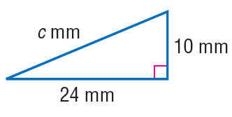

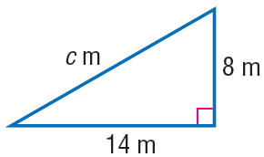

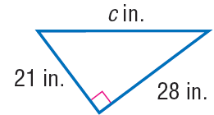

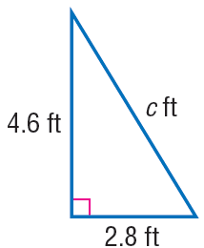

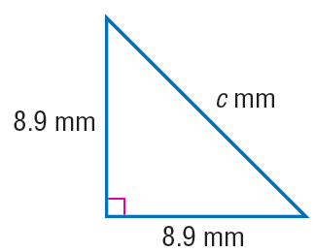

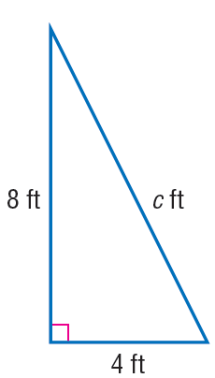

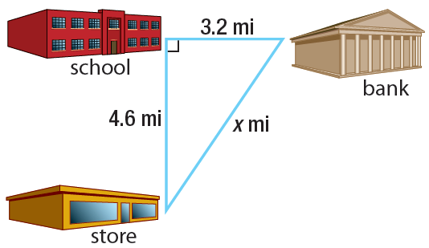

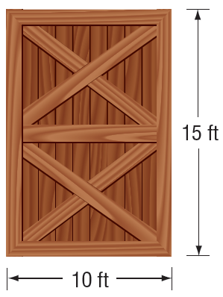
- A barn door is 10 feet wide and 15 feet tall. A square plank 16 feet on each side must be taken through the doorway. Can the plank fit through the doorway? Justify your answer.

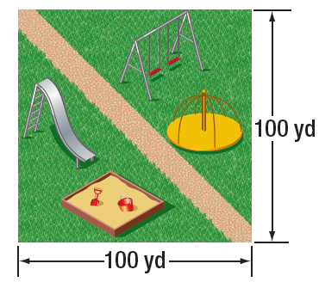
- A company designed a public play area in the shape of a square. The play area will include a pathway, as shown. Which is closest to the length of the pathway?

- Write a problem about a real-world situation in which you would use the Pythagorean Theorem.

