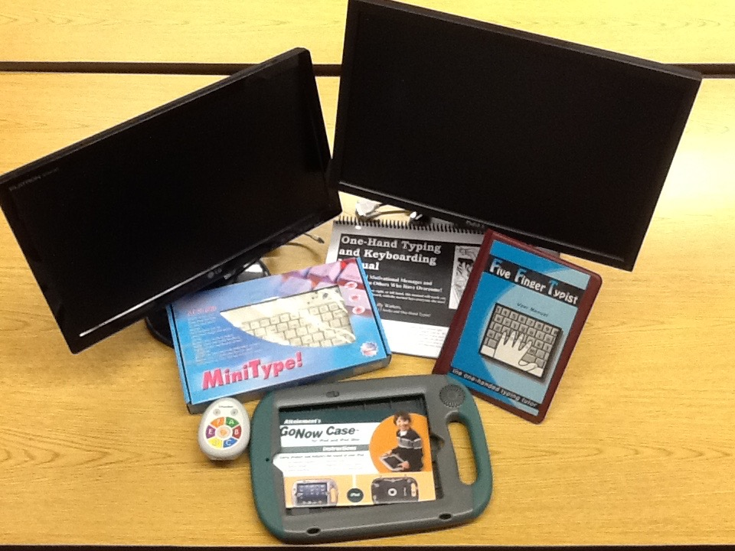

Typing Tools

- Mini Type Keyboard

- Five Finger Typist

- One-Handed Typing

- Promethean ActiVote

