Name: Date:

Work Habits Self-Assessment
Directions: Put a check mark in the column to rate your work habits.

What was your job?

 |  | Excellent | OK | Not good
Did you do your job without being asked? | 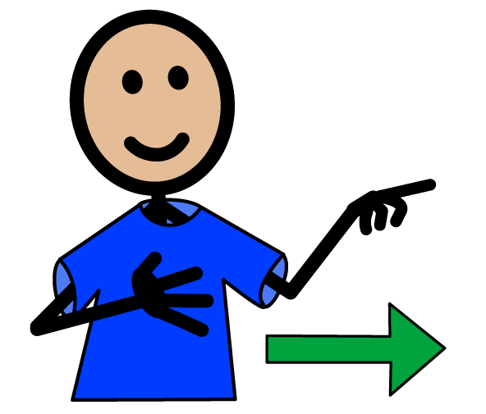
Did you work as part of a team? | 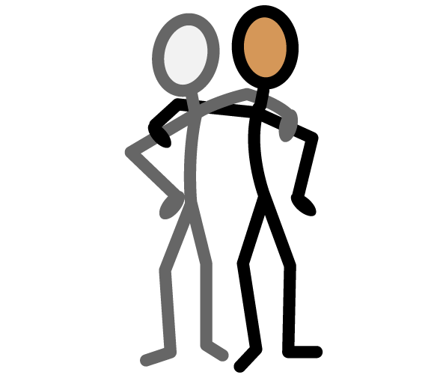
Did you follow directions? | 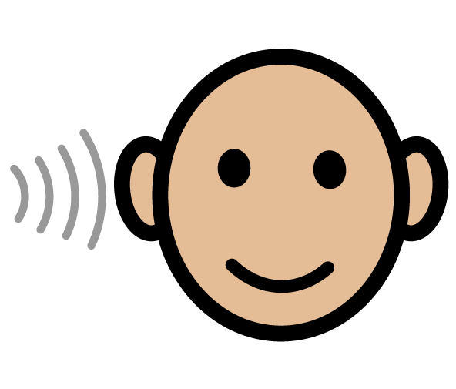
Did you ask for help if you needed it? | 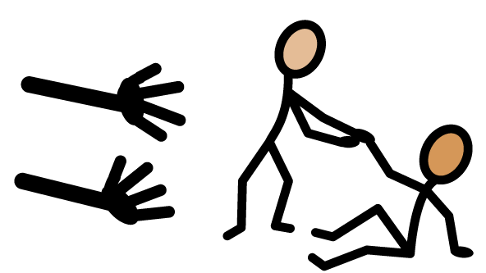
Were you respectful? | 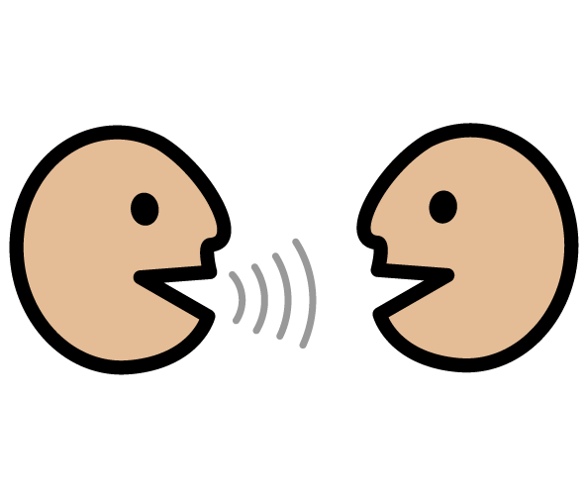
Did you do your job without complaining? | 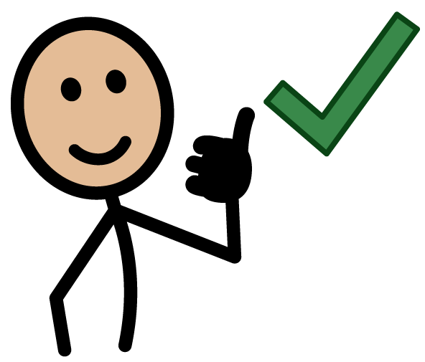
Did you stay on task? | 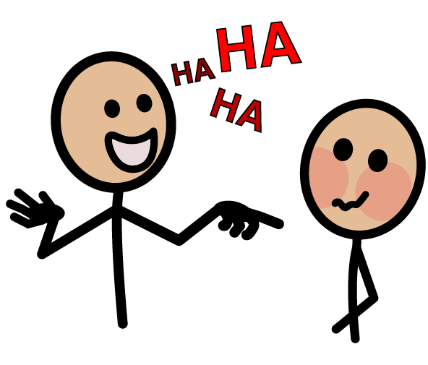

I’m good at:

I need to work on:

Staff Comments:

