Unit 3 - Equilibrium, Reversible Reactions, and the Equilibrium Constant

In equilibrium, the rates of the forward reaction and reverse reaction are equal. This is also true for equilibrium phase changes and solution equilibrium.
Note that in order for equilibrium to be maintained when a gas is involved, the reaction must be in a closed container.
Remember that though rates must be equal, concentrations need not be equal, only CONSTANT ina dynamic equilibrium.
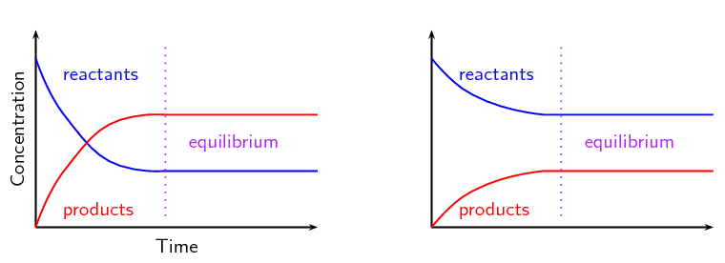
K_{eq} >1 K_{eq} <1

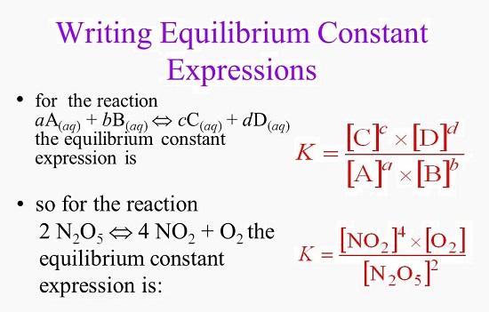

2 N₂ + 3 H₂ 2NH₃ Le Chatelier’s Principle
Concentration change
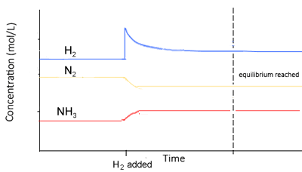

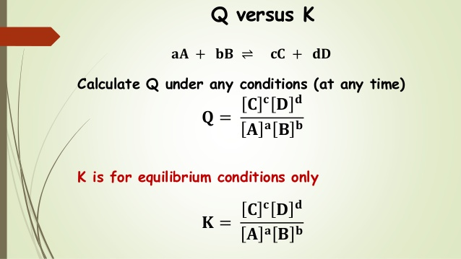

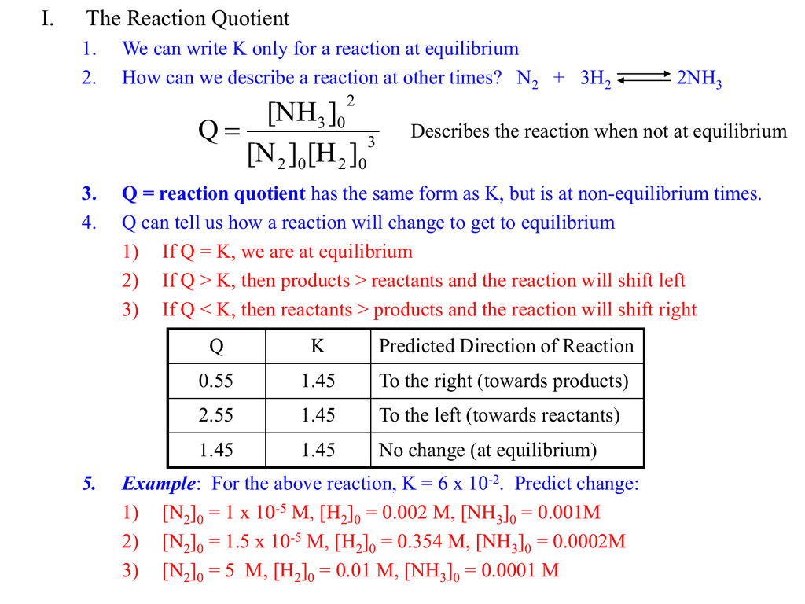

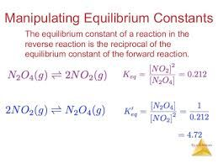
Note that pure solids and liquids do not have concentrations, so they are not included in the equilibrium expressions.

Types of K_{eq}

K_{c} – tells the equilibrium based on Molarities of aqueous of gaseous solutions

K_{p} – tells the equilibrium based on Pressures of gaseous solutions

K_{w} – tells the equilibrium of the autoionization of water (1x10⁻¹⁴ at 25ºC)

K_{a} – tells the equilibrium of a weak acid’s ionization in water, called the
acid dissociation constant

K_{b} – tells the equilibrium of a weak base’s ionization in water, called the
base dissociation constant

K_{sp} – tells the equilibrium of a salt’s solubility, called the
solubility product constant.
(NOTE in these expressions, there is NO denominator)

