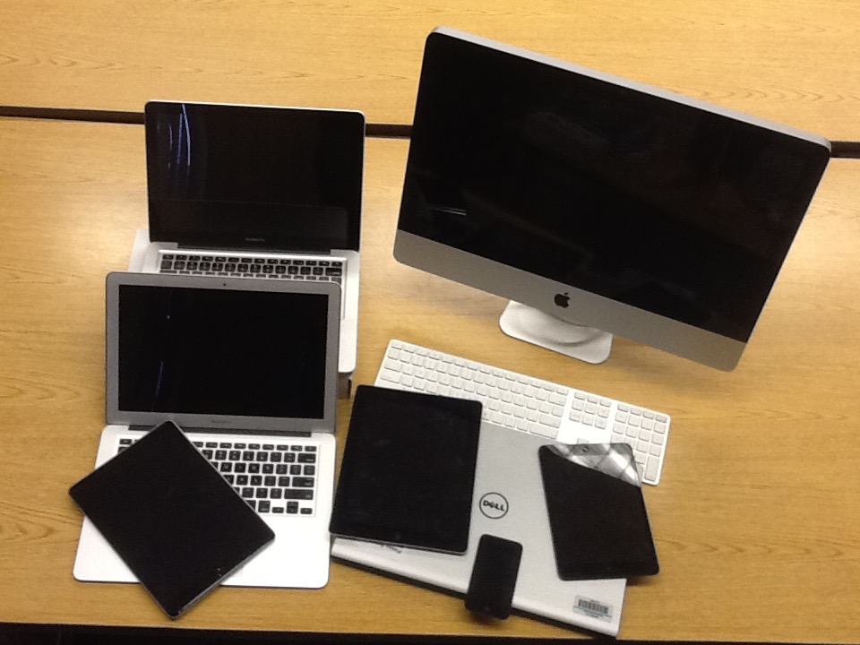

Hardware

- iMac Desktop Computer

- MacBook Air Computer

- iPad 2/ iPad Air

- iPod

- External Monitor

