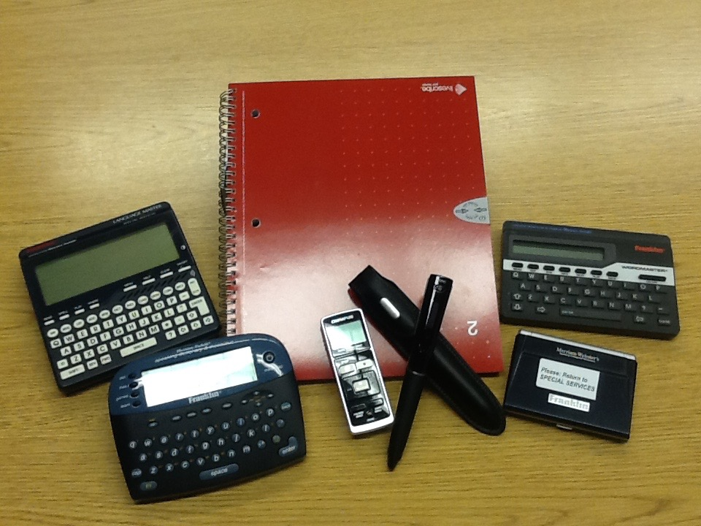

Audio and Visual Aids

CD and Cassette Player

Speakers

Projector

CD Player

Noise Reduction Headsets

Dragon Naturally Speaking

Pulse Pen and Paper

Scribe Software

Motiv-Aider

Headphones with Mic for dictation

Bee-Bots

Pro-Bot

Motiv-Aider

Digital Recorder

Talking Dictionary

Camera

Video Recorder

