**STUDENT ACTIVITY - Triple Point Phase Change Diagram**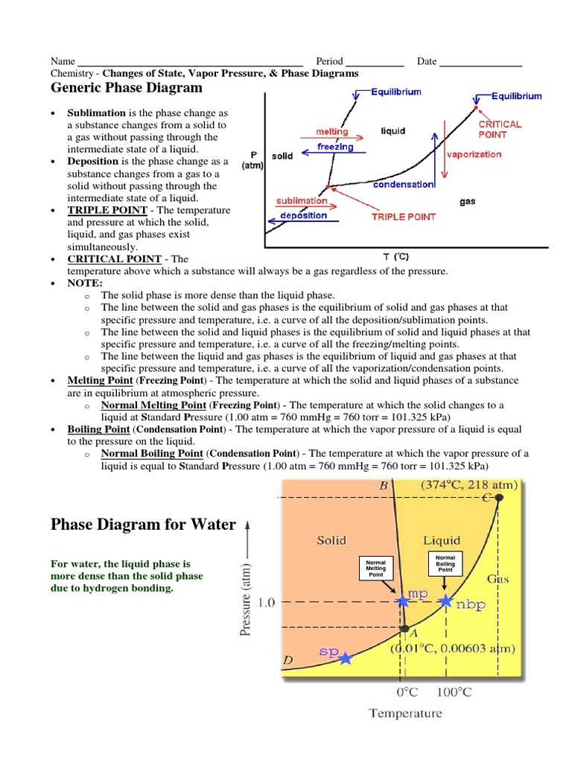

A phase diagram is a graphical way to summarize the conditions under which equilibria exist between the different states of matter. It also allows us to predict the phase of a substance that is stable at any given temperature and pressure.

**Use the Phase Change Diagram for Water to answer the following questions.**

1. What is the label is on the x-axis?

__________________________________

2. What Label is on the y-axis?

__________________________________

3. List the three phases of matter that are on the diagram.

____________, _______________, ____________

4. What is the name of the point where all three phases on the diagram meet?

__________________________________

5. **True or False**, the Triple Point of a single substance can only exist at a specific temperature and pressure for that substance.

__________________________________

6. The line extending from the triple point to the critical point stops. What does this mean in terms of any phase change beyond that temperature?

_________________________________________________________________________

_________________________________________________________________________

7. In your own words, define what you think the critical point is.

________________________________________________________________________

________________________________________________________________________

_______________________________________________________________________

8. The line AB represents the melting/freezing line for water. What does the AD line represent?

________________________________________________________________________

9. What does the AC line represent?

________________________________________________________________________

10. What phase would water be in if it had the following properties:

**a.** 50 ºC, and 0.9 atm _______________________

**b.** -50ºC, and 0.9 atm _______________________

**c.** 325 ºC, and 1.0 atm _______________________

11. **Name** the phase change that occurs (if any) when water is…

**a.** kept at 50ºC while the pressure is decreased from 1 atm to 0.001 atm

_______________________

**b.** kept at 1.00 atm while the temperature is increased from -10ºC to 15 ºC.

_______________________

**c.** kept at 60ºC while the pressure is increased from 0.001 atm to 2 atm

_______________________

**d.** kept at 1.00 atm while the temperature is increased from 120ºC to 220 ºC.

_______________________

11. What is the **normal boiling point** of water, and what is meant by "normal"?

________________________________________________________________________

________________________________________________________________________

_______________________________________________________________________

________________________________________________________________________

_______________________________________________________________________

Phase Diagram Carbon Dioxide (CO2)

Phase Diagram Water (H20)

** **

Notice that the slope of the solid-liquid lines for water and carbon dioxide are tilting in different directions. This is due to the difference in densities of these two substances in liquid and solid phases. Water has a **higher density in the liquid phase** than in the solid phase due to some unique intermolecular forces that water possesses. This also means that as **pressure increases**, the melting point of water **decreases.** Whereas carbon dioxide has a **higher density in the solid phase** than in the liquid phase, as would be expected for most substances. This means that as **pressure increases**, the melting point of CO2 also **increases.**

Another interesting thing about these two diagrams is the location of the triple point. Water's triple point is below 1 atm. This means that at normal pressure (1 atm), solid water (ice) can change from solid to liquid to gas just by increasing the temperature. However, carbon dioxide's triple point is well above 1 atm. This means that at normal pressure (1 atm), solid CO2 (dry ice) can only change from solid to gas by increasing the temperature. The only way to make liquid CO2 is to increase the pressure to above 5.1 atm and be at a temperature of -57oC or higher. However anything above 31oC and CO2 will remain a gas.

**PHASE DIAGRAM OF AN UNKNOWN SUBSTANCE**

|  |  |  |  |  |  |  |  |  |  |  |  |  |
| --- | --- | --- | --- | --- | --- | --- | --- | --- | --- | --- | --- | --- |
|  | 100  20 | **Phase Diagram for Compound X** | | | | | | | | | | |
| **Pressure (atm)** |  |  |  |  |  |  |  |  |  |  |  |
|  |  |  |  |  |  |  |  |  |  |  |
|  |  |  |  |  |  |  |  |  |  |  |
|  |  |  |  |  |  |  |  |  |  |  |
|  |  |  |  |  |  |  |  |  |  |  |
|  |  |  |  |  |  |  |  |  |  |  |
|  |  |  |  |  |  |  |  |  |  |  |
|  |  |  |  |  |  |  |  |  |  |  |
|  |  |  |  |  |  |  |  |  |  |  |
|  |  |  |  |  |  |  |  |  |  |  |
|  |  |  |  |  |  |  |  |  |  |  |
| 0 100 200 300 400 500 600 700 800 900 | | | | | | | | | | |
|  | **Temperature (°C)** | | | | | | | | | | |
|  |  |  | | | | | | | | | | |

12. At what temperature will Compound X sublimate be at 35 atm? _____________________

13. What is the critical temperature of Compound X? _________________________________

14. At what temperature and pressure will all three phases coexist? ________________________

15. What happens to the melting point of Compound X as pressure increases?

_________________________________________________________________________

16. If you had a bottle containing Compound X, what phase would it most likely be in?

____________________________________

17. If I have a bottle of Compound X at a pressure of 80 atm and temperature of 600oC, what phase would it be in?

____________________________________

18. If Compound X is at a pressure of 40 atm and temperature of 600oC, what will happen if I raise the pressure to 80 atm?

_________________________________________________________________________