**What is a mole?**

The **mole** is the unit of amount in **chemistry**. It is simply a number.

A **mole** of a substance is defined as: The mass of substance containing the same number of fundamental units as there are atoms in exactly12.000 g of 12C. Fundamental units may be atoms, molecules, or formula units, depending on the substance concerned.

Just as we use a "dozen" to mean twelve, a chemist uses "mole" (abbreviated  *mol*) to mean 6.022 1023. Further, just as the word dozen can apply to any collection of twelve objects, the word mole can apply to any collection of 6.022 1023 objects, whether they be atoms, molecules, or ions. Using the atomic mass unit scale, we can determine the mass of a mole of water molecules.



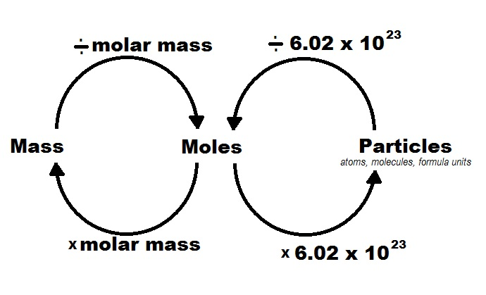

**6.022 1023 molecules of water = 1 mole of water**



Converting this to grams gives us a number of more convenient magnitude.

**It is more convenient to say that there are 18.02 grams of water in 1 mole of water.**

It is not a coincidence that we ended up with the same number in grams as the original number of amu. Just as one *molecule* of water has a mass of 18.02 amu, one *mole* of water molecules has a mass of 18.02 grams. Likewise, the mass of a molecule of CO2 is 44.01 amu, and the mass of a mole of CO2 molecules is 44.01 grams. Half of that mass would contain half as many particles.

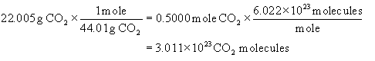

**Now how many Oxygen atoms were there in that 22.005 g sample of carbon dioxide?**

**Mole Poem**

**Carbon has six protons and six neutrons, it’s true.**

**Add them both together for the mass in a.m.u..**

**So if carbon-12 is what you have, 12 a.m.u. is carbon's mass.**

**But this is just one isotope, that is studied in this class.**

**And a mole's worth of carbon would then be 12 grams.**

**Remember this example and it will get you out of jams.**

**Atoms are quite tiny, too small to weigh just one.**

**Therefore, Avogadro sought to have a little fun.**

**He found the mole fits perfectly to tell the mass in grams.**

**You can find the mass of any substance if you add up its nucleons.**

**So if a carbon atom weighs 12 a.m.u., don't think it's lame.**

**A mole of carbon atoms weighs 12 grams, (Note the number is the same).**

**Now take, for an example, a mole of water clear.**

**Sum the mass of all atoms in the molecule you find there.**

**Then add them all together, and you will see its true,**

**That the mass of all the atoms is the mass in a.m.u..**

**That sum is 18, and its mass is in a.m.u..**

**And if you had a mole of water, the grams is 18 too.**

**Mr. Avogadro discovered what you need.**

**Made it more convenient to do measurements, indeed.**

**He found the number of particles and that number is the mole.**

**Use it in your calculations to help you reach your goal.**

**So memorize the number, and know it when its heard.**

**A mole is 6.02 times ten to the twenty-third.**

**The number of atoms found in one mole is also said to be**

**The number of molecules in a mole of compound of chemistry.**

**Don’t let it confuse you, for the number is the same.**

**Be it a number of atoms or a number of molecules, a mole is its name.**

**So memorize the number, and know it when its heard.**

**A mole is 6.02 times ten to the twenty-third.**

**Class Work on Molar Conversions**

**1.** Find the formulas of the following compounds:

Formula Molar Mass (grams/mol)

**a.** lithium phosphate Li3PO4 115.79

**b.** magnesium phosphate Mg3(PO4)2 262.84

**c.** sodium sulfide Na2S 78.04

**d.** sodium sulfate Na2SO4 142.04

**Now do the following:**

Convert 25.00 grams of lithium phosphate into moles.

Convert 2.50 moles of magnesium phosphate into grams.

Convert 3.75 grams of sodium sulfide into molecules.

Convert 9.033 x 1023 molecules of sodium sulfate into grams.

25.00 ~~grams~~ of Li3PO4 x 1 mole = **0.2159 moles of Li3PO4**

115.79 ~~grams~~

2.50 ~~moles~~ of Mg3(PO4)2  x 262.84 grams = **657 grams of Mg3(PO4)2**

1 ~~mole~~

3.75 **~~grams~~** of Na2S x **1 ~~mole~~** x 6.022 x 1023 molecules = **2.88 x 1022 molecules of Na2S**

78.04 **~~grams~~** **1 ~~mole~~**

9.033 x 1023 **~~molecules~~** of Na2SO4  x **1 ~~mole~~** x 142.04 grams = **213.1 grams of Na2SO4**

6.022 x 1023 **~~molecules~~** **1 ~~mole~~**

**% Composition by Mass**

**Mass** percent **composition** describes the relative quantities of elements in a chemical compound. **Mass** percent **composition** is also known percent by weight. For example, in H2SO4, in order to determine the % of each element, we take the molar mass of the elements divided by the molar mass of the compound x 100.

%H = 2 (1.008g/mol) / 98.076 g/mol x 100 = 2.056 %

%S = 32.06 g/mol) / 98.076 g/mol x 100= 32.69 %

%O = 4 (16.00/mol) / 98.076 g/mol x100 = 65.26 %

**Empirical Formulas**

An **Empirical formula** is the chemical **formula** of a compound that gives the proportions (ratios) of the elements present in the compound but not the actual numbers or arrangement of atoms. This would be the lowest whole number ratio of the elements in the compound.

Example: The **molecular formula** for glucose is **C6H12O6**.

Its **empirical formula** is **CH2O.**

In order to determine the Empirical formula for a compound or molecule, we need to know the mass percentages of the elements in the compound. Once we have this information we can convert it to moles to determine the ratios between the elements.

Here are the Steps needed to find an Empirical Formula:

**Turn Percent into Mass**. This is easily done by just assuming you have a 100 gram sample. Note if you are given grams to start with, you skip this step.

**Turn Mass into Moles.** Simply divide each element by its molar mass to find the moles of each element in the compound.

**Divide by the smallest number of moles.** Divide each of the moles by whichever number is the smallest. If this doesn’t give you a simple whole number ration, then you can multiply by a simple whole number that will give you one.

For Example:

**NutraSweet is 57.14% C, 6.16% H, 9.52% N, and 27.18% O.  Calculate the empirical formula of NutraSweet and find the molecular formula.  (The molar mass of NutraSweet is 294.30 g/mol)**

Start with grams of each element by assuming a 100. gram sample and change the % to grams.

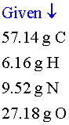

Convert the mass of each element to moles using the molar mass from the [periodic table](http://www.chem.tamu.edu/class/majors/tutorialnotefiles/periodictable.htm).

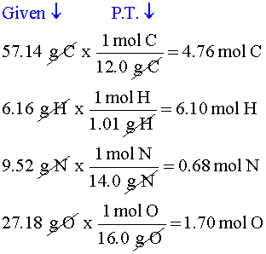

Divide each mole value by the smallest number of moles calculated.

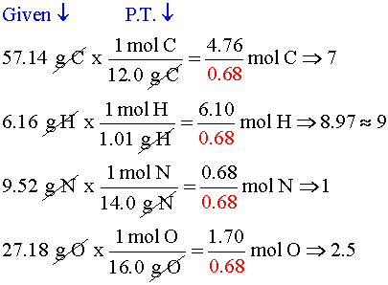

This is the mole ratio of the elements and is represented by subscripts in the empirical formula. Note that all the moles of each element are close to whole numbers (+/- 0.1) except for the moles of oxygen which is 2.50 moles. In order to fix this problem, we will double everything so the moles of oxygen will now be 5.00 moles.

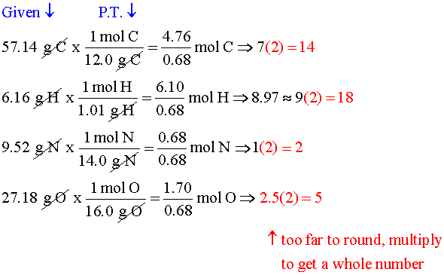



Here are the Steps needed to turn an Empirical Formula I to a Molecular Formula:

**Find the mass of the Empirical formula**. Add up all of the molar masses of all of the elements in the empirical formula.

**Divide the Given molar mass of the compound by the mass of the empirical formula you just calculated.**  This will give you a simple whole number.

**Multiply the whole number you calculated by the Empirical formula**. By doing this you will solve for the actual Molecular formula.

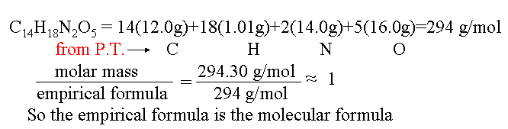



**Now you try one:**

Caffeine has the following percent composition: carbon 49.48%, hydrogen 5.19%, oxygen 16.48% and nitrogen 28.85%. Its molecular weight is 194.19 g/mol. What is its molecular formula?

1) Calculate the empirical formula:

carbon: 49.98 g ÷ 12.01 g/mol = 4.16 moles  
hydrogen: 5.19 g ÷ 1.008 g/mol = 5.15 moles  
nitrogen: 28.85 g ÷ 14.01 g/mol = 2.06 moles  
oxygen: 16.48 g ÷ 16.00 g/mol = 1.03 moles

carbon: 4.16 ÷ 1.03 = 4.04 = 4  
hydrogen: 5.15 ÷ 1.03 = 5  
nitrogen: 2.06 ÷ 1.03 = 2  
oxygen: 1.03 ÷ 1.03 = 1

2) Empirical formula is C4H5N2O. The "empirical formula weight" is about 97.1 grams/mol.

149.19 / 97.1 = 2

3) The molecular formula is:

C4H5N2O times 2 = C8H10N4O2 <--- that's the molecular formula

**Combustion analysis problem:**

**Problem:** A 1.50 g sample of hydrocarbon undergoes complete combustion to produce 4.40 g of CO2 and 2.70 g of H2O. What is the empirical formula of this compound? In addition, its molecular weight has been determined to be about 75.17 g/mol. What is the molecular formula?

We start with the chemical reaction. Even though we don’t know the exact formula for this unknown hydrocarbon, we can still write it as C***x***H***y*** (where ***x*** and ***y*** represent the possible moles of the carbon and hydrogen atoms respectively).

**C*x*H*y* + O2 CO2 + H2O**

1st we will determine the moles of CO2: 4.40 g CO2 x 1 mole = 0.100 moles of CO2

44.01 grams

Since there is one mole of **C** for every one mole of **CO2** we can say we have **0.100 moles of C**.

Therefore, we can replace ***x*** with **0.100**

Now we will determine the moles of H2O: 2.70 g H2O x 1 mole = 0.150 moles of H2O

18.016 grams

Since there are 2 moles of **H** for every one mole of **H2O** we can say we have **0.300 moles of H**.

Therefore, we can replace ***y*** with **0.300**

**C*x*H*y* becomes C*0.100*H*0.300*** which we can turn into an empirical formula by dividing by the smallest number (0.100) This gives us C1H3 or simply CH3.

Now to find the molecular formula. The molar mass of CH3 = 15.034 g/mol

75.17 / 15.034 = 5

Therefore, the molecular formula of our unknown hydrocarbon is 5 x CH3 = **C5H15**

**Balancing Equations**

Simply put, the number of atoms of each element on the reactant side (left) of a reaction must be equal to the number of atoms of each element on the product side (right) of a reaction. Since we cannot change the molecular formulas, we use **coefficients** to balance chemical equations.

Example: AgNO3 + BaCl2 AgCl + Ba(NO3)2

**Balance one element at a time from each side of the reaction.**

­2AgNO3 + BaCl2 2AgCl + Ba(NO3)2

**You try some:**

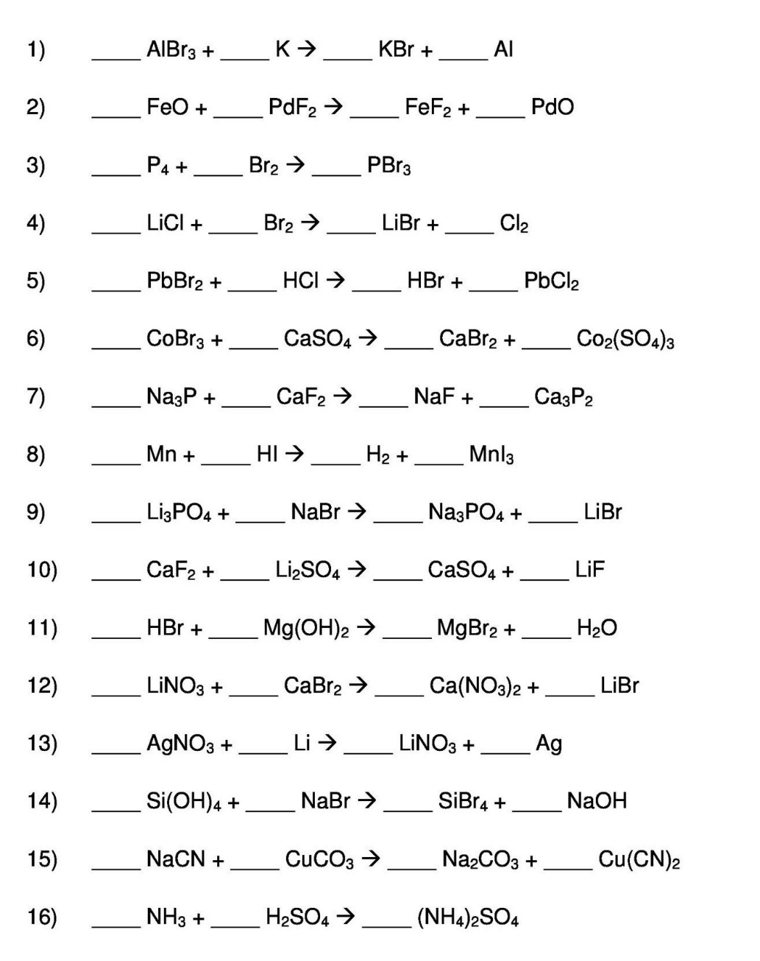

**Answer Key**

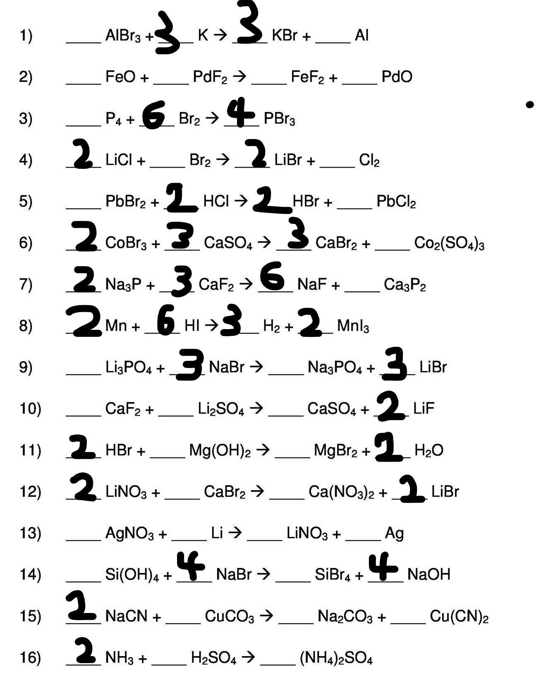

Stoichiometry: Mole-Mole Calculations

You will be asked to calculate the **moles** of a product produced (or the **moles** of a reactant needed), given a known quantity of moles to start with. This is simply done by setting up a proportion and solving for X.

For example, given the equation: 4 NH3 + 3 O2 🡪 2 N2 + 6 H2O

**4 moles** of NH3 and **3 moles** of O2 makes **2 moles** of N2 and **6 moles** of H2O.

This means that the ratio can be rewritten as: **4:3:2:6**.

Knowing this ratio, allows you to solve for any unknown from any one quantity.

Example: Suppose I told you that you had *2.500 moles of NH3*. How would you find the moles of oxygen needed and the moles of nitrogen and water produced?

**4** NH3 +  **3** O2 🡪 **2** N2 +  **6** H2O

*2.500 moles* _______moles _______moles ______moles

Set up theses proportions to find the answers as follows:

**4 moles** of NH3 = **3 moles of O2** 4 X = 7.5 X = **1.875 moles of O2**

*2.500 moles of NH3* X

**4 moles** of NH3 = **2 moles of N2** 4 X = 5.0 X = **1.250 moles of N2**

*2.500 moles of NH3* X

**4 moles** of NH3 = **6 moles of H2O**4 X = 15 X =**3.750 moles of H2O**

*2.500 moles of NH3* X

Stoichiometry Mole-Mass Calculations

To calculate the **mass** of a product produced (or the **mass** of a reactant needed), given a known quantity of moles to start with. This is done in **two steps**:

**Step 1:** **Set up a proportion to find moles.**

**Moles of A -----(use proportion)-----> Moles of B**

For example, given the equation: 4 NH3 + 3 O2 🡪 2 N2 + 6 H2O

Given *2.50 moles* of NH3, how would you find the mass of water produced?

4 NH3 + 3 O2 🡪 2 N2 + 6 H2O

*2.50 moles* ______moles

**4 moles** of NH3 = **6 moles of H2O** 4 X = 15

*2.50 moles of NH3* X X = **3.75 moles of H2O**

**Step 2: To convert Moles to Mass multiply by the molar mass.**

**Moles of B -----(x Molar Mass)-----> Mass of B**

H2O has a molar mass of 18 (Oxygen = 16, two Hydrogens = 2.016)

**3.75** ~~moles~~ of H2O x 18.016 grams =  **67.6 grams**

~~mole~~

Stoichiometry: Mass-Mole Calculations

Calculate the **moles** of a product produced (or the **moles** of a reactant needed), given a known quantity of **mass** to start with. This is done in **two steps**:

For example, given the equation: 4 NH3 + 3 O2 🡪 2 N2 + 6 H2O

Given *42.5 grams* of NH3, how would you find the **moles** of water produced?

**Step 1: To convert Mass to Moles, divide by the molar mass.**

**Mass of A ---(divided by the Molar Mass)---> Moles of A**

4 NH3 + 3 O2 🡪 2 N2 + 6 H2O

*42.5 grams*

The molar mass of NH3 is 17.034 grams per mole

42.5 ~~grams~~ of NH3 X 1 mole = 2.50 moles of NH3

17.034 ~~grams~~

**Step 2:** **Set up a proportion to find moles of the unknown.**

**Moles of A -----(use proportion)-----> Moles of B**

**4 moles** of NH3 = **6 moles of H2O** 4 X = 15

*2.50 moles of NH3* X X = **3.75 moles of H2O**

Stoichiometry: Mass-Mass Calculations

Calculate the **mass** of a product produced (or the **mass** of a reactant needed), given a known quantity of **mass** to start with. This is done in **three steps**:

For example, given the equation: 4 NH3 + 3 O2 🡪 2 N2 + 6 H2O

Given *42.5 grams* of NH3, how would you find the **mass** of water produced?

**Step 1: To convert Mass to Moles, divide by the molar mass.**

**Mass of A ---(divided by the Molar Mass)---> Moles of A**

4 NH3 + 3 O2 **🡪** 2 N2 + 6 H2O

*42.5 grams*

The molar mass of NH3 is 17.034 grams per mole

42.5 ~~grams~~ of NH3 X 1 mole = 2.50 moles of NH3

17.034 ~~grams~~

**Step 2:** **Set up a proportion to find moles of the unknown.**

**Moles of A -----(use proportion)-----> Moles of B**

**4 moles** of NH3 = **6 moles of H2O** 4 X = 15

2.50 moles of NH3 X X = **3.75** **moles of H2O**

**Step 3:** **To convert Moles to Mass, multiply by the molar mass.**

**Moles of B ---(x Molar Mass)---> Mass of B**

The molar mass of H2O is 18.016 grams per mole

**3.75 moles of water ( x 18.016 grams/mole) = 67.6 grams**

**Limiting Reactant**

The **limiting reagent** (or **limiting reactant** or **limiting** agent) in a chemical reaction is a **reactant** that is totally consumed when the chemical reaction is completed. The amount of product formed is limited by this **reagent**, since the reaction cannot continue without it. The other reactants in the reaction are said to be in **excess**, and should not be used in calculating the amount of product formed.

**How to Find the Limiting Reagent:**

Find the limiting reagent by looking at the number of moles of each reactant.

1. Determine the balanced chemical equation for the chemical reaction.
2. Convert all given information into moles (most likely, through the use of molar mass as a conversion factor).
3. Calculate the mole ratio from the given information. Compare the calculated ratio to the actual ratio.
4. Use the amount of limiting reactant to calculate the amount of product produced.
5. If necessary, calculate how much is left in excess of the non-limiting reagent.

Example: C6H12O6 + **6**O2 → **6**CO2 + **6**H2O

What mass of carbon dioxide forms when 50.0 grams of glucose with 40.0 grams of oxygen?

**Step 1:** Determine the balanced chemical equation for the chemical reaction.

The balanced chemical equation is already given.

**Step 2:** Convert all given information into moles

50.0 g of C6H12O6 × 1 mole = 0.278 moles of C6H12O6

180.156 g

40.0 g of O2 × 1 mole = 1.25 moles of O2

32.00 g

**Step 3:** Compare the calculated ratio to the actual ratio.

To do this, we need to pick one of the reactants and assume it is the limiting reactant. Then we test the hypothesis by comparing it to the amount of moles needed for the other reactant. If we calculate that the moles we need is less than the moles we have, then we guessed right because we have excess of the other reactant. However, if the moles we need is greater than the moles we have, then we guessed wrong because we don’t have enough of the other reactant. That means that the other reactant is the limiting reactant.

Let’s assume that the C6H12O6 is the limiting reactant.

We can look at the ratio of C6H12O6 to O2 using the coefficients (**1:6**) and set up a proportion to find the moles of O2 that we would need to prove this guess.

**1** mole C6H12O6  = **6** moles of O2

0.278 moles of C6H12O6 **X**

Solving for **X** we get 1.67 moles of O2 **NEEDED.** Note we only have 1.25 moles of O2. We guessed wrong, so O2 is the Limiting Reactant.

Let’s try it again this time guessing that O2 is the Limiting Reactant.

**1** mole C6H12O6  = **6** moles of O2

**X**  1.25 moles of O2

Solving for **X** we get 0.208 moles of C6H12O6 **NEEDED.** We have 0.278 moles of C6H12O6. Since we have excess C6H12O6, that means we guessed right. O2 is the Limiting Reactant.

**Step 4:** Use the amount of limiting reactant to calculate the amount of CO2 produced.

Since O2 is the limiting reactant, we will ignore the excess C6H12O6 and use O2 in our stoichiometry.

**6** mole O2  = **6** moles of CO2 1.25 moles of O2 **X** **X = 1.25 moles of CO2**

Converting moles to grams:

1.25 moles of CO2 × 44.01 g = **55.0 grams of CO2**will be produced

1 mole

Step 5: If necessary, calculate how much is left in excess.

Now let’s see how much C6H12O6 is left over.

We already established earlier that only 0.208 moles of C6H12O6 is used out of the 0.278 moles that we actually have. Therefore, if we subtract 0.278 – 0.208, we get 0.070 moles of C6H12O6 left over.

0.070 moles of C6H12O6 x 180.156 g = **12.6 grams of C6H12O6 remaining**  1 mole

**Percent Yield**

**Percent yield** is the percent ratio of actual yield to the theoretical yield. It is calculated to be the **experimental yield** divided by **theoretical yield** multiplied by 100.

Let’s say that when we did the experiment above, we only made 43.95 grams of CO2 instead of the predicted 55.0 grams. What is our % yield?

Experimentalyield x 100 = % yield 43.95g x 100 = **79.9% yield** Theoretical yield 55.0 g