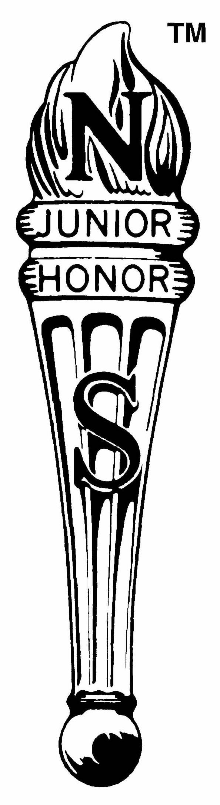
National Junior Honor Society Member

Five Pillar of the NJHS

- Scholarship – Scholarship means a commitment to learning. A student is willing to spend hours in reading and study, knowing the lasting benefits of a cultivated mind. We should continue to learn even when formal education has ended, for education ends only with the end of life. Knowledge is one great element in life, which leads to the highest success, and it can be acquired in only one way – through diligence and effort. Learning furnishes the lamp by which we read the past, and the light that illuminates the future. Candidates have the charge to continually expand their world through the opportunities inherent in scholarship.

- Service – Service can be described in various ways. In the routine of the day’s work, many opportunities arise to help others. Willingness to work for the benefit of those in need, without monetary compensation or without recognition, is the quality we seek in our membership. We are committed to the idea of volunteering our time and abilities to the creation of a better tomorrow.

- Leadership – Leadership should exert a wholesome influence on the school. In taking the initiative in class and school activities, the real leader strives to train and aid others to attain the same objective. The price of leadership is sacrifice – the willingness to yield one’s personal interests for the interests of others. A leader has self-confidence and will go forward when others hesitate. No matter what power and resources may exist in a country, they are ineffectual without the guidance of a wise leader. Leadership is always needed, thus, to lead is a substantive charge to each of our members.

- Citizenship – I represent Citizenship – the obligation each member of our society faces to live up to the democratic ideals given to us by the founders of our country. The responsibilities each of us has to our home community, our state, and our nation are many. As good citizens, we are bound to live up to the laws and guidelines which unite us a civilized society. Good citizens work together to improve not only our lives, but the lives of all fellow citizens. Good citizenship requires that we remain strong and vigilant in protecting the freedoms and rights that have been granted to us and in preventing injustice from entering our lives. We, the members of our chapter, are called to live up to the high standards of Citizenship from this day forward.

- Character – Character is the force within each individual which distinguishes that person from others. It gives each of us our individuality. It is that without which no one can respect oneself, nor hope to attain the respect of others. It is this force of character that guides one through life and, when once developed, grows steadily. Character is achieved and not received. It is the product of constant action, striving daily to make the right choice. The problem of character is the problem of self-control. We must be in reality what we wish to appear to others. By demonstrating such qualities as respect, responsibility, trustworthiness, fairness, caring, and citizenship, we may hope to prove by example that we value character.

After reading these five pillars of the National Junior Honor Society, please write a well-developed, five paragraph essay on why being a part of the NJHS is important to you and how you will incorporate these pillars into your everyday life here at school and home.

