September 23, 2019

Dear Families,
We have had another busy week at P.S. 24 filled with learning, from first graders engaging in math talks and showing multiple strategies to solve problems to fifth graders working collaboratively to solve complex math problems.

Upcoming Events

- Our First Parent Association Meeting of the 2019-2020 school year will be held on Wednesday, September 25, 2019. We hope to see everyone there!

Notes
- Please remember to check out our school website: www.ps24school.org Our wonderful parent coordinator. Florence Byrne, ensures that it contains all the information you need to help your children succeed and to keep you informed about school happenings.
- Please see letter below from the Division of School Facilities.
- Children in Grades K-3 received a letter today about Fountas and Pinnell MOSLs. Please check your child’s backpack for this notice.

If you have any questions or concerns please email the administration or parent coordinator directly at: sschwartz@schools.nyc.gov, namster@schools.nyc.gov, aparedes@schools.nyc.gov or fbyrne@schools.nyc.gov

We look forward to a great week! Thank you for your support and please remember to ask your children about all of the exciting things they are learning at school every day.

Sincerely,
P.S. 24 Administration

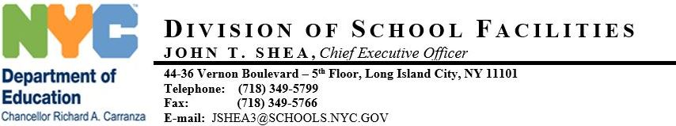

September, 18 2019
Steven Schwartz
P.S. 24 - BRONX
660 WEST 236 STREET
BRONX , NY 10463
RE: AHERA MANAGEMENT PLAN (AHERA)

In compliance with the U.S. Environmental Protection Agency (US EPA) Asbestos Hazard Emergency Response Act (AHERA), 40 CFR Part 763, Subpart E, the New York City Department of Education has performed an inspection of the asbestos containing building materials (ACBM) in your school.
This inspection was performed by accredited asbestos inspectors certified by the New York State Department of Labor and the U.S. Environmental Protection Agency. An accredited management planner, also certified by both agencies, reviewed the results of the inspection and recommended actions that should be taken to safely manage asbestos materials in the building.
The results of the inspection are contained in the AHERA Management Plan, which is available at the administrative office or custodian office for review by the public, including parents, teachers and other school personnel, and their representatives without any cost or restriction. Please share copies of this notification with the Parent Association President, UFT Chairperson and the custodian. However, you should post copies of this notification in the administrative office, custodial office, and faculty common rooms. Should there be any questions about asbestos in the building, I can be reached at (718) 610-3111. Your cooperation is greatly appreciated.
