Name: _________________________________________ Date: ___________________

Student Activity- Ionic Bonding
A chemical bond is a lasting attraction between atoms or ions that enables the formation of chemical compounds. The bond may result from the electrostatic force of attraction between oppositely charged ions as in ionic bonds or through the sharing of electrons as in covalent bonds. There is also a third type of bonding called metallic bonds that will be discussed later.
Chemical bonds form because atoms lack stability in their atomic structure. In order to become stable they must complete an outer shell of electrons. Normally this requires 8 electrons, so a complete shell of electrons is sometimes called an "octet" of electrons. Another reason bonds form is to lower the energy of the atoms. Atoms have very high potential energy. When they form bonds, that energy is released. Bond formation is always exothermic. Bond breaking is always endothermic.
Ionic Bonds
Ionic bonds are formed from the transfer of electrons. Usually, a metal will lose its valence electrons and become a cation (positive ion). The electrons that are lost are then transferred to the nonmetal where they are accepted. The nonmetal becomes an anion (negative ion). As mentioned before, the bond results from the electrostatic force of attraction between oppositely charged ions. These compounds are called salts.
The strength of the bond between the ions of opposite charge in an ionic compound depends on the amount of charges on the ions and the distance between the centers of the ions when they pack to form a crystal. You may remember this as Coulomb's Law. When many ions pack together in a crystal, it is called a lattice. An estimate of the strength of the bonds in an ionic compound can be obtained by measuring the lattice energy of the compound, which is the energy given off when oppositely charged ions in the gas phase come together to form a solid.
Example: The lattice energy of NaCl is the energy given off when Na⁺ and Cl⁻ ions in the gas phase come together to form the lattice of alternating Na⁺ and Cl⁻ ions in the NaCl crystal shown in the figure below.
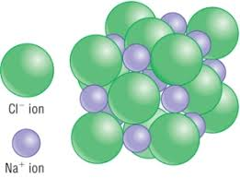
What does it mean if a crystal has a large amount of lattice energy? It means that the bonds holding the ionic compound together are strong and they would be difficult to break. The greater the lattice energy an ionic compound has, the higher its melting point. But what determines the lattice energy? Remember Coulomb's Law… "Large Charge, Small Ball." The bigger the charge on the ions, the stronger the attraction. And the smaller the size of the ions, the stronger the attraction.
NaCl has a lattice energy of -787.3 kJ/mol and a melting point of 801ºC.
MgO has a lattice energy of -3800 kJ/mol and a melting point of 2852ºC.
Notice a difference? Why is MgO so much stronger? Well let's compare the ionic charges in MgO to NaCl.
NaCl is comprised of an Na⁺¹ ion and a Cl⁻¹ ion.
MgO is comprised of an Mg⁺² ion and a O⁻² ion.
Notice that MgO has double the charge on both its ions compared to NaCl. That would be enough to conclude the MgO is stronger. But wait, there's even more! Remember your periodic trends, Mg⁺² is smaller than Na⁺¹. And O⁻² is smaller than Cl⁻¹. So not only does MgO have larger charges, it has smaller ions. (Large Charge, Small Ball).
Let's see what you've learned.
1. Define these terms
a) ionic bond -____________________________________________________________
____________________________________________________________
b) lattice energy - _________________________________________________________
_________________________________________________________
c) salt - ____________________________________________________________
____________________________________________________________

2. Determine which of the following pairs has the greatest lattice energies and therefore the strongest ionic bonds. Circle the correct one from each pair.
LiF or LiCl CaCl₂ or MgCl₂ MgO or Al₂O₃ Na₂O or Na₃N

Properties of Ionic Compounds
Ionic compounds generally have the following properties: (MEMORIZE THESE!)
- High melting points
- Solid crystals (or powder) at room temperature
- Brittle
- Mostly soluble in water (but not all of them - we'll learn that later)
- They do not conduct electricity except when melted or dissolved in water.

Lewis Dot Structures for Ionic Bonds
3. You have already learned how to draw Lewis Dot (or Electron Dot) structures for ionic compounds. Let's see if you remember how to do it. Draw the Lewis Dot structures for the following ionic compounds.
LiF

Na₂O

BaO

CaCl₂

K₃N

Why do some ionic compounds (salts) have subscripts and others do not?
The composition of ionic compounds is determined by the requirement that the compounds must be electrically neutral. That is that the charges of the cations and anions must balance or 'cancel' out one another. For example consider sodium cations (Na⁺) and chloride anions (Cl⁻). Sodium has a positive 1 charge and chloride has a negative 1 charge. Thus one sodium cation cancels one chloride anion resulting in the formula, NaCl. This formula is called the "formula unit" since it represents only one unit of the vast NaCl array or lattice. However, when the charges do not cancel out, you need to balance the formula by using subscripts to represent the ratio of each cation to each anion. We call this the "drop and switch method." See the example below.

Write the symbol and charge of the cation (metal) first and the anion (nonmetal) second.
Example: Aluminum oxide Al⁺³ O⁻²
Drop and switch the number from each charge if they do not match. You can leave out the charges now.
Al⁺³ O⁻² becomes Al₂O₃

4. Now you try some. Find the formulas of each of the following ionic combinations.
Lithium and Fluorine __________________________
Calcium and Sulfur __________________________
Magnesium and Bromine (Br) __________________________
Strontium (Sr) and Phosphorous __________________________
Sodium and Sulfur __________________________
Aluminum and Chlorine (Cl) __________________________
Aluminum and Phosphorous __________________________

Polyatomic Ions
A polyatomic ion has two or more covalently bonded atoms that act as a single ion. The polyatomic ion forms ionic bonds with other ions and acts externally as a unit, just like monatomic ions. The resulting polyatomic ionic compounds can take part in the different types of chemical reactions, dissolving and dissociating in water. While behaving as a single unit externally, the internal structure of a polyatomic ion is more complicated because two or more atoms form internal covalent bonds. See the chart below.
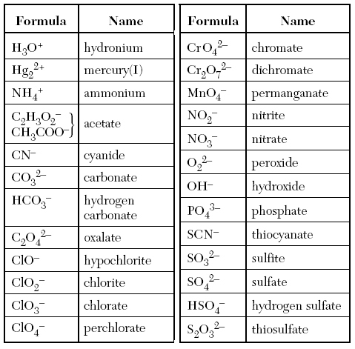
So how do ionic bonds form with polyatomic ions? The same way they do with monatomic ions. The composition of the ionic compounds must always be electrically neutral. That means the charges of the cations and anions must balance or 'cancel' out one another. When the charges do not cancel out, you need to balance the formula by using subscripts to represent the ratio of each cation to each anion. (Drop and switch method). See the examples below.
Lets write the formula for sodium carbonate. Sodium is Na⁺¹ and Carbonate is CO₃⁻².
Na⁺¹ CO₃⁻² becomes Na₂CO₃

Lets write the formula for magnesium phosphate. Magnesium is Mg⁺² and Phosphate is PO₄⁻³.
Mg⁺² PO₄⁻³ becomes Mg₃(PO₄)₂
Notice I needed to put parenthesis around the PO₄⁻² to show that there are two units of this anion. This would only be necessary if there is a subscript coming after the polyatomic ion.
5. Now you try some. Find the formulas for the following ionic compounds that contain polyatomic ions. Use the list from the previous page.
sodium hydroxide ___________________________

aluminum hydroxide ___________________________

lithium sulfate ___________________________

calcium nitrate ___________________________

potassium phosphate ___________________________

lithium chlorate ___________________________

lithium perchlorate ___________________________

calcium perchlorate ___________________________

ammonium fluoride(F) ___________________________

ammonium acetate ___________________________

ammonium thiosulfate ___________________________

