Personnel Evaluation Process
Peer Observations

Meet the teacher or other professional to determine time of observation and focal points for evidence gathering based on the Framework for Teaching.
After the observation, look at the evidence gathered. Remove or change evidence based on bias or interpretation. Connect evidence to the framework. Finalize evidence for presentation.
Observe the teacher or meet with the other professional at the pre-determined time. Gather evidence around the focal points as requested by the person being observed.
Meet with the teacher or other professional within 5 days of the observation. Present the evidence for self-reflection and facilitate conversation to promote growth in the areas observed.

Peer Observer Training

Peer Observation
A Peer Observer observes, collects, shares evidence, and provides feedback for formative purposes only. Peer Observers do not rate an educator’s practice, nor is peer observation information shared with anyone other than the observee unless permission is granted. Peer Observers are trained, certified school personnel.

- All teachers and other school-based certified professionals will receive a peer observation in their summative year.
- All educators are eligible to participate in the district-approved peer observation certification training to increase understanding of the peer observation component.
- Peer observers should have completed a minimum of three years of teaching or other professional experience.
- Peer observers must complete the approved peer observation certification training every three years. Completion of training will be monitored by the building principal or designee.
- Each year the principal, in collaboration with a school team, will select and assign peer observers.
- Peer observers shall have no more than five educators to observe, and the recommendation is three or fewer.
- Peer observers will be in the same role group as the peer observee. For some role groups, a modified site-visit approach may be more fitting.
- Peer observation feedback must not be shared with the administrator and is never used as part of the evaluation.
- The date of peer observations and conferences must be reported to the principal.

Orientation to Observer Training

Classroom Observations
Guidelines to follow when conducting your observations using the applicable Framework for Teaching:

Step 1: Provide a teacher orientation.
Before you conduct a classroom observation or site visit, provide the teacher/other professional with information about the process and the criteria that are used as the basis for the observation.

Step 2: Gather Evidence.
Record what you see, hear or read during the visit. After you have collected all of the evidence, you will interpret it using the rubrics in order to determine the levels of performance.

Evidence is not evenly distributed throughout the visit. You may find that one brief event contains evidence for more than one component. You may also find that some evidence is more pertinent than other evidence

Refrain from interpreting evidence and making judgments until you’ve considered the evidence against the rubrics.

Evidence: It is important that you record as evidence only what you see, hear, or read, not your interpretation of what you see or your opinion about it. Evidence may be what the teacher/other professional or a student says or what they do, including body language (e.g., walking around the classroom, students waving their hands in the air to be recognized, students slumping in their chairs, students putting their heads on their desks).

Interpretation: To make a scoring judgment for each component, you will need to interpret your evidence. However, you should use the criteria established in the rubrics to interpret evidence after you have collected all of the evidence. While you are in the process of collecting evidence, you should refrain from making interpretative statements. This helps to ensure that the evidence is not misrepresented and helps to ensure fair and reliable determination of levels of performance. It would be interpretation to say, for example, that the students appear comfortable, happy, or bored. These are interpretations of the actual evidence from the classroom, which would describe what students actually did or said.

Bias: When you make value judgments based on a teacher/other professional’s or the students’ age, race, gender, appearance, perceived economic status, or accent, these judgements may influence both how you collect evidence and make scoring decisions based on that evidence. For example, if a teacher/other professional is wearing jeans, it would be bias to assume that the teacher has established a casual, laid-back classroom atmosphere. Bias may also exhibit itself when personal preferences about teaching think that using technology is the best way to teach and let that opinion get in the way of identifying evidence of what is actually happening in the classroom when no technology is used, then bias interferes with your collection of evidence and determining the appropriate level of performance. Warning flags can sometimes be words like could have, should have, must have, ought to have, and so on.

Consider what you do not see or hear.

There might be times when what you do not see or hear is relevant evidence. For example, pertinent evidence may be that students do not ask any questions, that students are not participating in an activity, or that no inappropriate behavior is observed in the classroom.

Step 3: Align evidence with components.

Align the evidence you gathered with the appropriate component in the applicable Framework for Teaching. You may have more evidence for some components than others.

Remember evidence may have two aspects.

You may find that you need to split the evidence between two components. For example, a teacher may be asking a question to the entire class while taking attendance. The evidence of the quality of the question and student participation aligns with one component (3b Using Questioning/Prompts and Discussion Techniques) and taking attendance aligns with a different component (2c Managing Classroom Procedures).

Signing up for Professional Learning for Peer Observers

How do I sign up for the on-line version of Peer Observation Training, 2nd edition?
- Sign in to www.idrivedigital.com
- If you have signed up in the past, enter your district provided e-mail address (first.last@district.kyschools.us) and password
- If you have not signed up in the past, click Sign Up
- Follow the prompts and submit your registration
- Log in on the home landing page
- Once you log in, you are ready to engage in the training.
- Click Help in the black bar to learn how to navigate the idrivedigital platform.

Is the first version of Professional Learning for Peer Observers still available?
Peer Observation Training, 2nd Edition replaces the KET course Professional Learning for Peer Observers.
Educators certified through the KET training, are not required to complete the new training until their certification expires or directed otherwise by leadership. Additionally, the Kentucky Department of Education encourages educators to engage in this learning to explore the benefits

Who should complete this training?
- Educators interested in receiving initial or renewal certification as peer observers
- Educators interested in learning about the benefits of the peer observation process
- Teachers and other professionals currently serving as peer observers
- Coaches responsible for facilitating the training of peer observers in the district or school.

Will I receive a certificate?
Peer observer certification is awarded to all educators who complete the online training. Districts may recognize the certificate as initial or renewal certification, as appropriate, required by the Professional Growth and Effectiveness System (PGES) for peer observers.

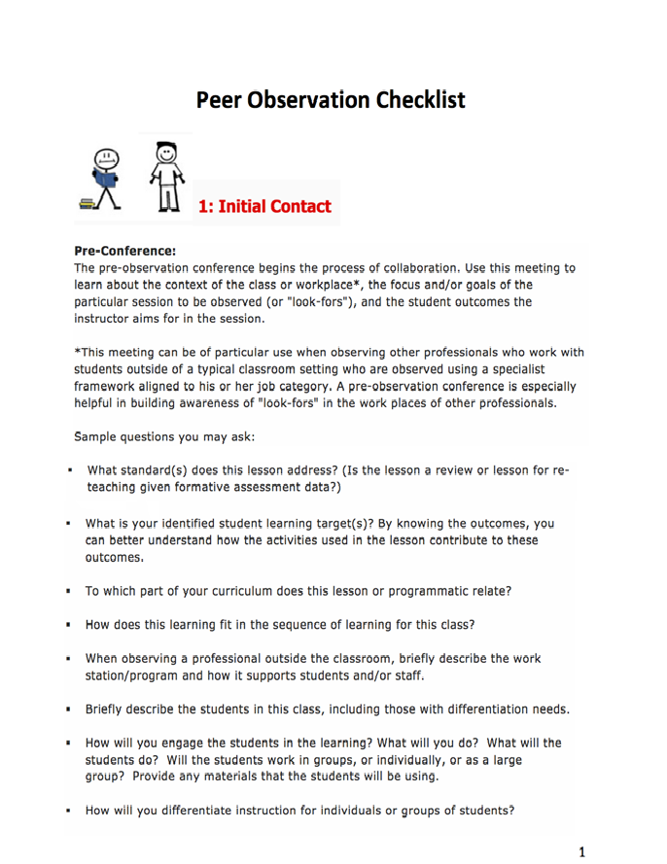

Frequently Asked Questions

Peer Observation | Will Peer Observations be entered in CIITS?  No, nothing is entered into CIITs.
Peer Observation | Can other professionals serve as teacher peer observers?  No.
Peer Observation | Will peer observers who were trained last year have to be retrained? Can GCC serve as peer observers?  No, training/certification lasts for 3 years. GCCs can serve as peer observers for other instructional specialists, but not for teachers.
Peer Observation | Are only tenured teachers eligible to be peer observers?  According to the CEP, they must have three years experience.
Peer Observation | If you are an other professional, do you only observe other professionals?  Yes, in the same framework only.
Peer Observation | To be certified as a peer observer, do they need 3 years in JCPS or just career?  Does not have to be all in JCPS.
Peer Observation | When peer observers do a pre-conference, does it have to be a face-to-face or can it be on a short form with questions they answer? Last year I asked the person I was observing which they preferred.  According to the CEP, the preconference may be conducted in person or electronically.

