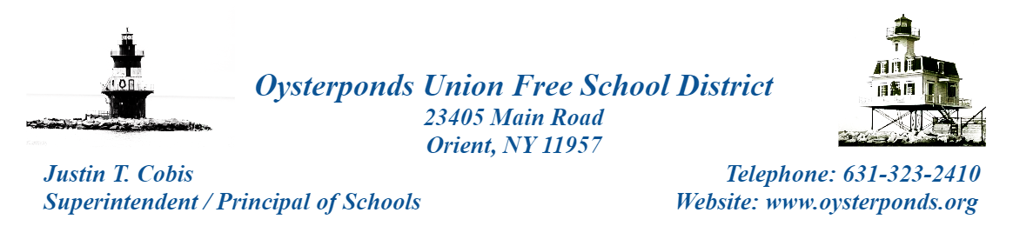

OUFSD IPAD and Internet Use
Agreement Terms and Conditions - BOE Policy 4526E

Acceptable Use
The iPAD is an educational tool that can be used to enhance instructional programs. The following items help define the acceptable use of the iPAD:
- Transmission of any material in violation of any national, state or local laws and regulations is prohibited. This includes, but is not limited to, copyrighted materials, threatening or obscene material, racially offensive material, or materials protected by trade secret or contact.
- Vandalism will result in cancellation of privileges. Vandalism is defined as any attempt to harm or destroy the iPAD itself, or software in the computer, on the network through the Internet, or of other use. This includes the uploading or creation of computer viruses.
- Installation of any software, personal email accounts and applications by students is prohibited.

Network and Internet Use
Students are expected to abide by generally accepted rules of district network and Internet etiquette. These include, but are not limited to, the following:
- Do not reveal your personal address or phone numbers.
- Be polite and use appropriate language.
- All files, programs, communications and information accessed via the network or Internet should be assumed to be copyrighted material. Permission should be obtained before using such material.

Security
Security is a high priority and essential to proper maintenance of our network system. If you feel that you know of a security problem, you must notify your teacher or administrator immediately. Do not use another user's account or attempt to log into the network server as anyone other than yourself.

OUFSD Computer, Network and Internet Use Agreement
Authorization Form

USER (Students)
I have read fully and understand the District’s Computer and Network Use Policy and Internet Use Agreement. I agree to abide by it and further understand that any violation of the rules as set forth is unethical and may constitute a criminal offense, and that should I commit a violation, my access privileges will be revoked, and school disciplinary and/or appropriate legal actions may be taken.

User name (print): ____________________________________________________________

User signature: _____________________________________ Date: _________________

PARENT/GUARDIAN
As the parent or guardian of this student, I have read the District’s Computer and Network Use Policy and Internet Use Agreement. I grant permission for my child to access networked computer services, such as electronic mail and the Internet. I understand that this access is designed for educational purposes. I accept the fact that use of the Internet is a privilege and not a right. I further accept the fact that the Oysterponds Union Free School District has reserved the right to review all materials and may revoke each person’s privilege to use the network services. With regard to commercial services on the Internet, I will be liable for fees that the student incurs outside the framework of school authorizations. Additionally, I accept the possibility of financial responsibility for damages incurred as a result of direct actions by my child as a result of misuse or abuse of equipment, systems or network resources.

Parent/Guardian’s name (print): ___________________________________________________

Parent/Guardian’s signature: _______________________________ Date: _________________

