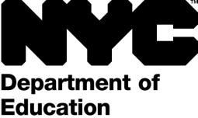 | Office of Communications and Media Relations  52 Chambers Street, New York, NY 10007 Tel: 212.374.5141 Fax: 212.374.5584

CONSENT TO PHOTOGRAPH, FILM, OR VIDEOTAPE A STUDENT FOR NON-PROFIT USE
(e.g. educational, public service, or health awareness purposes)

Student Name: School:

I hereby consent to the participation in interviews, the use of quotes, and the taking of photographs, movies or video tapes of the Student named above by .
I also grant to the right to edit, use, and reuse said products for non- profit purposes including use in print, on the internet, and all other forms of media. I also hereby release the New York City Department of Education and its agents and employees from all claims, demands, and liabilities whatsoever in connection with the above.

Signature of Parent/Guardian (if Student is under 18): Date:

Address of Parent/Guardian:

OR

Signature of Student (if 18 or over): Date:

Address of Student:

