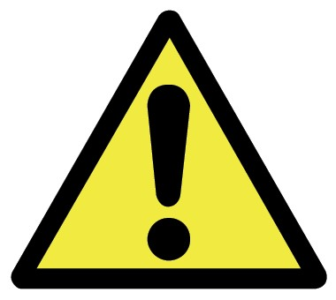

what to say when kids make reading mistakes

…without giving them the answers!

teachmama.com
Please note: This is just a starting point, not to be used on every child in every situation. But it’s a place to begin for parents so that we’re not just ‘giving’ kids the words that they’re stuck on during read-alouds and we’re not just correcting kids in the middle of their reading.
Any one of these ideas can be used alone or along with the others while listening to an emerging reader in action!

When kids won’t even try to sound out a word or they won’t budge, say:

Think about the letters you recognize and the sounds they make. What sound does this letter make (point to first letter)? Let me hear you make the sound. Now what sound does this letter make (point to second letter)?
Let’s put the sounds together. . . o This works for words with letter-sound patterns that are familiar or decodable to the child.

- Look at the letters you know in the word and the picture on the page. The picture is here to help you. Think about the sound this letter makes (point to first letter of word) and what you see in the picture. . .

- Think about what’s going on in this story. You just read, (read previous line). Look at the picture, look at the word, and think about what might happen next.

- Skip the word you don’t know and move to the next word you can read.
  - Sometimes this will get the wheels turning and kids will go back to ‘selfcorrect’ and re-read this word; sometimes they won’t, and that’s okay.

- You might not recognize this word, but I know you know this word
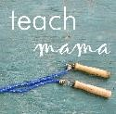
(cover the first letter and let him read the part he knows—at from

another resource from http://www.teachmama.com to help our little ones learn while they play. . .

what to say when kids make reading mistakes

…without giving them the answers!

teachmama.com
‘bat’). Think about the sound that ‘b’ makes, put the sounds together, and you’ll have it!

- You just read this word on the previous page, and you read it correctly. Use your detective eyes, find the word on the other page, and see if that helps.

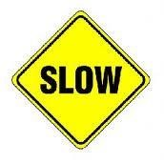
When a child makes an error on a page and moves right on by like nothing happened, even if what she read makes no sense:

- Let her go! Don’t interrupt mid-reading; instead consider saying at the end of the sentence, phrase, or paragraph:
  - Are you correct? o Read it again and check closely. o Can you find the tricky part? o It’s in this line.
  - I’ll point it out and help you find it.
- Use this prompt occasionally even when your child reads the words correctly! That way she’ll get in the habit of self-monitoring while she’s reading.
- Use the above prompts in this order—it’s important that you give her an open-ended question (Are you correct?) initially so that she goes back and checks her reading without your help!

*Please note: If a parent or teacher is taking a Running Record of a child’s reading, rules change. No prompting should be given unless noted on the Running Record sheet.
Ideas gleaned from a variety of reliable sources, clinical work, and experience.
another resource from http://www.teachmama.com to help our little ones learn while they play. . .

