Name:__________________________________ Date:___________________ Period:_____
Light Interaction Practice
Directions: For each object, determine if light is reflected, transmitted, and/or absorbed. Explain your answer. Then, draw a model of what is happening.
Material | What’s Happening  Reflect, transmit, and/ or absorbed | Explain | Draw a Model
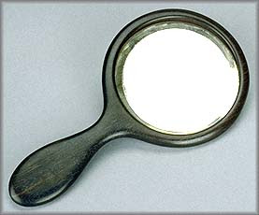
This Photo by Unknown Author is licensed under CC BY
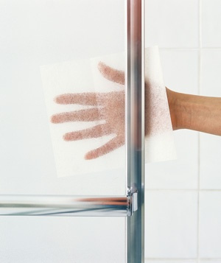
This Photo by Unknown Author is licensed under CC BY-NC-ND
This Photo by Unknown Author is licensed under CC BY
This Photo by Unknown Author is licensed under CC BY
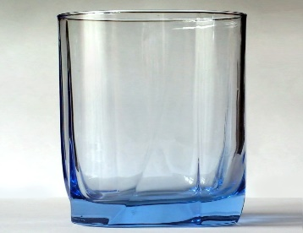
This Photo by Unknown Author is licensed under CC BY-SA
This Photo by Unknown Author is licensed under CC BY

