Light Notes
Travels | Light travels in a straight line from the source.
Light Behavior | Reflection: When light hits a surface and bounces back  Retraction: bending of light due to a change in speed  Transmits: When light passes through a material  Absorbs: When light strikes an object  ** Remember ALL objects reflect SOME light**
Types of Materials | Transparent: A type of material that transmits light without scattering it.  Ex. Clear Window  Translucent: A type of material that transmits light as it passes through.  Ex. Frosted Glass  Opaque: A type of material that reflects or absorbs all of the light that strikes it.  Ex. Text Book, Birthday Cake
Reflection | When light hits a surface and bounces back.  Regular Reflection: Reflection that occurs when parallel rays of light hit a smooth  surface and all reflect at the same angle. Also known as  specular reflection.  Diffuse Reflection: Reflection that occurs when parallel rays of light hit an  uneven (bumpy) surface and all reflect at different angles.  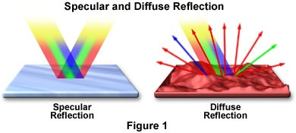  This Photo by Unknown Author is licensed under CC BY-SA
Law of Reflection | States the angle of incidence equals the angle of reflection.  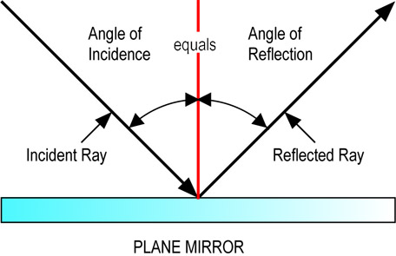  This Photo by Unknown Author is licensed under CC BY-SA
Refraction | The bending of light waves due to a change in speed.  It bends because the light wave has to slow down when entering a new medium.  Doesn’t happen all the time when entering.  Example: Light going from air to glass of water.  This Photo by Unknown Author is licensed under CC BY-SA This Photo by Unknown Author is licensed under CC BY-SA
Why we see… | Rays of light reflect, or bounce off, objects and enter our eyes. This reflection of light is what enables us to see everything around us.  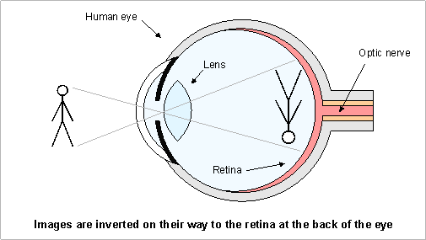  This Photo by Unknown Author is licensed under CC BY-SA-NC
Other important information | *Light must enter our eyes in order for us to see objects.  *Materials can reflect or transmit light that shines on them and many do both.  *All materials reflect some light.  *Different materials reflect and/or transmit different amounts of light.  *When light transmits through a material, less light comes out the other side, but how much less depends on the material.  *When light reflects off of a material, less light bounces back, but how much less depends on the material.  *When light shines on bumpy surfaces at the micro scale, it scatters in all directions.  *When light shines on smooth surfaces at the micro scale, it reflects in a certain direction.
Color | Opaque objects: The color of an opaque object depends on the wavelengths of lights that the object reflects. The color of an opaque object is the color it reflects.  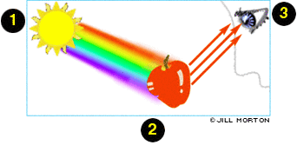  This Photo by Unknown Author is licensed under CC BY-NC-ND  The color white reflects ALL colors of light.  The color black absorbs ALL colors of light.
Other terms | Diffraction: When a wave moves around a barrier or through an opening in a  barrier, it bends and spreads out  Interference: is the interaction between waves that meet  Constructive Interference: when waves combine to form a wave with larger  amplitude than the individual waves  Destructive Interference: When waves combine to form a wave with a smaller  amplitude than the original waves
Variables | Independent: The variable we are testing or changing each time we do it  Dependent: The variable we are collecting data with. (Measure)  Control: The variables that stay the same.
Models:
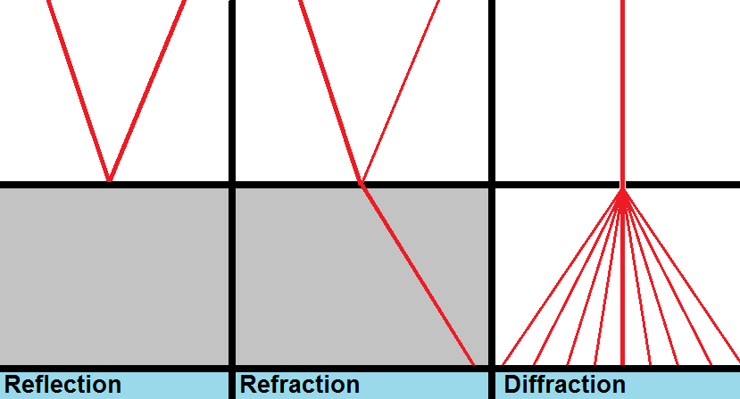

This Photo by Unknown Author is licensed under CC BY-SA-NC

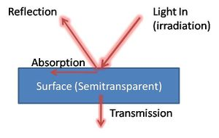
This Photo by Unknown Author is licensed under CC BY-SA

