Lesson #8 – Bonding

A chemical bond is a lasting attraction between atoms or ions that enables the formation of chemical compounds. There are three main types of bonds. The bonds that result from the electrostatic force of attraction between oppositely charged ions are called ionic bonds. Bonds that occur through the sharing of electrons are called covalent bonds. Bonds that form between metal cations and their surrounding electrons are called metallic bonds.

Why do atoms bond?
Atoms bond because they are chemically unstable and need to complete their outer shell of electrons. By doing so, they lower their potential energy and become more chemically stable. Atoms generally must have eight electrons in their outer shell to be stable. This is often called the octet rule. (Note - later one will discuss exceptions to this rule).

What are the three types of Chemical Bonds?
Ionic bonds – This occurs when atoms (usually metals) transfer their valence electrons to nonmetals. The electrostatic attraction between the cations and anions creates a strong bond. Any metal that combines with a nonmetal will form an ionic bond. However, you can also determine if a bond will be ionic by measuring the difference in electronegativities between the atoms that are bonding. Generally speaking (though there are exceptions) if the electronegativity difference between two atoms is 1.7 or higher, then the bond between them will be ionic.
Compounds that form ionic bonds are brittle solids at room temperature and generally have high melting points. Many of them are soluble in water. They do not conduct electricity as a solid because their ions are not mobile. However, if an ionic compound is either melted or dissolved in water, then it will conduct electricity because the ions are now mobile. Most ionic compounds are salts. Salts are electrolytes.

A measure of the magnitude of the electrostatic attractive forces in ionic compounds is the lattice energy. The lattice energy is defined as the energy required to convert a mole of an ionic solid into its constituent ions in the gas phase. The amount of lattice energy in a crystal (such as a salt or a group of metal ions) is dependent on two things: the size of the ions and the charge of the ions. The smaller the ions, the greater the lattice energy, and the larger the charge the ions have, the greater the lattice energy will be. Therefore, a compound such as MgO would have a greater lattice energy than NaCl. Mg⁺² and O⁻² ions are smaller in size than Na⁺¹ and Cl⁻¹ ions. Also, the charges on magnesium and oxygen are double that of sodium and chloride.
You will be required to draw these Lewis-dot structures for ionic structures. Ionic compounds do not have covalent bonds, instead, you simply draw each ion in the structure and the charge of that ion.
For example, here is how you draw the Lewis-dot structure for MgCl₂:
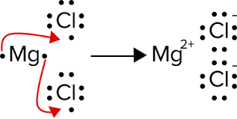

Note that the charges on the magnesium and chloride ions are shown.

Draw the Lewis Dot structures for the following ionic compounds.
LiF Na₂O BaO Cal₂ K₃N

Metallic bonds – This occurs when metal atoms allow their electrons to freely flow from one metal to another throughout the entire crystal structure. This creates a series of metal cations with delocalized electrons surrounding them. It is often referred to as a “sea of mobile electrons.”
Because of this unique way of bonding, metals can conduct electricity even in the solid state. This is because metals have freely moving electrons. Metals are also malleable, ductile and have high metals points.

Covalent bonds – (Also called Molecular Bonds) – These bonds occur when atoms share pairs of electrons. Covalent bonds are found between two or more nonmetals.
There are two types of covalent bonds: Polar and Nonpolar. A polar covalent bond exists when atoms with different electronegativities share electrons in a covalent bond. Consider the hydrogen chloride (HCl) molecule. Each atom in HCl requires one more electron to complete its outer shell. Chlorine has a higher electronegativity than hydrogen, but the chlorine atom’s attraction for electrons is not sufficient to remove an electron from hydrogen. Consequently, the bonding electrons in hydrogen chloride are shared unequally in a polar covalent bond. The unequal sharing of the bonding pair results in a partial negative charge on the chlorine atom and a partial positive charge on the hydrogen atom. The symbol δ (Greek lowercase delta) denotes these fractional charges. Polar molecules are called dipoles because they have a partial negative and partial positive end in their molecular structure. See the diagram on the next page.
δ+ δ-
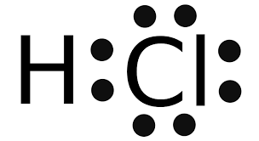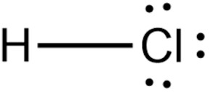
o

A non-polar covalent bond is a type of bond that is formed when electrons are shared equally between two atoms. The covalent bond is also termed as nonpolar because the difference in electronegativity is mostly negligible. Here you can see two chlorine atoms combine to make a nonpolar covalent bond. The bond is obviously nonpolar because the two chlorine atoms have the same electronegativity. Therefore, their electronegativity difference is zero.

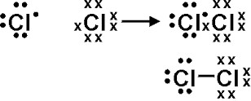

Multiple Covalent bonds – The bond produced by sharing one pair of electrons is called a single bond. However, many molecules require more than one pair of electrons being shared to complete their outer shell of electrons (called an octet). Below is an example of a double bond:

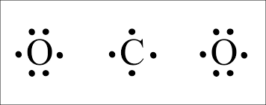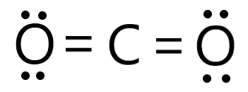
And here is an example of a triple bond:
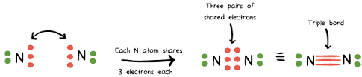

A single line denotes the sharing of two electrons in a single bond. It is important to note that a single bond would have a bond order of 1 and would have a longer bond length than a double or triple bond. Lewis structures can also be used to show multiple bonding in a molecule or polyatomic ion. A double line means that two pairs of electrons are shared in a double bond (bond order of 2), and a triple line means that there are three pairs of electrons that are shared in a triple bond (bond order of 3).

A quantitative measure of the polarity of the bond in a diatomic molecule is the dipole moment. When two charges of equal magnitude and opposite charge are separated by some distance, a dipole is established.
Drawing Lewis structures is an important first step toward understanding bonding in compounds. Use the following guidelines to practice drawing these structures.
- Sum the valence electrons from all atoms. For an anion, add an electron to the total for each negative charge. For a cation, subtract an electron for each positive charge. Don't worry about keeping track of which electrons come from which atoms. Only the total number is important.
- Write the symbols for the atoms to show which atoms are attached to which, and connect them with a single bond (a dash, representing two electrons). Chemical formulas are often written in the order in which the atoms are connected in the molecule or ion. When a central atom has a group of other atoms attached to it, the central atom is usually written first.
- Complete the octets of atoms bonded to the central atom. (Note hydrogen can have only two electrons.)
- Place any leftover electrons on the central atom, even if doing so results in more than an octet.
- If there are not enough electrons to give the central atom an octet, try multiple bonds. Use one or more of the unshared pairs of electrons in the atoms bonded to the central atom to form double or triple bonds.

Draw the Lewis Dot structures for the following molecular compounds.
CH₄ H₂O O₂
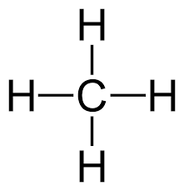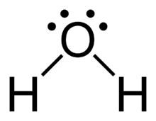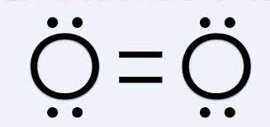

NH₃ C₂H₄ CH₂Cl₂

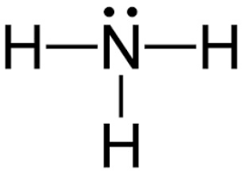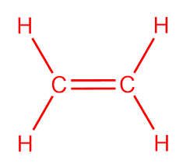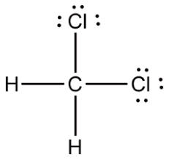

Polar vs. Nonpolar Molcules
A molecule in which the dipoles present do NOT cancel each other out are called polar molecules. In short, if the molecule has polar bonds and is asymmetrical, the molecule remains polar and thus results in a molecular dipole.
Example: H₂O is a bent molecule with 2 bond dipoles that are not oppositely directed. Therefore, the bond polarities do not cancel and the molecule is polar.
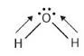
A molecule in which the dipoles present do cancel each other out are called nonpolar molecules. In short, if the molecule has polar bonds, but the molecule itself is symmetrical, the molecule is nonpolar and has no dipole. This is because the pulls on the electrons are evenly distributed.
Example: CO₂ is a linear molecule with 2 bond dipoles that are equal and oppositely directed. Therefore, the bond polarities cancel and the molecule is nonpolar.

Polyatomic ions
A polyatomic ion, also known as a molecular ion, is a covalently bonded set of two or more atoms, or of a metal complex, that can be considered to behave as a single unit and that has a net charge that is not zero. Unlike a molecule, which has a net charge of zero, this chemical species is an ion.

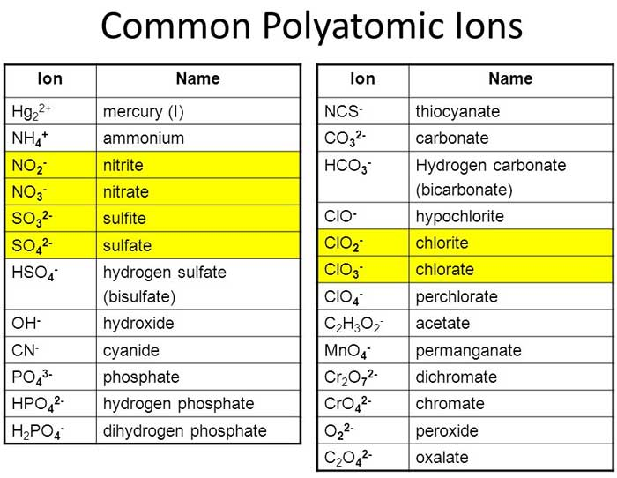

Drawing the Lewis-Dot structure of a polyatomic ion is similar to drawing a Lewis-Dot structure of a molecule. All the valence electrons must be accounted for. Each atom must have an octet of electrons (with some exceptions). However, the charge of the ion must be considered as well. For example, if an ion has a +2 charge, then two electrons must be removed from the dot notation and the entire polyatomic ion should be put in brackets with a +2 on the outside. If an ion has a -2 charge, then two electrons must be added to the dot notation and the entire polyatomic ion should be put in brackets with a -2 on the outside.

Below you can see the Lewis-Dot structure for a carbonate ion. Note also that this ion has three resonance structures. Resonance structures are a set of two or more Lewis Structures that collectively describe the electronic bonding a single polyatomic species. Resonance structures are used when a single Lewis structure cannot fully describe the bonding. Simply put, when there is a double bond next to a single bond, the 2nd pair of electrons in the double bond may shift over.

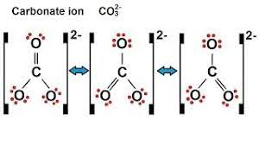
Coordinate Covalent Bond
A coordinate covalent bond is a covalent bond (a shared pair of electrons) in which both electrons come from the same atom. A covalent bond is formed by two atoms sharing a pair of electrons. The atoms are held together because the electron pair is attracted by both nuclei. In the formation of a simple covalent bond, each atom supplies one electron to the bond - but that does not have to be the case. Some polyatomic ions will have coordinate covalent bonds, in which one atom will donate two of its valence electrons (or more) to form a bond with the other atoms.

Draw the Lewis Dot structures for the following species that contain coordinate covalent bonds.
NH₄⁺ NO₃⁻ CO

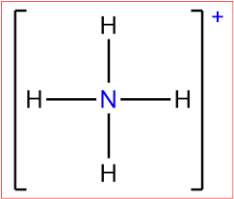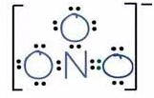

The skeleton for a Lewis structure is usually straightforward. Place in the center a unique atom of lowest electronegativity. On occasion, though, the two criteria (uniqueness and low electronegativity) do not give the same central atom. To solve this problem, we use a formal charge analysis of the Lewis structures resulting from each possibility. Formal charge is the charge assigned to an atom in a molecule, assuming that electrons in a chemical bond are shared equally between atoms. This helps determine which of a few Lewis structures is most correct. Below is the formula to calculate formal charges on atoms within a molecule or polyatomic ion:

Formal charge = valence electrons - [nonbonding electrons + bonds]

To determine which structure is the better choice when more than option is plausible, we draw the possible Lewis structures for each and calculate the formal charge on each atom in each structure. Then we see which formal charge makes the most sense. Below is one possibility for the structure of N₂O, Let’s use formal charge to determine if it is correct.
.. ..
:N = O = N:

N has 5 valence electrons and each one has 4 non-bonding electrons and 2 bonds.
Formal charge = valence electrons - [nonbonding electrons + bonds ]
Formal charge = 5 – [4 + 2] = -1. So each N has a formal charge of -1.

O has 6 valence electrons, 4 non-bonding electrons and 0 bonds.
Formal charge = 6 – [4 + 0] = +2. So O has a formal charge of +2.

This would not seem logical because oxygen has a higher electronegativity than nitrogen. So, let us look at another possible structure.
The 1st N has 5 valence electrons, 2 non-bonding electrons and 3 bonds.
Formal charge = 5 – [2 + 3] = 0. So this N has a formal charge of 0.
The 2nd N has 5 valence electrons, 0 non-bonding electrons and 4 bonds.
Formal charge = 5 – [0 + 4] = +1. So this N has a formal charge of +1.
O has 6 valence electrons, 6 non-bonding electrons and 1 bond.
Formal charge = 6 – [6 + 1] = -1. So each O has a formal charge of -1.
This seems more reasonable since oxygen has a higher electronegativity than nitrogen.

