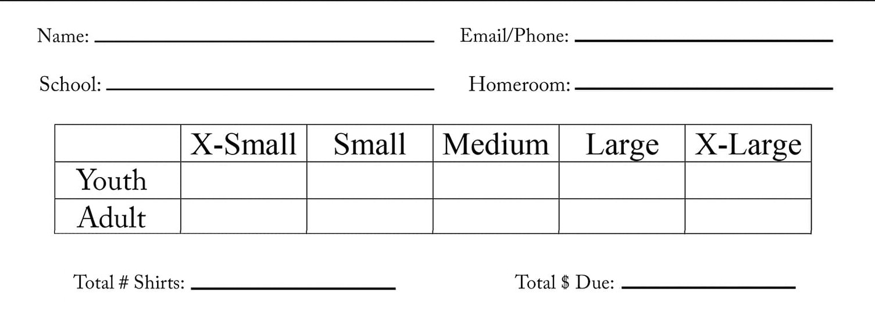
McCullough Families

The PTO will be purchasing this “Warriors All the Time” T-shirt for all students and staff of McCullough Elementary. If any parent, sibling, or any other person wants to purchase a shirt, please forward $10/shirt along with the order form to Mrs. Schadler(schadlers@penntrafford.org) at McCullough Elementary by Friday, February 1, 2021

Please make checks out to the McCullough PTO. All proceeds support the McCullough Elementary Library.

Thank you Mrs. Schadler for designing this awesome shirt!

$10/shirt

