Principal’s Message
The year is passing very fast at Catherine A. Miller Elementary. Students have been busy this Fall in the classrooms, working towards mastery of Common Core skills. Teachers have moved towards a more rigorous small group instruction model through support from the Empower Inc. Consultants. Intensive small group instruction allows teachers to reach students where they are at and help them progress in their learning faster. Students get a greater depth of knowledge and also develop stronger social skills working in groups.
Our Positive Behavior Support is fully implemented throughout the school. Students participate in daily classroom support systems and we have weekly assemblies to celebrate positive behavior. Starting in January we will open “Outlaws”-- our school store. Students will earn Doggie Dollars each day for exhibiting positive behavior aligned to our school behavior expectations. They then will have an opportunity each week to go to the store to cash in for school supplies and treats.
On behalf of all the staff and faculty of CME, thank you for your partnership in our learning community and we pray rich blessing over your winter break! Principal Joel A. Copley
Miss. Catherine A. Miller Princess
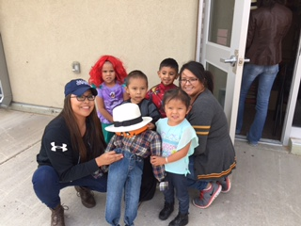
Please congratulate our recently crowned Miss Catherine A. Miller Princess, Abigail Nelson! Last Thursday both Abigail and Lauren Charley competed in traditional singing, baking, and quizzing. We are proud of both girls; both of these young ladies were courageous and composed while they performed in front of a large audience of family, friends, and school staff. Special thanks to Mrs. Tom for organizing the event.

Pre School & PreK (Martinez, Boucher, Nelson, Diaz, Christian)
We continue to be very busy in the 3 year old preschool classroom. We have learned about our 5 senses, the 4 seasons, and all about animals. During center time we take turns, practice new words we have learned, and act out what we talk about in circle time and what we have read in books. We love singing, especially about the new letters we have learned in class.
Our families have helped us with fun monthly projects. We made a pumpkin patch and decorated a turkey & Christmas tree with family members. Our families also came and joined us for “Trick or Trunk” and Thanksgiving dinner. Soon they will be helping us decorate Christmas cookies with frosting and sprinkles!

Kindergarten: (Ceronie, Chicharello, Garcia, Nakai, Platero, Williams)
This month in reading, Kindergarten is working on sounding out words like mug, tap, and stop and reading books with sight words. We are also working on answering “who,” “what,” “when,” “where,” “why” and “how” questions.
In writing, we are learning how to write stories about small moments in our lives. Many of the students are choosing to write about the snow this week!
In math, we are working on writing our numbers up to 50, solving addition problems, and exploring the different ways to make 10.

1st Grade: (Gorman, Hale, Schmaltz, Swan)
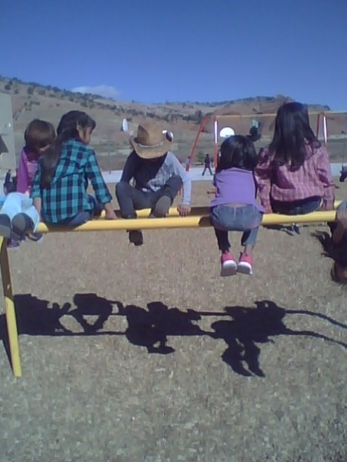
1st grade is working on ways to tell time. Shadows can help us understand time. We are learning about folktales and reading several over the next few weeks. Share your favorite family stories with your kids. Family stories eventually are written down and become folktales.

2nd Grade (Acosta, Dawes, Forbes, Khory, Weida)

Second Grade is working on growing our brains. In ELA, we are working on different ways of expressing ourselves. In writing, we are comparing and contrasting The Polar Express. In math, we are working on measurement, solving word problems and data analysis. We hope you have a wonderful Holiday Season! Thank you for your support —From the 2nd Grade Team

3rd Grade (Bitah, Blake, Buikema, Hubbard)

Third grade has been busy little bees, learning as much as we can before Christmas break. We have been learning to divide. We have also been learning about measurement. Our favorite work, though, is in Writing. We wrote our letters to Santa! These aren’t just any normal letters. We are learning to persuade. We know this is different than begging. We have given Santa our reasons we should get our presents. Watch for our letters when we bring them home next week. We are preparing to learn about Christmas all over the world next week. We will read stories and write about what they do that is different than the United States. We will make games, and crafts, that go with each country. We can’t wait to tell our families what we learned!
4th Grade (Cole, Seibert, & Tahe)
The 4th graders have been working hard in Math on problem-solving word problems, predicting patterns, multiplying two-digit by two digit numbers, as well as multiplying up to four-digit numbers by one-digit. We've also been working on division problems. Please help your child memorize their multiplication and division facts, as some are struggling in this area.

(4th Grade continued…)
In Reading, 4th graders continue to apply their skills in reading for details and examples to support their answers. Also, we've been working on inference skills and comparing two types of texts (a story to a poem). In Language, 4th graders are increasing their knowledge of prepositional phrases, identifying whether a sentence is complete, a fragment, or a run-on, as well as using subject-verb agreement correctly. PLEASE have your child read at least 20 minutes EVERY day!

In Writing, we've seen an improvement in the 4th graders' writing skills. They are writing 3 paragraphs at this point, and we're confident by the end of the year they will be easily writing 5 paragraphs so that they will be ready for 5th grade.

Please help with our recycling project by saving any kind of plastic lids and sending them into the school. We are trying to collect at least 400 pounds of plastic lids to have them recycled into a bench or a picnic table for our school grounds.

5th Grade: (Prough, Ramos, & Tahe)
In Math, students have been working on division of whole numbers, decimals, and powers of 10. They took the second TLI test for Math this week which covered a number of different skills including graphing, multiplication of decimals, and numerical expressions. We also introduced graphing and measurement.

In Writing, students just finished with a three-week explanatory writing project. The prompt was “If someone came to visit your school, what three places would you show them and why?”

In Reading, students are working on writing effective summaries of different types of stories and figuring out unknown words using context clues (words around the word they do not know).

Trunk or Treat
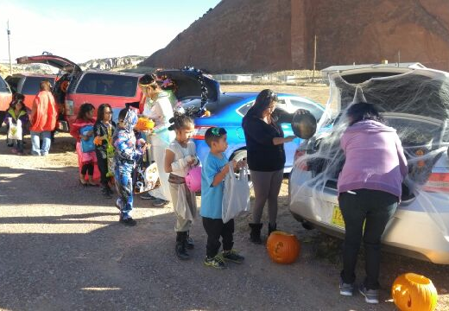
On the morning of Halloween our students had a great surprise from volunteer parents. We had 16 cars decorated in spooky themes. Students were dressed up and enjoyed trick or treating at school. Thank you to all the parents who made this a special day!

Catherine A. Miller’s Recycling Project
Last Spring during Earth Week, students in Ms. Seibert’s 4th grade researched a company called GreenTree Plastics, Inc. that takes plastic caps and lids and recycles them into benches and picnic tables for school groups or other organizations. The ABC (A Bench for Caps) PROGRAM is a cap and lid program specifically designed by school children for school children. It is to be a tool in the hands of teachers to teach children about caring for the earth and green living. We are continuing the project this year at Catherine A. Miller in the hopes of getting the entire community involved in recycling so that we can have a brand-new bench or picnic table made completely out of recycled materials for us to use at our school. WE NEED YOUR HELP!
So far, we have collected approximately 40 pounds of plastic lids since last Spring. In order to get a plain bench (without a back), we need 10 TIMES that amount! We need 400 pounds of plastic caps and lids for a bench! (That’s approximately TEN 55-gallon contractor-size plastic bags full!!) If we want a 6 ft. picnic table, we’ll need 1000 pounds! The students in the school have been bringing in plastic caps and lids, but we wanted to get the word out to more people so that every home in the community could get involved, even the Chapter Houses!
These are the ACCEPTABLE caps: plastic drink bottle caps, lids from food containers like coffee cans, peanut butter jars, butter tubs, tops from spray cans, caps from liquid laundry detergent. NOT ACCEPTABLE caps/lids: ANY metal, pumps, fast food cup lids. Please make sure caps are clean and free of any dirt or debris before sending them in. Let’s try to reach our goal of getting at least 400 pounds by the end of this school year so that Catherine A. Miller can have a nice bench for outside our school. Thanks for your help and support! Ms. Seibert
- Christmas Food
Next Friday many classrooms are asking for parent support with Christmas parties. This is great fun for kids. Please remember to bring a healthy snack when supporting parties and, unlike birthday parties, your child only needs to bring enough to share.
- Drop off Times
With the mornings getting colder, we would like to remind families students may be dropped off after 7:15. At this time they will be allowed into the gym. The entryway is open at 7:00, however, it is not heated.
- Early Check Outs
In the last few weeks we have had an increase in early student checkouts. We do understand that families may sometimes need to check their students out for appointments. However, excessive early checkouts hurt students’ academic progress in school and add an extra burden on the front office. Therefore, please limit your appointments to 1-2 per semester and adhere to the 2:15 checkout policy.
Important Upcoming Dates
12/13/16 – Basketball Game 12/17/16-1/2/16 – Christmas Break
12/14/16 – Christmas Concert 1pm 1/25/17 – Winter Story Telling 5pm

