News In Your School
Atlantic City Schools
May 2018 | Sodexo Food Service
In This Issue  - Teaching Kids to Cook  - Age Appropriate Kitchen Activities  - Chicken & Vegetable Stir Fry  RD Corner  Hello! My name is Amy Krehely and I am your school Registered Dietitian. My main goals are to teach students lifelong healthy eating habits and to keep you in the loop on food and nutrition news. If you have any questions or comments, feel free to contact me at:  Amy.Krehely@sodexo.com. | Teaching Kids to Cook  The best way to teach kids about eating well is to get them into the kitchen to prepare healthy meals together. Cooking is a valuable life skill that teaches children about nutrition and food safety while building math, science, literacy and fine motor skills.  Encourage your children’s interest and excitement in healthy foods by teaching them how to cook safely with this guide of age-appropriate kitchen activities.  Food Safety Basics  Before you enter the kitchen, cover the ground rules with children first. Teach them these four simple steps:  - Wash hands, surfaces and kitchen utensils.  - Keep raw meat, poultry and seafood separate from ready-to-eat foods.  - Cook to proper temperatures.  - Refrigerate promptly to 40 degrees F or below.  monkeybusinessimages/iStock/Thinkstock
Age-Appropriate Kitchen Activities

Ages 3-5:
Young children love to help, but need very close adult supervision since their motor skills are still developing. Teach these youngsters the importance of washing produce and using clean appliances and utensils.

Appropriate Tasks:
- Wash hands with warm, soapy water for at least 20 seconds. Make it a game by singing the "Happy Birthday" song together twice as you wash your hands.
- Wash fruits and vegetables in the sink with cool tap water.
- Clear and wipe up tabletops.
- Cut cookies with fun shaped cookie cutters (but don't eat the raw dough!).

Ages 6-7:

Most kids ages 6-7 have developed fine motor skills, so they can handle more detailed work, but they will still need food safety reminders.

Appropriate Tasks:
- Snap green beans.
- Shuck corn and rinse before cooking.
- Mix ingredients with electric mixer or spoon.
- Use salad spinner to dry lettuce.

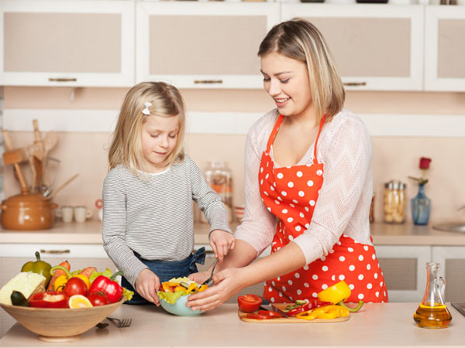
Ages 8-9:
There is a wide range of skills in this age group, so tailor your tasks to each individual's maturity level. Teach the importance of wiping down all surfaces and refrigerating perishables, such as meat and milk, within two hours.

Appropriate Tasks:
- Put leftovers in shallow containers and refrigerate within two hours.
- Load the dishwasher.
- Beat eggs.
- Check the temperature of meat with a food thermometer – it's like a science experiment!
Ages 10-12:
For the most part, kids ages 10 -12 can work independently in the kitchen, but should still have adult supervision. Before letting these kids do grown-up tasks on their own, assess whether they can follow basic kitchen rules such as tucking pan handles, unplugging electrical appliances, using knives and safely using the oven or microwave.

Appropriate Tasks (with adult supervision):
- Boil pasta.
- Sauté vegetables.
- Microwave foods.
- Follow a recipe, including reading each step in order and measuring ingredients accurately.

Adapted from Eatright.org
Teaching Kids to Cook
Published June 23, 2015
dimasidelnikovi/Stock/Thinkstock

Let’s Get Cooking…

Chicken & Vegetable Stir Fry

This is a great recipe to make with your kids. Younger kids can help wash the fresh vegetables while the older kids can help prepare the vegetables and sauté the stir fry. Everyone can help with clean-up!

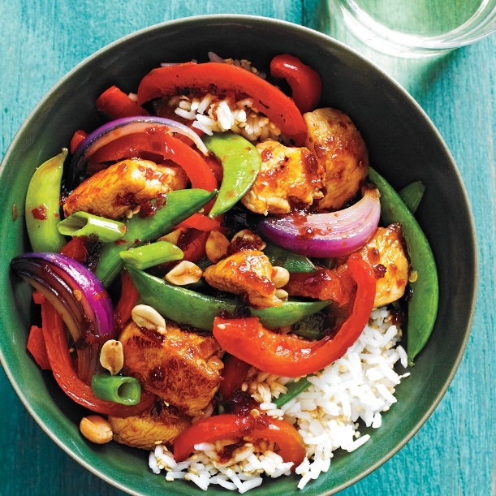
Ingredients:
- 2 Tbsp oil
- 1 lb chicken breast, sliced thin
- 1 tsp garlic, minced
- 1 cup green pepper, sliced
- 1 cup red pepper, sliced
- 1 cup yellow onion, sliced
- 1 cup carrots, julienned
- 2 cups kale, chopped
- ½ cup soy sauce
- 1 Tbsp sesame oil

Instructions:
- In a wok or large skillet, heat oil over medium-high heat until almost smoking.
- Cook and stir meat until cooked through, about 5-6 minutes.
- Move meat to the side of the wok and add the garlic, peppers, onions and carrots to the center of the wok while stirring constantly. Sauté for 2 minutes.
- While continuing to stir, add the kale. Sauté for 1 minute.
- Mix the meat with the vegetable, pour the soy sauce and sesame oil over all and sauté for 1-2 more minutes or until vegetables are crisp-tender.

Serving Suggestions:
- May serve over brown rice or whole grain noodles.
- May substitute chicken with tofu or beans for vegetarian protein.
- May substitute chicken with beef or pork for other non-vegetarian protein.

