VSEPR THEORY CHART

Type of Molecule Example Molecular Geometry Bond Angles
AB₂ CO₂ Linear 180º
AB₃ SO₃ Trigonal Planar 120º
AB₂E SO₂ Bent < 120º
AB₄ CH₄ Tetrahedral 109.5º
AB₃E NH₃ Trigonal Pyramidal < 109.5º
AB₂E₂ H₂O Bent < 109.5º
AB₅ PCl₅ Trigonal Bipyramidal 120 º and 90º
AB₄E SF₄ Seesaw/ Sawhorse 120 º and 90º
AB₃E₂ ClF₃ T-shape 90º
AB₂E₃ XeF₂ Linear 180º
AB₆ SF₆ Octahedral 90º
AB₅E BrF₅ Square Pyramidal 90º
AB₄E₂ XeF₄ Square Planar 90º

Standard Examples
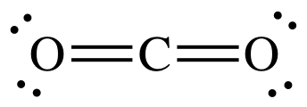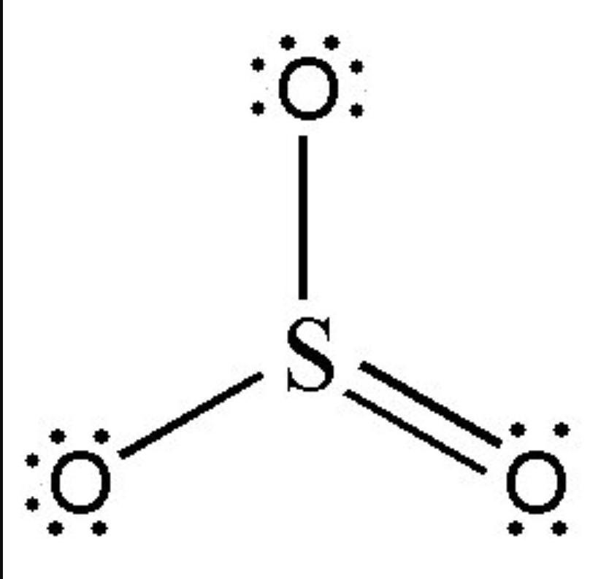

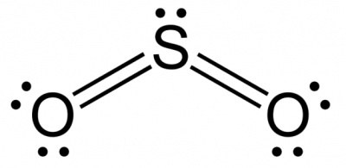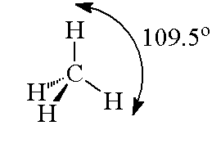

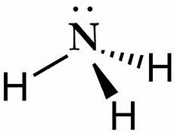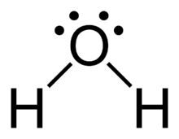

Examples that violate the Octet Rule – (Trigonal bipyramidal electron geometries)

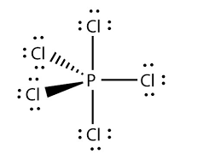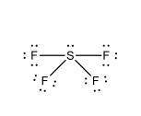

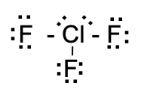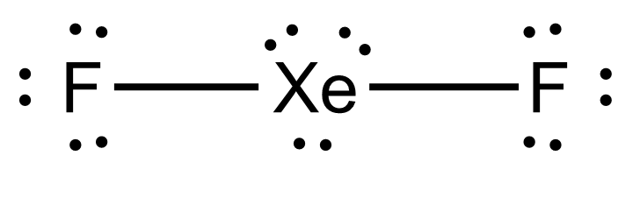

Examples that violate the Octet Rule – (Octahedral electron geometries)
