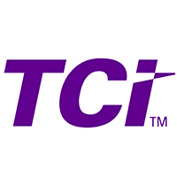

TCI

Online TCI you-tube webinars:
https://www.youtube.com/playlist?list=PLl11Tz7sP2eIuic9ZXpZaBwN-53Fc-1l7

TCI Distance Learning Hub:
https://www.teachtci.com/bring-distance-learning-alive-with-tci-2/

Getting Started with TCI webinar 8-13-20:
https://zoom.us/webinar/register/WN_Zo7h6cz-QOaI9HUvFYfKjA

Back to School Webinar 8-5-20:
https://zoom.us/webinar/register/WN_CHLlwh-XTruRQofK7wPV-A

