Magnet Notes
Magnets | What is it?  A magnet is an object that produces a magnetic force.  What affects it?  - The strength of a magnet’s magnetic force depends on the size of the magnet and the material the magnet is made of.  What is it made of?  - Most magnets are made of iron, nickel, or cobalt.  The strongest magnets are made of rare Earth metals. The most commonly used rare Earth metal magnet is called the Neodymium.  How it works?  - A magnet has ends called poles.  - One pole is called the north pole. The other is called the south pole.  - The north pole of one magnet is attracted to the south pole of an another magnet.  - The north pole of one magnet is repelled by the north pole of another magnet.  Types of Magnets:  Permanent Magnet: a magnet that retains its magnetic properties in the absence of an inducing field or current  Temporary Magnet: Temporary magnets are those that simply act like permanent magnets when they are within a strong magnetic field. Unlike permanent magnets however, they loose their magnetism when the field disappears. Paperclips, iron nails and other similar items are examples of temporary magnets.
Magnetic Field  Magnetic Field: the area of magnetic force around a magnet | What is it?  - The area of a magnetic force around a magnet.  What affects it?  - The strength of the magnetic field weakens as you move away from the magnet. (distance increases)  - The strength of the magnetic field strengthens as you move closer to the magnet. (distance decreases)  - Stronger magnets have larger and more powerful magnetic fields.  Field Lines  - Magnetic field lines are lines we draw to help use a magnetic field.  - The magnetic field begins at the magnet’s north pole and travels outward and around a magnet to the south pole.  - We draw magnetic field lines with arrows to show the direction of the magnetic field.  - Magnetic field lines never cross.  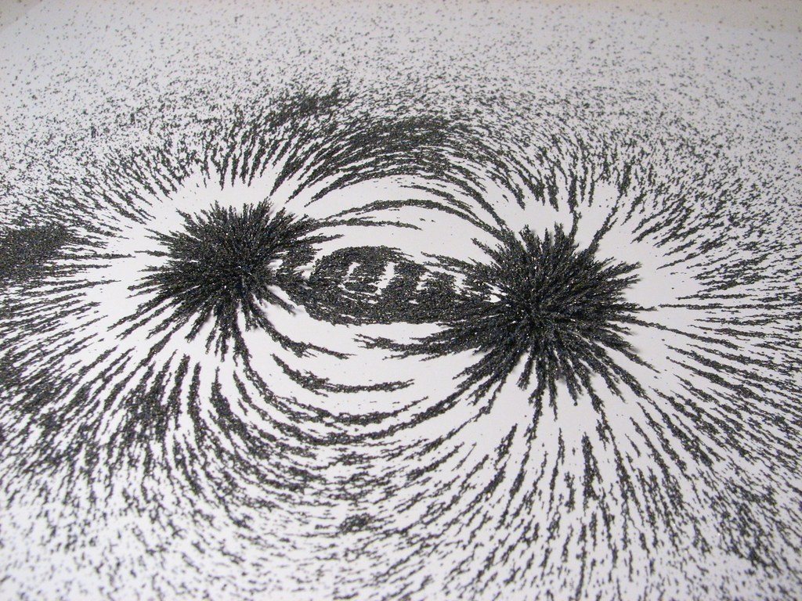  This Photo by Unknown Author is licensed under CC BY  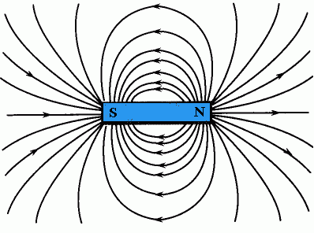  This Photo by Unknown Author is licensed under CC BY-SA
Earth’s Magnetic Field | - The center of Earth is called the core. The core is made of iron.  - Earth’s iron core acts like a bar magnet. It creates a magnetic field around Earth.  - Earth’s magnetic field extends outward  around Earth and down towards the core of Earth at the poles.
Compass | - A compass is a device that detects Earth’s magnetic field. It points towards the magnetic poles.  - A compass contains a small magnetic needle that spins freely inside.  - The North pole of a compass needle points toward the North geographic pole.  (Remember that the North pole of one magnet is attracted to the South pole of an another magnet. (Opposites attract)  - If the North pole of the compass needle points North, Earth’s magnetic South pole is located at the geographic North end of Earth.
Electromagnet  Electromagnetism: the relationship between electricity and magnetism  Electromagnet: a solenoid with a ferromagnetic core  Solenoid: a coil of wire with a current | What is it?  - An electromagnet is a magnet created by an electric current.  - When the wire is connected to a battery and it is wrapped around a magnetic object, then object becomes a magnet.  When it is disconnected from the battery, the object loses its magnetism.  - Copper coil when it is connected to a current is called a ferro magnet.  - The current inside the coil changed directions which reserves the direction of the magnetic field.  What affects it?  - The bigger the battery the stronger the magnet.  - The more you wrap the wire the stronger the magnet.  - The smaller the diameter coil the stronger.  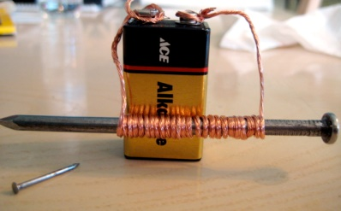  This Photo by Unknown Author is licensed under CC BY
Producing Electricity with Magnets  Generator: is a device that transforms mechanical energy into electrical energy | How?  - An electric current can be created by a magnet.  - If you place a loop of wire inside a magnet’s magnetic field and then move the magnet, you can create an electric current in the wire.  - A current is created because a moving magnet has a moving magnetic field, which pushes electrons in the wire.  - An electric generator is a device that uses magnets to create an electric current and produces electricity.  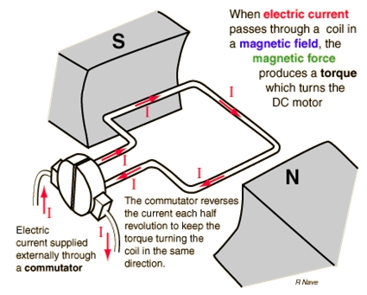  This Photo by Unknown Author is licensed under CC BY
Identifying Variables  Example:  Does distance affect the force of the magnetic field?  I: Distance  D: Force  C: Magnets | Independent: The variable we are testing or changing each time we do it  Dependent: The variable we are collecting data with. (Measure)  Control: The variables that stay the same.

