Concussion Definition

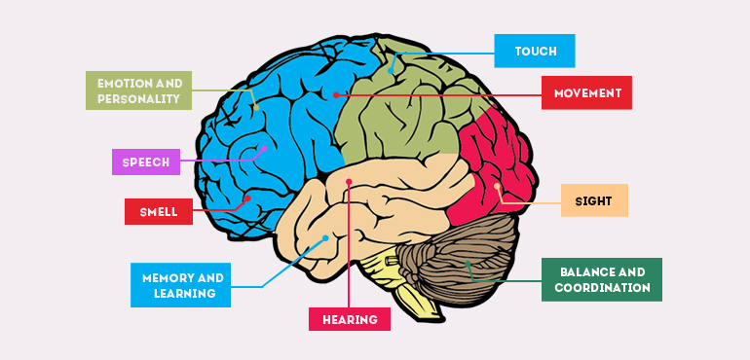

A concussion is a type of traumatic brain injury caused by a bump or blow to the head that causes the brain to move rapidly inside the skull. A concussion is a serious injury that changes how the cells in the brain normally work. The brain has to work overtime and has a decreased blood flow which causes the signs and symptoms that people feel when they have a concussion. These concussion symptoms can last briefly or last for a long period of time, while the brain tries to recover.
As long as the person is still reporting having signs or symptoms it would be dangerous for a student to return to full scholastics or an athlete to return to play before all their concussion symptoms have resolved. In addition, signs and symptoms have to return to normal while both at rest and with exertion because an increase in blood pressure can bring back the symptoms.
Concussions are a serious injury no matter how slight it is thought to be. An adolescent needs to be treated more conservatively than an adult. It may take longer for the adolescent to recover from concussion due to the belief that the brain is still developing. But no matter how long the recovery process is, never return to full scholastics or sports participation while still suffering from the effects of a concussion.

