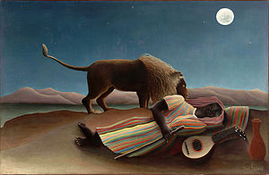
Ms. Dunn’s 8th Grade ELA
Daily Work
1/27/17
Know: How does this painting build my knowledge of how artists tell stories?
(Part 2)
- Warm Up: In a poem, you cite words as evidence. What kinds of evidence might your cite from a painting?
________________________________________________________________________________________________________________________________________________________________________________________________________________________
- Learn—Distill Meaning: What is the essential meaning of this painting?
- What makes this scene dreamlike?
Complete the evidence chart to support the claim that the scene is like a dream.

Claim:

- What do you think Henri Rousseau wants viewers to understand from this painting?
Evidence from painting: | Reasoning:

- Sometimes authors and visual artists treat related ideas in different ways. How do you think Henri Rousseau and Nikki Giovanni express ideas about imagination in our lives? Respond in paragraph form, with a claim, evidence, and reasoning.
________________________________________________________________________________________________________________________________________________________________________________________________________________________________________________________________________________________________________________________________________________________________________________________________________________________________________________________________________________________________________________________________________________________________________________________________________________________________________________________________________________________________________________________________________________________________________________________________________________________________________________________________________
- Closing Task
Describe the ways in which studying The Sleeping Gypsy builds your knowledge of how an artist tells stories by filling in the sentence frames.
- Rousseau chose colors that________________________________________________________________________________
- Rousseau used lines that _________________________________________________________________________________
- Rousseau used shapes that________________________________________________________________________________
- These colors, lines, and shapes in the painting give the feeling of __________________________________________________
- An idea I get from this painting is ___________________________________________________________________________

