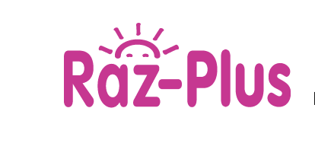

Reading A-Z and Raz Kids

Teacher Tools and Video Resources
https://www.raz-plus.com/helpful-tools/video-library/

