How to Upload a Lesson Plan to Frontline Oasys
Step 1: Click on “Teachers” and “Frontline Oasys”
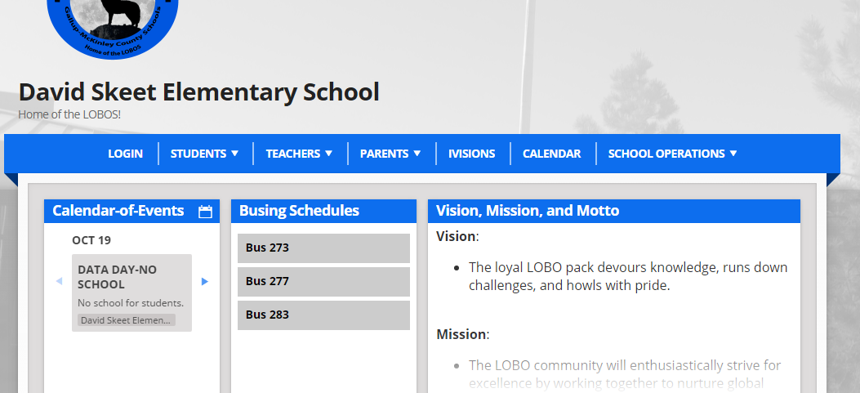
Step 2: Log in using your e-mail address. Your password was sent to your e-mail.
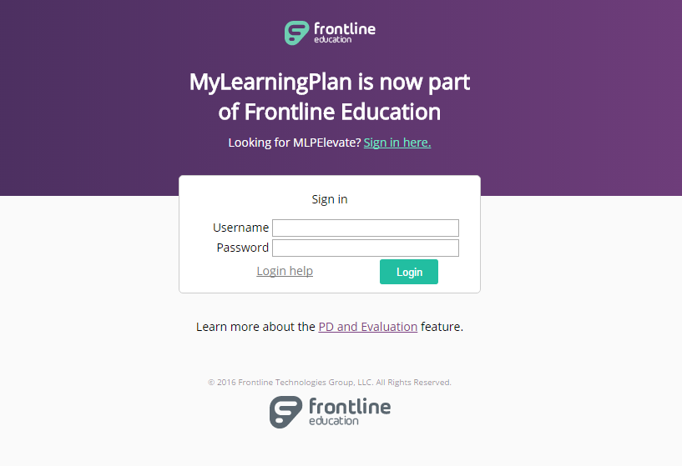

Step 3: Click on “NMTEACH: Domain 1 Artifacts – Professional Responsibilities Domain 1”
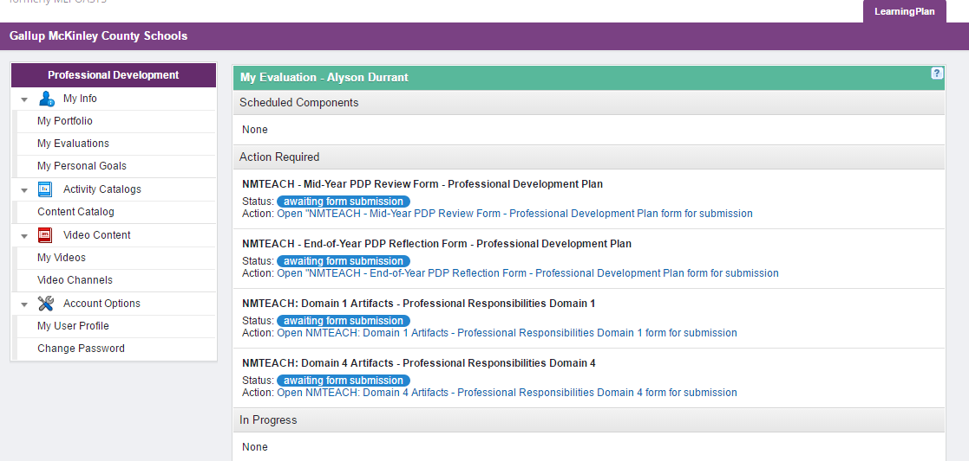
Step 4: Click on “Add an Artifact”
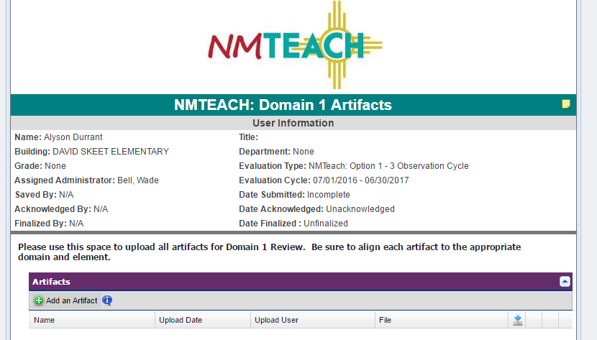

Step 5: Enter the name of your lesson plan with the standard and upload your lesson plan
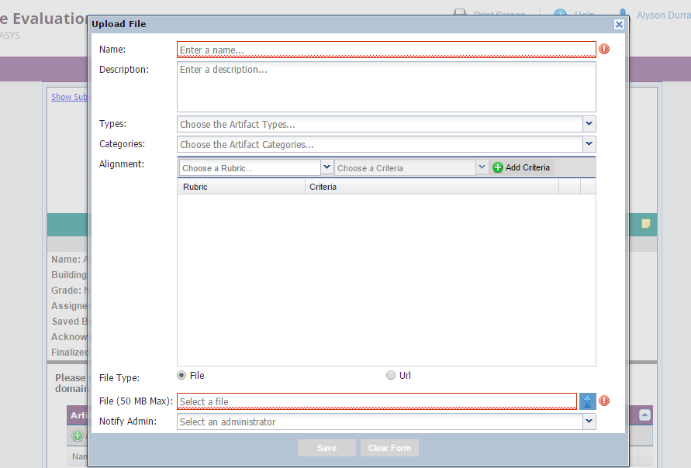
When you are done, click “Save.”
Click on the blue arrow to upload your lesson plan.
Step 6: Click “Submit” to finalize
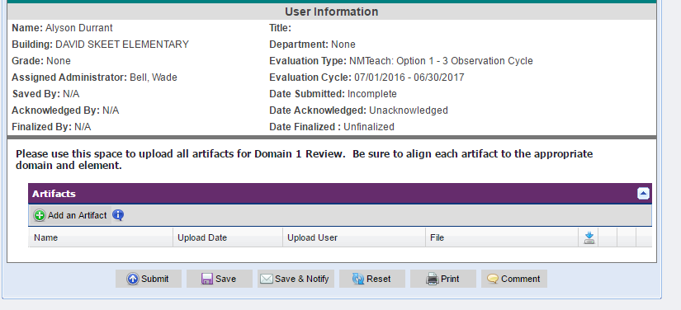
Step 7: Celebrate! You are done

