Contact Forces Notes
Balanced Force | Balance forces are two forces acting in opposite directions on an object, and equal in size. Anytime there is a balanced force on an abject, the object stays still or continues moving continues to move at the same speed and in the same direction.  This Photo by Unknown Author is licensed under CC BY-SA-NC
Unbalanced Force | Forces that cause a change in the motion of an object are unbalanced forces.  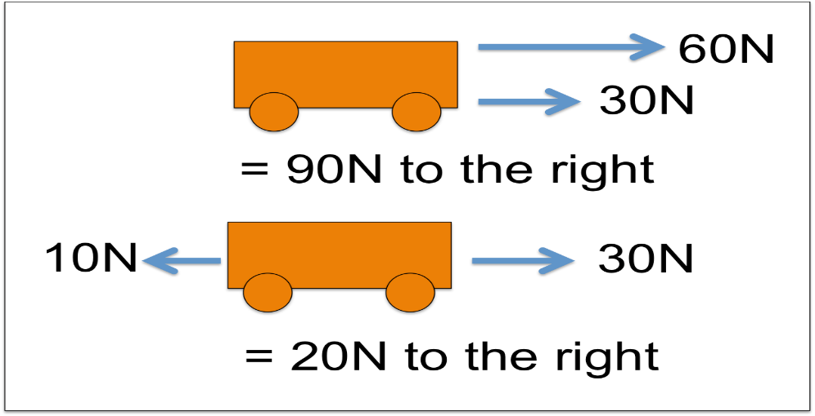  This Photo by Unknown Author is licensed under CC BY-SA
Net Force | The sum of all forces acting on an object,  How to find:  Same direction (helping each other) you will add to get the net force.  Opposing direction (against each other) you will subtract to get the net force  When net force is 0N= object is balanced  When net force is greater than 0N= object is unbalanced and moving  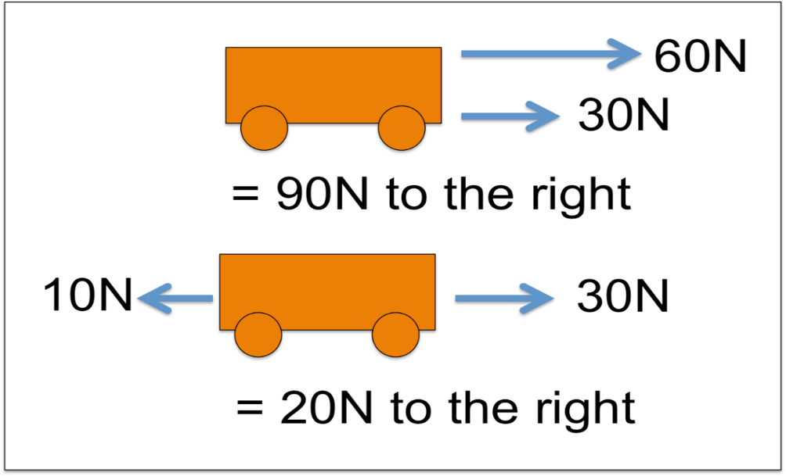  This Photo by Unknown Author is licensed under CC BY-SA
Newton’s 1st Law of Motion | Newton's first law of motion- sometimes referred to as the law of inertia. Newton's first law of motion is often stated as. An object at rest stays at rest and an object in motion stays in motion with the same speed and in the same direction unless acted upon by an unbalanced force.  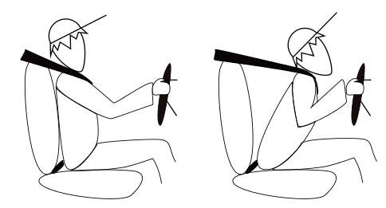  This Photo by Unknown Author is licensed under CC BY-SA  Resistance to change in motion is called inertia.  Ex. An object is moving at 4mph. The object will continue moving at 4mph if no force is applied to it.  Ex: When riding in the car, the person driving brakes. It stops the car not you. You keep moving forward because of inertia. The force of the seat belt is what pulled you back.  Inertia Depends on Mass  The greater the mass the greater the inertia.  Example: 4000g cane truck as more inertia than a 1000g car because the cane truck as more mass.
Potential Energy | potential energy is the energy that is stored in an object due to its position relative to some zero position. An object possesses gravitational potential energy if it is positioned at a height above (or below) the zero height  The greater the height the more potential energy.  The greater the mass the more potential energy.
Kinetic Energy | The equation for kinetic energy is so the two factors that influence kinetic energy are the object's mass and its speed (squared). ...  The more mass the more kinetic energy.  The lighter the mass the less kinetic energy.
2nd Law of Motion | Newton’s 2nd Law of Motion  An object’s acceleration depends on its mass and on the net force acting on it. F=MA  How to increase acceleration (motion):  Decrease mass on object  Increase the net force  How to decrease acceleration (motion):  Increase the mass on an object  Decrease the net force
3rd Law of Motion | Newton’s Third Law of Motion: For every action there is equal and opposite reaction.  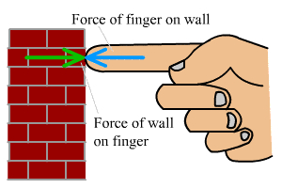  This Photo by Unknown Author is licensed under CC BY-SA  Example: When you sit in chair, you are exerting a force on the chair and the chair is exerting a force on you.
Friction | Friction: The force that two surfaces exert on each other when they rub against each other  Causes things to slow down
Other: | * All solid objects deform elastically when smaller amounts of force are applied to them; they will spring back to their original shape when this force is removed.  *How much a solid object deforms for a given amount of force applied to it is dependent on the type of material it is made of, its shape, and its thickness.  *Different objects have a different elastic limit, which is the maximum amount of deformation they can withstand, beyond which they deform permanently.  *Different objects have a different breaking point, which is the maximum amount of deformation they can withstand, beyond which they will crack (fracture).  *We figure out that regardless of the speed or mass of two objects in a collision, the forces are equal and in opposite directions.  *The more mass an object has, the more damage it can cause in a collision.  * The faster something is moving before a collision, the more damage it can cause during the collision.  * The greater the amount of force (net force) applied to an object, the more its motion will change.  *We have to push harder to get something with more mass to change its motion from zero to a high speed.  *The effect of a force changes depending on the mass of an object.  *The same net force makes a more massive stationary object speed up less and a less massive stationary object speed up more
Variables | Independent: The variable we are testing or changing each time we do it  Dependent: The variable we are collecting data with. (Measure)  Control: The variables that stay the same.

