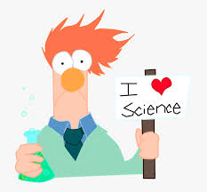

Art and Science Expo Re-imagined
Hello all, hope you are having a great school year. Since things are so different this year, the Art and Science Expo will be too. We can’t have gatherings, and volunteers are not permitted in the school, so we will be having monthly virtual sessions this year and a mini project.

On the second week of every month from October – March, there will be videos posted on the McCullough website with a guest expert in either Art or Science. The videos will contain Science experiments or Art activities from a different expert every month. They will be posted under Art and Science Expo.

If there are any materials needed, they will be posted along with the videos.

Instead of the Expo projects this year, we will be doing Art and/or Science related Trioramas. A Triorama is a 3D Diorama made out of card stock. All the students participating in the Triorama activity will be entered in a raffle for a prize. Instructions and registration for the Triorama will be posted in January. The Trioramas are due in March.

November Videos

“A Look Inside: Anatomy and Physiology with Dr. Donna”

1) A tour around Dr. Donna’s lab
2) Dr. Donna shows us a sheep brain(If you are a little squeamish, might want to skip this one)

December Videos

“Holiday Art Projects from Amanda of FLOW Art Studio”

Keep checking THT, the PTO Facebook page, and the McCullough website for upcoming videos and more information on the Triorama project for March. Have fun!

