Zoom Poll Setup Instructions

Step 1: After you schedule your meeting on the Zoom platform, on the ‘My Meeting’ page click on the polling feature on the bottom right of the screen.
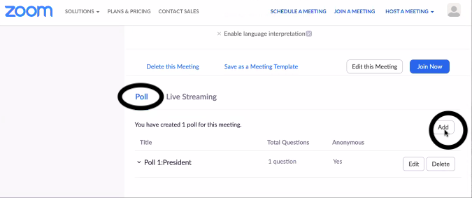
Step 2: The ‘add a poll’ page will pop up. Fill in the title of the position you are creating the ballot for.
Step3: Click the ‘anonymous’ box under the title. Where it says, ‘type your question’, rewrite the title of the position.
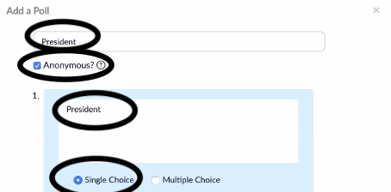
Step 4: Where it indicates to fill in the answer, type in the name of the candidate, one row for each nominee.
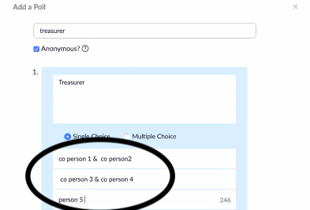
Step 5: Click the ‘Save’ button on the bottom right. Repeat the process for each position you create a ballot for.
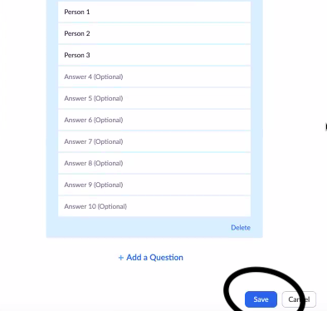
Note: You MUST create a poll for each contested officer position. The host cannot vote. After the poll is created, hosting must be transferred to someone who is not a member of the PA/PTA. This may be a member of the Presidents’ Council, the FLC, or a FACE representative.

