Unit: Sound Notes
Lesson 1 | Phenomena  Sound: is a pressure wave in air or any other material medium.
Lesson 2 | - Just like speakers, musical instruments vibrate back and forth when they are making sound.  - To make vibrations we need to apply some type of force to the instrument to deform it.  Vibration: is a back and forth movement
Lesson 3 | - All objects move back and forth (vibrate) when making sound. Objects vibrate further back and forth when a greater force is applied which will create a sound that is louder.
Lesson 4 | - The more deformed the instrument the higher the peaks and valley of a motion graph. We call the distance from peak (crest) to valley (trough) the amplitude.  Amplitude: Height of wave  Tells us how loud or soft sound is  ****To make a louder sound source needs a greater force. The sound source will go farther back and forth.  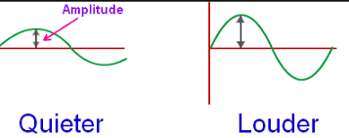
Lesson 5 | - Objects of shorter length play at a higher pitch.  - They will vibrate more frequently than longer length.  Pitch: is determine by wavelength  Short wavelength= high pitch, high frequency  Long wavelength= low pitch, low frequency  Frequency: Number of waves in a certain amount of time  *** To make a higher frequency the sound source needs to move faster***  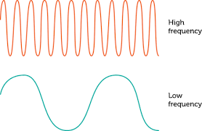
Lesson 6 | - The vibration of objects is the source of the sound.  - The amplitude of the vibration of objects affects the volume of the sound.  - The frequency of the vibration of objects affects the pitch of sound.
Lesson 7-10 | - Sound needs a medium (solid, liquid, or gas) to travel through.  - The speaker pushes a bunch of particles of air close together, then those particles expand together, hitting another group of air particles next to them.  Compression: Packed Particles  Rarefaction: Spread out particles  ** Sound travels the fastest through solid, then liquid. Sound travels the slowest through gases (air).**  Energy travels across the medium when vibrating matter causes particles to push closer together and then spread apart in compression and expansion patterns.  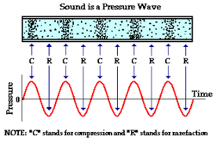  - Sound can’t travel through empty space the has no matter.  - A vacuum is an area with no particles. Space is a vacuum. Sound CANNOT travel in vacuum. Sound NEEDS particles to travel through.
Lesson 13 | - Waves with bigger amplitude and higher frequency transfer more energy, and increases in amplitude have bigger effect on the energy transferred than does increases in frequency.
Other Vocabulary:
Crest: Top of wave
Trough: Bottom of wave
Transverse Wave: A wave that vibrates the medium at right angles, or perpendicular to the directions in which the wave travels.
Longitudinal Wave: vibrates the medium in the same directions in which the wave travels
Compression: Areas where the coils are close together
Rarefaction: area where the coils are spread apart.
Longitudinal Wave: Write an R in the rarefaction areas and a C in the compression areas.
Surface Wave: Combination of two transverse and longitudinal wave. Travels in two medium. Like oceans that travel to water and air.

