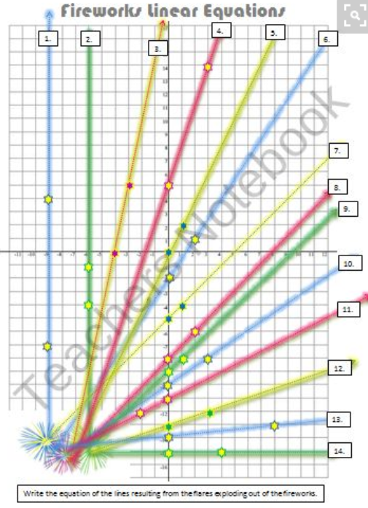

Fireworks Linear Equations
Write the equations from the graphs in y=mx + b form.
1. | 2.
3. | 4.
5. | 6.
7. | 8.
9. | 10.
11. | 12.
13. | 14.

