Dealing
with the
Basic Facts
3-5

Games for using a deck of playing cards to practice basic math facts.
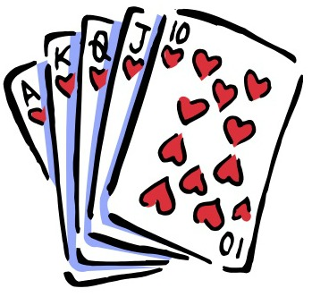
Exploratorium, March 24, 2015
Presented by Beth Finkelstein and Kerri Gristina

Pile Up 100
Objective: Addition. Be the first to reach 100, in piles of 10 or 20 at a time.

Grades: 3-5
2-4 players
Materials: Deck of cards with face cards and jokers removed.
Set up. Each player sets out 5 cards face up. Set the remaining cards in a pile to draw from.
How to play
- Take Turns. On your turn: Draw a card and add it to your layout.
- Look for cards in your layout that total 10 or 20 (such as 8, 7, and 5). Remove those cards from your layout and set them next to you, then the next person goes.
- If you can't make 10 or 20 on your turn, the next person goes.
- The first player to reach 100 wins.
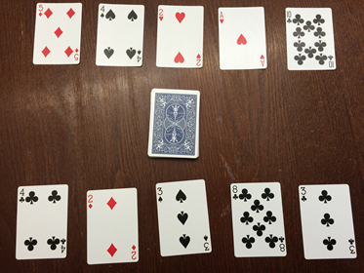
Objective: Find the difference between two 2-digit numbers. The player with the greater difference wins all the cards in the hand.
Multi-Digit Subtraction Number Battle, “War”
Grades: 3-5
2-4 players
Materials: Deck of cards with 10’s, face cards and jokers removed.
Set Up: Shuffle cards. Deal an equal number of cards to each player until the deck runs out. Each player keeps his/her cards in a stack.
How to Play:
- Each player turns four cards face up and creates two 2-digit numbers and finds the difference between the two numbers. Players may move the 4 cards around to create any 2-digit minus 2-digit expression.
- Players finds the difference for their expression. For example, if a player draws an 8, 5, 3 and a 4, s/he says “85 minus 34 is 51”. If the opponent draws a 6, 7,9 and a 2, then his/her number sentence is “97minus 26 is 71”.
- The player with the greater difference wins the hand and keeps all eight cards.
- If each player has a number sentence with the same difference, then it's “war!”
- Each player puts three cards face down and places an additional four cards, face up, to find the difference. The player with the greater difference wins.
- Set up the timer and play the game for 10 to 15 minutes. When the bell goes off, each player counts his/her cards. The player with the most cards wins. If one player runs out of cards before time is up, then the other player wins.
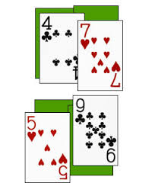
If dealt a 4, 7, 5 and 9 a player may create the expression 97-45 to get the greatest difference, 52.
Objective: Find the sum of two 2-digit numbers. The player with the greater sum wins.
Advanced Addition High Card, “War”
Grades: 3-5
2-4 players
Materials: Deck of cards with face cards and jokers removed…or assign a value to face cards (11, 12, 13).
Set Up: Shuffle cards. Deal an equal number of cards to each player until the deck runs out. Each player keeps his/her cards in a stack.
How to Play:
- Each player turns four cards face up and creates two 2-digit numbers. S/he finds the sum of the numbers.
- The player with the greater sum wins the hand and keeps all eight cards.
- If each player has a number sentence with the same sum, then it's “war!”
- Each player puts three cards face down and places an additional four cards, face up, to find the sum of the new 2-digit numbers. The player with the greater sum wins.
- Set up the timer and play the game for 10 to 15 minutes. When the bell goes off, each player counts his/her cards. The player with the most cards wins. If one player runs out of cards before time is up, then the other player wins.

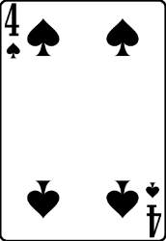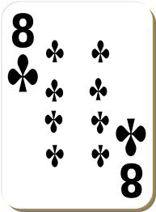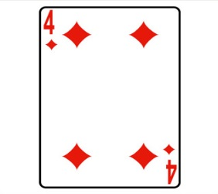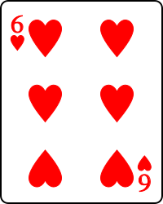
“84 plus 64 is 148” (player created the two highest numbers, 84 and 64)
Objective: Find the product of two numbers. The player with the greater product wins all the cards in the hand.
Grades: 3-5
Multiplication Battle, “War”
2-4 players
Materials: Deck of cards with face cards and jokers removed.
Set Up: Shuffle cards. Deal an equal number of cards to each player until the deck runs out. Each player keeps his/her cards in a stack.
How to Play:
- Each player turns two cards face up and finds the product of the two numbers. For example, if a player draws an 8 and a 4, s/he says “8 times 4 is 32”. If the opponent draws a 6 and a 2, then his/her number sentence is “6 times 2 is 12”.
- The player with the greater product wins the hand and keeps all four cards.
- If each player has a number sentence with the same product, then it's “war!”
- Each player puts three cards face down and places an additional two cards, face up, to find the product. The player with the greater product wins.
- Set up the timer and play the game for 10 to 15 minutes. When the bell goes off, each player counts his/her cards. The player with the most cards wins. If one player runs out of cards before time is up, then the other player wins.
Player 1: “4 times 7 is 28”
Player 2: “5 time 9 is 45, I win!”

Objective: Find the product of two numbers. The player with the greater product wins all the cards in the hand.
Grades: 3-5
Multi-Digit Multiplication Battle, “War”
2-4 players
Materials: Deck of cards with 10’s, face cards and jokers removed, scrap paper and pencil
Set Up: Shuffle cards. Deal an equal number of cards to each player until the deck runs out. Each player keeps his/her cards in a stack.
How to Play:
- Each player turns three cards face up and creates a 2-digit x 1-digit expression that will yield the greatest product. For example, if a player draws an 3, 4, and 5 , s/he has to think what to play: 34x5, 43x5, 35x4, 53x4, 54x3, 45x3.
- One needs to use his/her estimation skills and perhaps scrap paper to think about the combination that gives the greatest product.
- The player with the greater product wins the hand and keeps all six cards.
- If each player has a number sentence with the same product, then it's “war!”
- Each player puts three cards face down and places an additional two cards, face up, to find the product. The player with the greater product wins.
- Set up the timer and play the game for 10 to 15 minutes. When the bell goes off, each player counts his/her cards. The player with the most cards wins. If one player runs out of cards before time is up, then the other player wins.

“84 times 4 is 336.”

Over- Under

Objective: Find the product of two numbers.
Grades: 3-5
2 players
Materials: Deck of cards with face cards and jokers removed.
Set Up: Shuffle cards. Deal an equal number of cards to each player until the deck runs out. Each player keeps his/her cards in a stack. Players decide on one person to be “Under” and the other person to be “Over”.
How to Play:
- Each player turns over a card at the same time and the two numbers are multiplied.
- If the product is less than 30, the Under player keeps the cards.
- If the product is greater than 30, the Over player keeps the cards.
- If the answer is exactly 30, each player takes back his/her card and places it back in his/her deck.
- When all the cards have been used, the person with the most cards is the winner.
“7 times 2 is 14. ‘Under’ gets the card.” (The product is less than 30.)

Multiplication Salute

Objective: To use clues to figure out the hidden factor.
Grades: 3-5
3 Players
Materials: Deck of cards with face cards and jokers removed.
Set Up: Shuffle cards. One person acts as a “Captain” to deal the cards.
How to Play:
- The Captain deals one card to each player, face down. Players do not look at the card.
- Captain counts to three and players place the card on their foreheads, facing out, and say “Salute”.
- The captain finds the product of the two cards.
- The players have to look at their opponent’s card that they can see and think about the product and the factor they can see to figure out the hidden factor they are holding up on their card.
- The player to guess the number on his/her card first wins both cards.
- Continue to play. You can take turns being the captain.
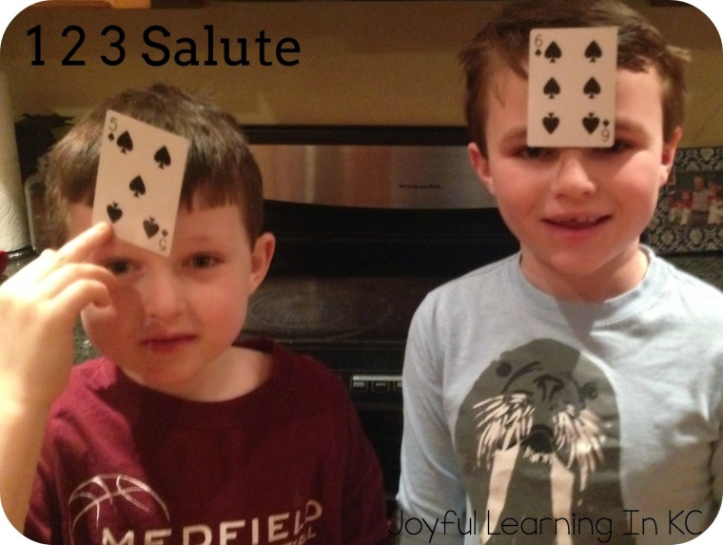
Captain: “The product of your cards is 30”
Player 1: “ I have 5” (He knows this because he can see the 6 on his opponent’s head and knows 5 x 6 = 30”
Objective: Create the highest 3-digit number given 3 cards. The player with the greater number wins.
Place Value Number Battle, “War”
Grades: 3-5
2-4 players
Materials: Deck of cards with 10’s, face cards and jokers removed.
Set Up: Shuffle cards. Deal an equal number of cards to each player until the deck runs out. Each player keeps his/her cards in a stack.
How to Play:
- Each player turns three cards face up and creates the largest 3-digit number possible. Players may move the cards and place them in any position (hundreds, tens, ones) they wish.
- The player with the highest 3-digit number wins the hand and keeps all six cards next to him/her.
- If players create a number that is equal, it is “war!”
- Each player puts three cards face down and places an additional three cards, face up, to find a new 3-digit number. The player with the greatest number wins.
- When players are finished with the cards in their deck, the player with the most cards wins.
Variation: Try playing with 4 or more cards and creating a 4, 5, or 6-digit number.
Try to create the smallest number possible…the player with the least value wins.
“644”
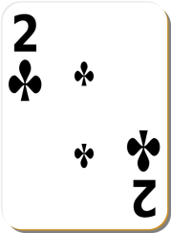 “821” “821 is greater than 644.”

Objective: Create two, 3-digit numbers that have a sum as close to 1000 as possible, without going over.
Make 1000: An Addition Game

Grades: 3-5
2-4 players

Materials: Deck of cards with 10’s, jokers and face cards removed; paper and pencils (for scratch paper)

Set Up: Shuffle the deck of cards. Deal each player 6 cards. Place the remaining cards, face down, in a pile between the players.

How to Play:
- Each player creates two 3-digit numbers. The goal is to create two numbers that have a sum as close to 1000 as possible, without going over. (For example, a player may use the cards 4, 9, 7, 6, 8, and 1, creating the problem 791 +186=977)
- After players have made their selections, they place their cards face up in front of them, arranging them so other players can see which two numbers they have created, sharing the sum with their opponent.
- The player with the sum closest to 1000, without going over, wins a point. In the case of a tie, a point is awarded to each team.
- For the next hand, players are dealt six new cards.
- Play continues for 5 rounds. The player with the most points after the last round wins the game.

Variations:
- Change the number of cards dealt (6 cards dealt gives no choices, 8 cards gives more choices)
- Try to create two 3-digit numbers that have the lowest sum.

“684 and 241 is 925. That is close to 1,000.”

I Spy Products

Objective: Find products and search for factors that equal a given product

Grades: 3-5
2-4 players

Materials: Deck of cards with jokers and face cards removed

Set Up: Shuffle the deck of cards. Place 21 cards out, face up, in a 7x3 array.

How to Play:
- One player challenges the other player to find two cards next to each other, either vertically or horizontally, that have a given product. The player will say, “I spy two cards with a product of 63.”
- The other player then looks for two cards with the product of “63” and picks this pair up. If there are any other pairs with a product of “63” that the player sees, s/he may pick these up too.
- If the player misses any pairs that have a product of “63” then the first player may claim them.
- Players swap roles for the next turn. Fill in any spaces with cards from the deck so a 7x3 array remains. When there are no more cards to fill in the spaces, just move cards to form a new array and continue play.
- Play continues until the cards are cleared.
- The winner is the player with the most cards at the end of the game.
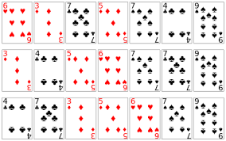 “I spy two cards with a product of 21.”

Multiplication Quick Draw

Objective: Be the first player to find the product of two cards.

Grades: 3-5
2 players

Materials: Deck of cards with jokers and face cards removed

Set Up: Shuffle the deck of cards. Deal the cards evenly among the players. Players keep their cards in a pile, face down, in front of them.

How to Play:
- One player calls, “Draw” and both players turn over their top card and place it face up between the two players.
- The players multiply the two numbers that are showing and the first player to call out the product wins the two cards, placing them in a pile next to him/her.
- After all the cards have been used, the players count the cards they have won. The winner is the person who has the most cards.

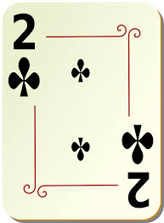 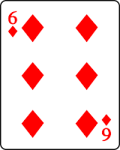 “Twelve!”

Ten-Twenty-Thirty

Objective: Remove piles of cards when the sum equal 10, 20 or 30.

Grades: 1-2
1 player

Materials: Deck of cards (face cards have a value of 10, ace has a value of 1)

Set Up: Shuffle the deck of cards. Create a row of seven cards, face up. Place two cards, face up, on top of each of the seven. You will now have seven piles with three cards in each. Be sure you can see the face value of all of the cards. (See the picture below)

How to Play:
- Look at each pile of cards. You may remove a whole pile if it has a sum of 10, 20, 30, 40, etc. .
- After you remove any piles with a sum of 10, 20…, you may deal a fourth card on top of the existing piles.
- Continue to look for new piles that have a sum of 10, 20, 30, 40…(multiples of 10).
- Each time you have removed all piles with a multiple of 10, deal another card.
- Continue adding cards and removing piles with multiples of 10 until your deck is depleted or the piles have all been removed.
- If you remove all the piles before you have used all the cards in the deck, you have won!
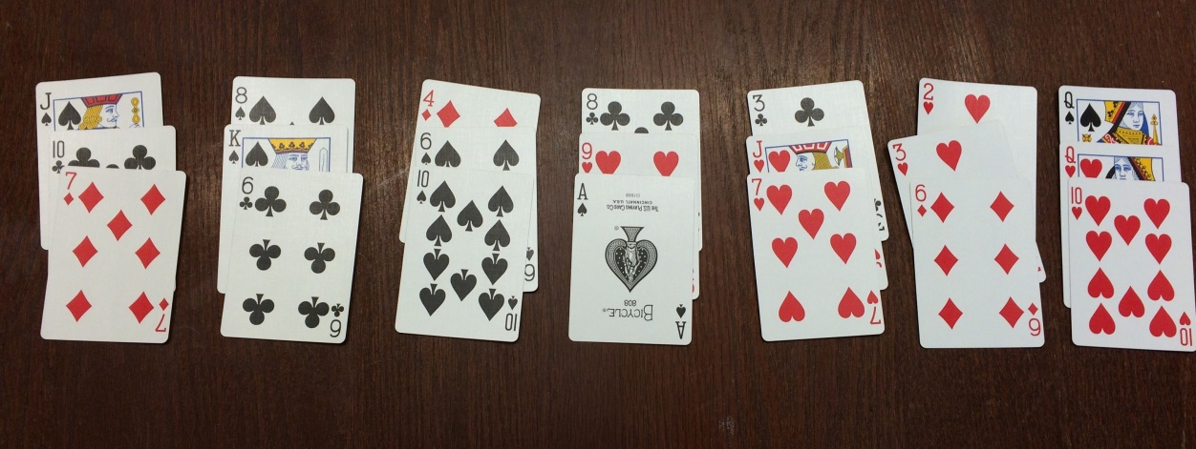
4 +6 + 10=20 (remove this pile); 3 + 10 (Jack) + 7= 20 (remove this pile);
10 (queen) + 10 (queen) + 10=30 (remove this pile)
Gain and Loss

Objective: Add and subtract numbers.
Grades: 2-5
2-4 players
Materials: Deck of cards with face cards and jokers removed, paper and pencil
Set Up: Shuffle cards. Place the deck face down between the players.
How to Play:
- Each player has his/her own scrap paper…try to use mental math too!
- Each player begins with 15 points. They should write this number down on their paper.
- Players take turns. Player one draws a card from the pile.
- If the card is a black card s/he adds the value (Gain) to 15 and records the new total.
- If the card is a red card s/he subtracts the value (Loss) from 15 and records the new total.
- Player two goes and does the same.
- Players continue to take turns drawing one card at a time, adding or subtracting, and recording the total.
- If the pile of cards runs out, shuffle all the cards and continue to play.
- At the end of 20 rounds, the person with the highest total wins.
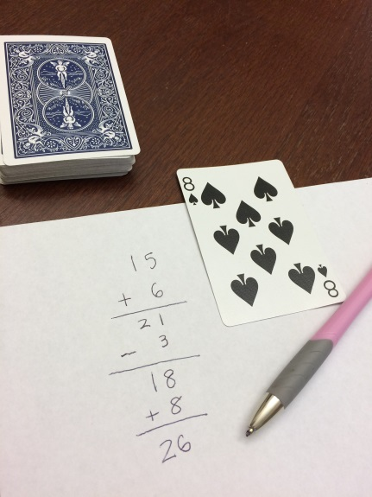
This player added 8 to 18 because it was a black card (Gain). The new total after 2 rounds is 26.
Hit the Target
Objective: Add, subtract, multiply and divide numbers to reach a target number.
Grades: 3-5
2-4 players
Materials: Deck of cards with jokers removed. Face cards can be removed or counted as 11, 12, and 13, paper and pencil for each player
Set Up: Shuffle cards. Place the deck face down between the players.
How to Play:
- Players select a target number from 1-30 for the whole group for each player to work with.
- One of the players turns over 5 cards from the deck, face up.
- Each player must use all of the 5 numbers (the five cards) in any order to make an equation to equal the target number.
For example, suppose the target number is 20 and the cards in play are 5, 5, 6, 2 and Ace (worth 1).
One combination might be (5x2) + (5+6)- 1= 20 or
(6x5) – (2x5x1) = 20 or (6 $÷$2) x 5 + (5x1)=20

- The first player to find a winning combination keeps the cards and chooses the next target number (before the new cards are picked).
- If no combination is found by any players after 2 minutes, flip over another card and try to use all 6 cards to reach the target.
Variation: To make the game easier for both players or one of the players, have the player have the choice to use four of the five cards rather than always using all five cards at the same time.

