McCullough Elementary School
Virtual Holiday Shop
Enjoy the Gift of Giving while Giving Back to our School!
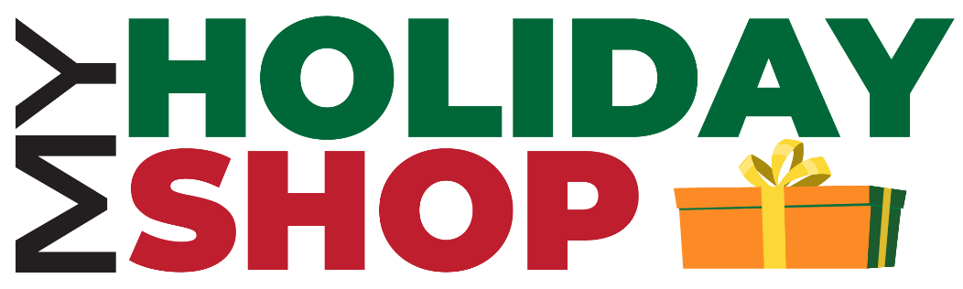

Online Shopping Starts Now! Visit:
https://myholidayshop.org/school/447441

McCullough Elementary School presents MyHolidayShop - an online holiday shopping experience where students and families enjoy shopping together while supporting their school. With a wide selection of gifts priced within a child’s budget (most under $5), students can shop the personalized gift collections for Mom, Dad, Grandma, Grandpa, siblings, pets, and more!

- Visit: https://myholidayshop.org/school/447441
- Shop opens November 16th
- Shop ends: November 25th, 2020
- Families shop and pay for gifts online (site is available in both English and Spanish).
- Gifts are shipped directly to your home.
- E-Gift Cards available: A great option if you would like to ask a family member to sponsor your child.
- Share the link with friends and help raise money for our school!

If you have questions, please contact:
Jaime Yaremko via email at jevanuik@yahoo.com

