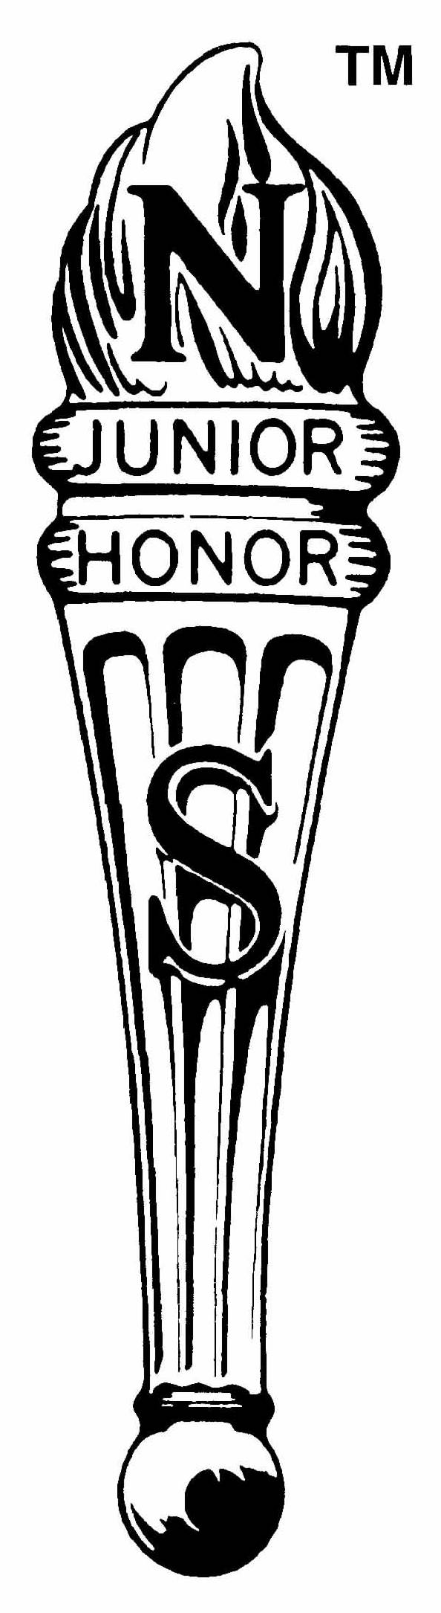
National Junior Honor Society Member

Student: ___________________________________ 2016/17

NJHS Requirements

Below is a list of requirements you must meet in order to become a member of the National Junior Honor Society:

- You must maintain an A- average or above in all of your classes even Specials (such as: physical education, art, and Spanish).
- You must not receive any Zero Days, In-School suspensions, or Out-of-School suspensions.
- You must be role models in your classes and receive outstanding recommendations from all of your teachers.

Requirements for Continuing Membership in the NJHS

The requirements for continuing membership in the National Junior Honor Society are as follows:

- You must maintain an A- average or above in all of your classes even Specials (such as: physical education, art, and Spanish).
- During each marking period, your progress reports will be checked, by a NJHS advisor, to see how you are your maintaining grades. If need be a conference may be needed to discuss how you can pull up your grade.
- You must not receive any Zero Days, In-School suspensions, or Out-of-School suspensions.
- Documentation of participation in meetings, athletics, clubs, church, or community service hours will be required.
- You must continue to be role models in your classes and receive outstanding recommendations from all of your teachers.

If you fall below on any of these requirements, you will be placed on probation. Written notification of this warning will be forwarded to you. If a second offense in any one of these areas occurs, it will end your membership in the National Junior Honor Society.

Student signature: _______________________________________________

Parent signature: _______________________________________________

