Bloom's Taxonomy and Higher Order Thinking
In the 1950's Benjamin Bloom developed his taxonomy (classification) of cognitive objectives called Bloom's Taxonomy. This categorized and ordered thinking skills. His taxonomy follows the thinking process. You can not understand a concept if you do not first remember it, similarly you can not apply knowledge and concepts if you do not understand them. It is a continuum from Lower Order Thinking Skills (LOTS) to Higher Order Thinking Skills (HOTS).
Bloom's Taxonomy 1950’s
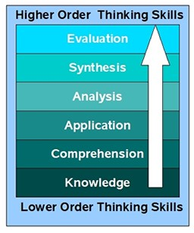
- Knowledge: Remembering, memorizing recognizing recalling identification recalling information: who, what, when, where, how, describe
- Comprehension: Interpreting, translating from one medium to another, describing in one's own words, organization and selection of facts and ideas, retell...
- Application: Problem solving, applying information to produce some result, use of facts, rules and principles
- Analysis: Subdividing something to show how it is put together, finding the underlying structure of a communication, identifying motives, separation of a whole into component parts, parts or features, classify, outline/diagram, compare/contrast, evidence
- Synthesis: Creating a unique, original product that may be in verbal form or may be a physical object, combination of ideas to form a new whole, predict/infer, add to, create/design, combine, solutions
- Evaluation: Making value decisions about issues, resolving controversies or differences of opinion, development of opinions, judgements or decisions

In the 1990's, a former student of Bloom, Lorin Anderson, revised Bloom's Taxonomy and published this- Bloom's Revised Taxonomy in 2001. Key to this is the use of verbs rather than nouns for each of the categories and a rearrangement of the sequence within the taxonomy. They are arranged in increasing order, from low to high.
Bloom's Revised Taxonomy 1990’s The new terms (verbs) are defined as:
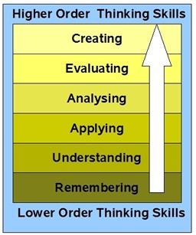
- Remembering: Retrieving, recognizing, and recalling relevant knowledge from long-term memory.
- Understanding: Constructing meaning from oral, written, and graphic messages through interpreting, exemplifying, classifying, summarizing, inferring, comparing, and explaining.
- Applying: Carrying out or using a procedure through executing, or implementing.
- Analyzing: Breaking material into constituent parts, determining how the parts relate to one another and to an overall structure or purpose through differentiating, organizing, and attributing.
- Evaluating: Making judgments based on criteria and standards through checking and critiquing.
- Creating: Putting elements together to form a coherent or functional whole; reorganizing elements into a new pattern or structure through generating, planning, or producing.
(Anderson & Krathwohl, 2001, pp. 67-68)

Higher-order thinking essentially means thinking that takes place in the higher-levels of the hierarchy of cognitive processing. A common example is shown below, applying the taxonomy to the Pledge of Allegiance:
Knowledge statements ask the student to recite the pledge. Example: “Say the pledge.”
Comprehension statements ask the student to explain the meaning of words contained in the pledge. Example: “Explain what indivisible, liberty, and justice mean.”
Application statements ask the student to apply understandings. Example: “Create your own pledge to something you believe in.”
Analysis statements ask the student to interpret word meanings in relation to context. Example: “Discuss the meaning of ‘and to the Republic for which it stands’ in terms of its importance to the pledge.”
Synthesis statements ask the student to apply concepts in a new setting. Example: “Write a contract between yourself and a friend that includes an allegiance to a symbol that stands for something you both believe in.”
Evaluation statements ask the student to judge the relative merits of the content and concepts contained in the subject. Example: “Describe the purpose of the pledge and assess how well it achieves that purpose. Suggest improvements.”
(Wiederhold, C. (1997). The Q-Matrix/Cooperative Learning & Higher-Level Thinking. San Clemente, CA: Kagan Cooperative Learning.)

Questioning for Quality Thinking at Each Level of Bloom’s Taxonomy

Knowledge: Identification and recall of information
Who, what, when, where, how? Describe ___________________.

Comprehension: Organization and selection of facts and ideas.
Retell ___________ in your own words. What is the main idea of ________________?

Application: Use of facts, rules, principles
How is __________ and example of __________? How is __________ related to ________? Why is _________________ significant?

Analysis: Separation of the whole into component parts
What are the parts or features of ________? Classify _______ according to ___________.
Outline/diagram/web ______. How does __________ compare/contrast with ___________? What evidence can you list for _____________________?

Synthesis: Combination of ideas to form a new whole
What would you predict/infer from ___________? What ideas can you add to ________________? How would you create/design a new __________? What might happen if you combine ___________ with ________________? What solutions would you suggest for __________________?

Evaluation: Development of opinions, judgments, or decisions
Do you agree with ___________? What do you think about __________? What is the most important _____________? Prioritize ____________. How would you decide about _____________? What criteria would you use to assess ______________________?

