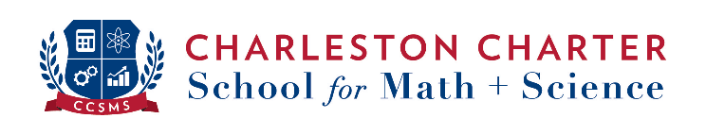
Class of 2021 College Acceptances

As of April 29, 2021, our 80 seniors in the Class of 2021 have submitted 388 applications to 146 colleges!
– many have received remarkable scholarships!

Alabama A & M University
Albany State University
Alcorn State University
Appalachian State University
Arkansas Baptist College
Benedict College
Bethune-Cookman University
Brevard College
Claflin University
Clark Atlanta University
Clemson University
Coastal Carolina University
College of Charleston
College of Charleston (Honors Program)
Colorado State University-Fort Collins
Dartmouth College
Edward Waters College
Elizabeth City State University
Florida Institute of Technology
Furman University
Hampton University
High Point University
Hollins University
Howard University
Jackson State University
Johnson & Wales University-Charlotte
Johnson C Smith University
Lander University
Liberty University
Limestone College
Loyola University New Orleans
North Carolina A & T State University
North Carolina Central University
North Carolina State University at Raleigh
Ohio University-Main Campus
Pennsylvania State University-Main Campus
Philander Smith College
Roanoke College
Rochester Institute of Technology
Rust College
South Carolina State University
Southern University and A & M College
Spartanburg Methodist College
Stillman College
Talladega College
Tennessee State University
University of Alabama in Huntsville
University of Arkansas at Pine Bluff
University of Miami
University of New Hampshire-Main Campus
University of North Carolina at Greensboro
University of North Carolina at Pembroke
University of North Carolina Wilmington
University of South Carolina - Beaufort
University of South Carolina-Columbia
Vanderbilt University
Virginia Commonwealth University
Virginia State University
Voorhees College
Western Carolina University
Wingate University
Winston-Salem State University
Winthrop University
Worcester Polytechnic Institute

