Algebra 2 – Course Overview
Course Instructors:
Mr. Diallo (Cohort A) Mrs. Gent Mr. Broderick(Cohort B)
mdiallo@bcamhs.org lgent@bcamhs.org abroderick@bcamhs.org
Algebra 2: Course Overview
Welcome to Algebra 2, Cohort A & Cohort B and BCAM Guardians. We would like to officially welcome you back to BCAM. This year will be a trying year where students will be split between remote learning and BCAM’s hybrid model. In order to connect to this course’s curriculum, students will be using Google Classroom within ILEARN’s website structure. In order to utilize Google classroom within ILEARN, you will need a DOE email. Make sure students are equipped with the appropriate email in order to engage in curriculum materials such as lessons, study guides, homework, and tutorials/tutoring sessions. We will first review common algebraic skills and content prior to building on said skills later on in the course. It will be imperative to communicate with us to make sure we can clear up any misconceptions you have. The best action any student can make is to ask questions if students don’t understand a problem.
Curriculum:
We will be providing curriculum that will be designed to help you identify patterns that you can use to make decisions that impact this culturally rich world. At BCAM, with the leadership of Mr. O’Brien, Ms. Exantus, and Ms. Bello, and all support staff, we will be providing you curriculum that is culturally relevant. Our goal is to develop lessons, activities, and experiences that help you make sense of the world.
We will be using a combination of Emathinstruction.com, original lessons, IXL.com and Edpuzzle to guide our instruction. Algebra 2 is the third year in a three-year sequence of high school mathematics. This course will cover advanced functions, sequences and series, polynomial functions, exponential and logarithmic functions, conic sections and trigonometry. The real number system is extended to include complex numbers. All topics are studied from an algebraic, graphical, numerical and exploratory approach. An emphasis on applications and appropriate calculator use will be integrated throughout the year.
Located at Emathinstruction.com under classes and Algebra 2 Common Core
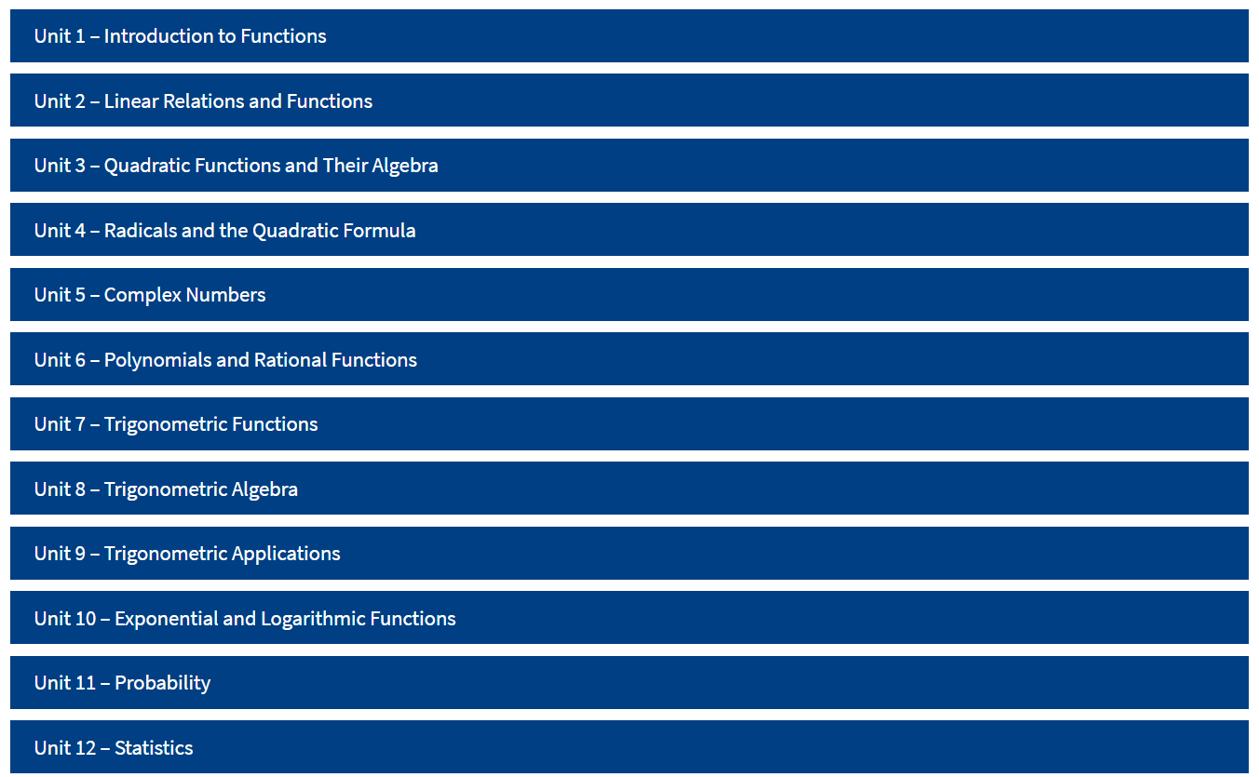
Expectations:
Students will need to attend 3 classes, online and/or in-person, a week. There will be 2-75 minute classes and one 40 minute class within your cohort schedule. Attendance will be important when grading each term in the year. Parents and students should take the necessary steps to make sure they have the technology that will allow them to connect to BCAM’s online environment.
Grading Criteria: (subject to change)
Students will have a variety of methods to display mastery of the subject The following are the criteria used to evaluate students.
Attendance: 15% of the grade will be attendance
Class Participation: 20% Teachers will observe student work and involvement in discussion in online or in-person classes.
Quizzes & Tests: 40% Teachers will use 100 points for quizzes and 50 points for quizzes. You will be provided with 5-6 assessments a quarter.
Homework: 15% Completed assignments on IXL or provided worksheets will count
Projects: 10% Students will be given an alternative method to prove their mastery at the end of the term
Homework and Assessments:
Please expect an assignment each time we meet. Assigned work is due the next class period for full credit. We will provide worked out solutions key online and ask questions for those you struggle during class or after/before school. (Late or incomplete homework will earn partial credit; otherwise it is counted as no credit.) The best way to be successful is to keep pace with the class and ask questions when students are confused. You can expect at least one quiz per unit, perhaps a team quiz if it is a challenging chapter, a test upon completion of the chapter, and a comprehensive final exam at the end of the semester. If a student experiences unlikely poor performance on a chapter test they may edit their test for increased understanding and points. If students fail to complete three assessments and assignments, we will contact parents through Kinvolved or phone calls home. A practice test is provided for each chapter test and the final exam along with answer keys. Practice is the key to positive performance. We as teachers only want you to succeed. The way to succeed is to complete tasks that challenge your abilities. Take advantage of these opportunities!
Primary Instructional Resources:
Emathinstruction.com Google Classroom
IXL.com Goformative.com
Edpuzzle.com ***more to come

Grades:
90-100 | A
80-89 | B
70-79 | C
65-69 | D
Below 64 | Non-credit

Graphing Calculator: TI-84 Plus or higher is required. Purchasing a TI-84 Plus CE is highly recommended.

I look forward to a successful year of math for each of us ~ welcome.
Mr. Diallo & Mr. Broderick
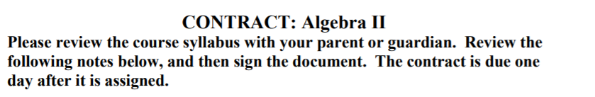
Classroom & Course Norms:
- You must complete or make up any assessments(tests & quizzes) in order to pass a quarter.
- Attendance is mandatory depending on your Cohort Schedule
- You must wear a mask
- You must be in your seat and prepared for class when the bell rings
- If you are late to class three times in a row, a call home will take place.
- Use appropriate language
- Participate in class
- Class notes will be graded randomly so make sure to take notes in the guided notes provided.
- If you are absent it is your responsibility to find out what you missed. Absence for a school activity should be notified to the teacher ahead of time and assignments are still due the same day as the rest of the class.
10)Be prepared to have all of the passwords you need to complete assignments weather it be IXL, Google Classroom, Email, or other prominent account information.
11) No Cell Phones when you are in person.

