Canvas

District Website page(All about Canvas)= http://www.sweetwater1.org/canvas

Log in page(google)= https://sw1.instructure.com/

Integrates with Google/Syncs with powerschool (both ways) / Quick GradingBook /

PTSB credit for on-line webinars

24/7 support. Canvas Support Hotline
1 (833) 482-2868

Getting Started for Teachers= https://community.canvaslms.com/docs/DOC-18573-getting-started-with-canvas-as-an-instructor

Video Tutorial( Set Up Your Canvas Course in 30 minutes or Less)= https://community.canvaslms.com/docs/DOC-18584-set-up-your-canvas-course-in-30-minutes-or-less
Instructor Training Site: https://community.canvaslms.com/docs/DOC-18088-how-do-i-use-the-training-services-portal-as-an-instructor

Commons (use already made resources) = https://sw1.instructure.com/accounts/1/external_tools/82?launch_type=global_navigation

SW1 already has saved classes in commons to help start = search SW1

Training portal= https://training-portal-prod-pdx.insproserv.net/pages/tutorial
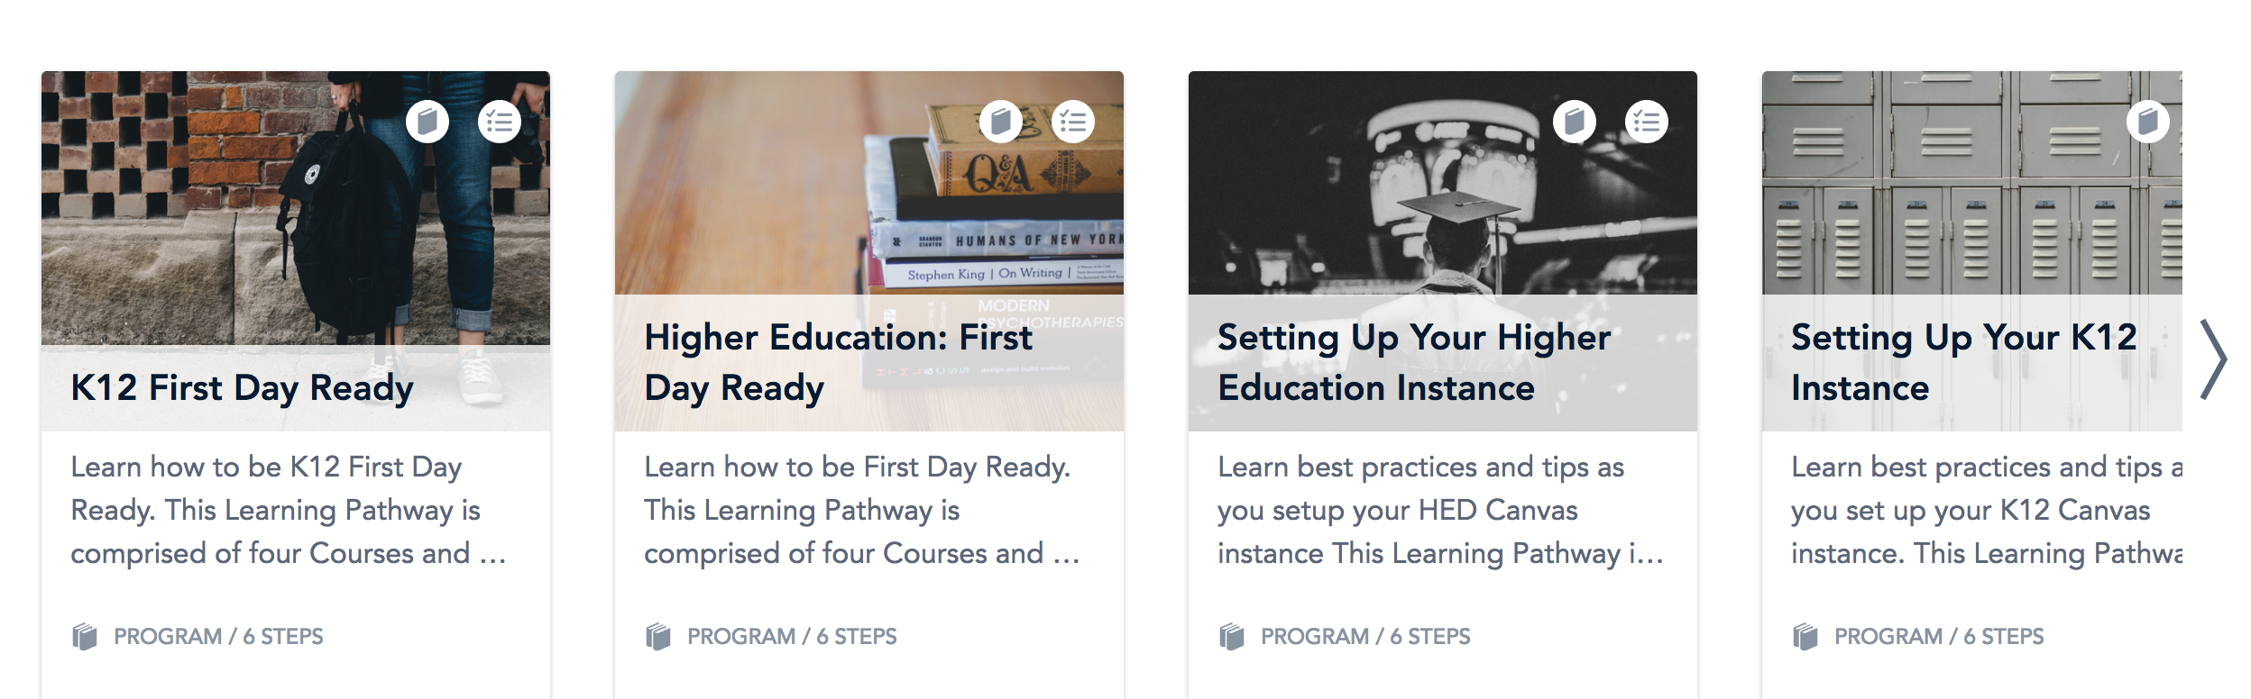

Pre-recorded step by step instructions for setting up Canvas course(2 hours and start at 16:30)= https://instructure.zoom.us/rec/play/6JV7cryg-Do3HdeQ4wSDBPEtW46-J_2s2yga-_oKmUm0BnhRNwKhM7Iba-UR5CTe5xsUFf-55N1pIiH_?continueMode=true&_x_zm_rtaid=b98iDKA9SNug66GNzeIvMQ.1594907108214.d338ed367dae9bd227ffb6f0c54e5e6f&_x_zm_rhtaid=415

Google Integration with Canvas

Using Google in Canvas= https://community.canvaslms.com/docs/DOC-6464-using-google-in-canvas

Canvas integrates with google= https://www.instructure.com/canvas/en-au/integration-canvas-google

- View your Google Drive files within Canvas
- Create a Google Drive collaboration within your Canvas course
- Create a cloud assignment in your Canvas course using a Google Drive file
- Link to or embed a file from your Google Drive into a Canvas page

