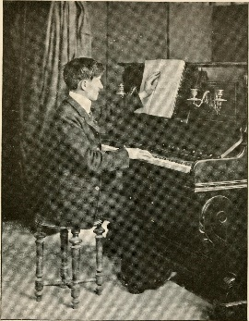
Ms. Dunn’s 8th Grade ELA
Daily Work
2/3/17
Reveal: What does a deeper exploration of historical facts reveal in “The Forbidden Dots?”
- Warm Up: Read the Content Framing Question. What is a “historical fact? ____________________________________________________________________________________________________________________________________________________________________________________________________________
- Launch
Definition
historical fact

- Learn
Evidence Organizer
Focusing Question: How did Louis Braille open up the world of reading to sight-impaired people?
- Land
What did our deeper exploration of historical facts reveal? Cite evidence from our work in class to support your thinking. 3 sentences minimum.
____________________________________________________________________________________________________________________________________________________________________________________________________________________________________________________________________________________________________________________________________________________________________________________________________________________________________________________________________________________________________________________________________________________________

