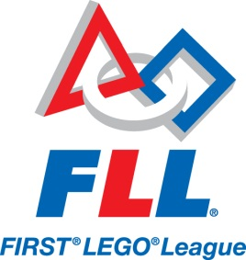
Mesquite Elementary FIRST® Programs

The Mesquite Elementary M.E.R.I.T. Club is looking to get an early start on the upcoming 2018-2019 season. This program will create an opportunity for students to compete in the FIRST® LEGO® League competition (http://firstlegoleague.org)
We are looking for motivated and team-oriented students interested in taking their Robotics skills to the next level. FLL teams compete on three fronts:
- Robot Game – design, build and program a robot to autonomously complete a series of missions around this year’s theme: “Animal Allies” (http://www.firstlegoleague.org/challenge)
- Project – identify a problem, research/develop an innovative solution, and create an entertaining presentation of your work
- Core Values – demonstrate teamwork and the other FLL Core Values (http://www.firstlegoleague.org/mission/corevalues)
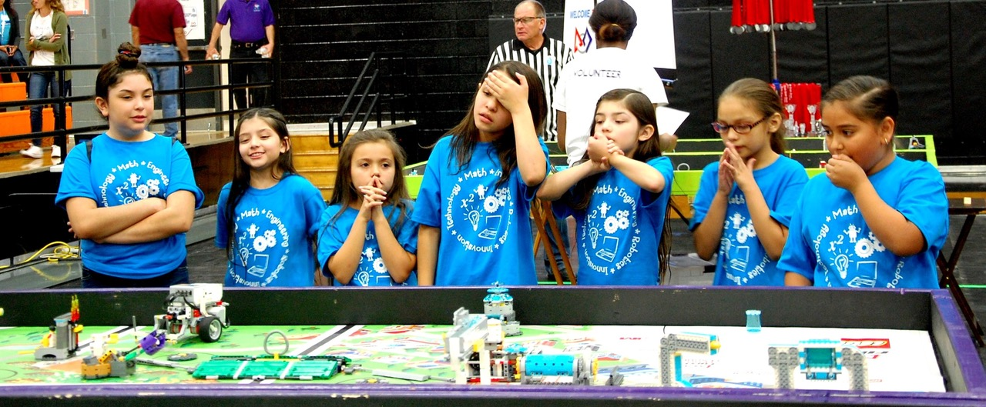
The club will initially meet after school Mondays and Wednesdays from 2:30 to 3:30 p.m. Additional meetings will be added as the season progresses to include Thursday evening and Saturday sessions.
The club will run at as long as a team is in contention; December for the Regional Qualifier, or February for the State Championships.
Here are some things to keep in mind if you are considering applying to be on the Mesquite Elementary M.E.R.I.T. Club:
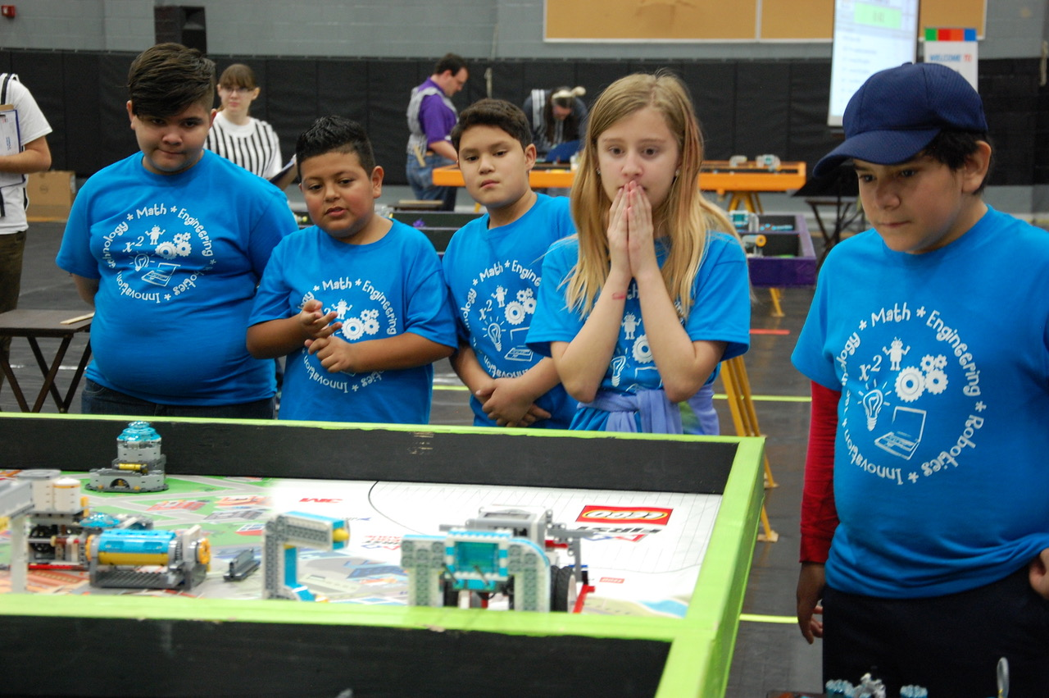
- FLL’s Core Values (http://firstlegoleague.org/mission/corevalues) stress teamwork, so you must be committed to work with others to find compromise and be able to give and receive positive/constructive feedback as your team develops their solutions – you must be a team player
- Your ability to work hard as part of team to complete whatever task needs to be addressed is essential – you must be flexible
- Regular attendance at the club is vital – you must be reliable
- Some work outside of club hours will be required (research, preparation, competitions) – you must be committed
- This is a second year team, so you are expected to bring some skills to the team in at least one of the competition areas– you must be experienced, getting started in the off-season will help up get this necessary experience.
- Students do all the work at FLL, so you will be expected to multi-task and take on responsibilities outside of your comfort zone – you must be willing to grow
- You will be representing your school at the club and competitions, so your behavior must be exemplary at all times – you must be mature
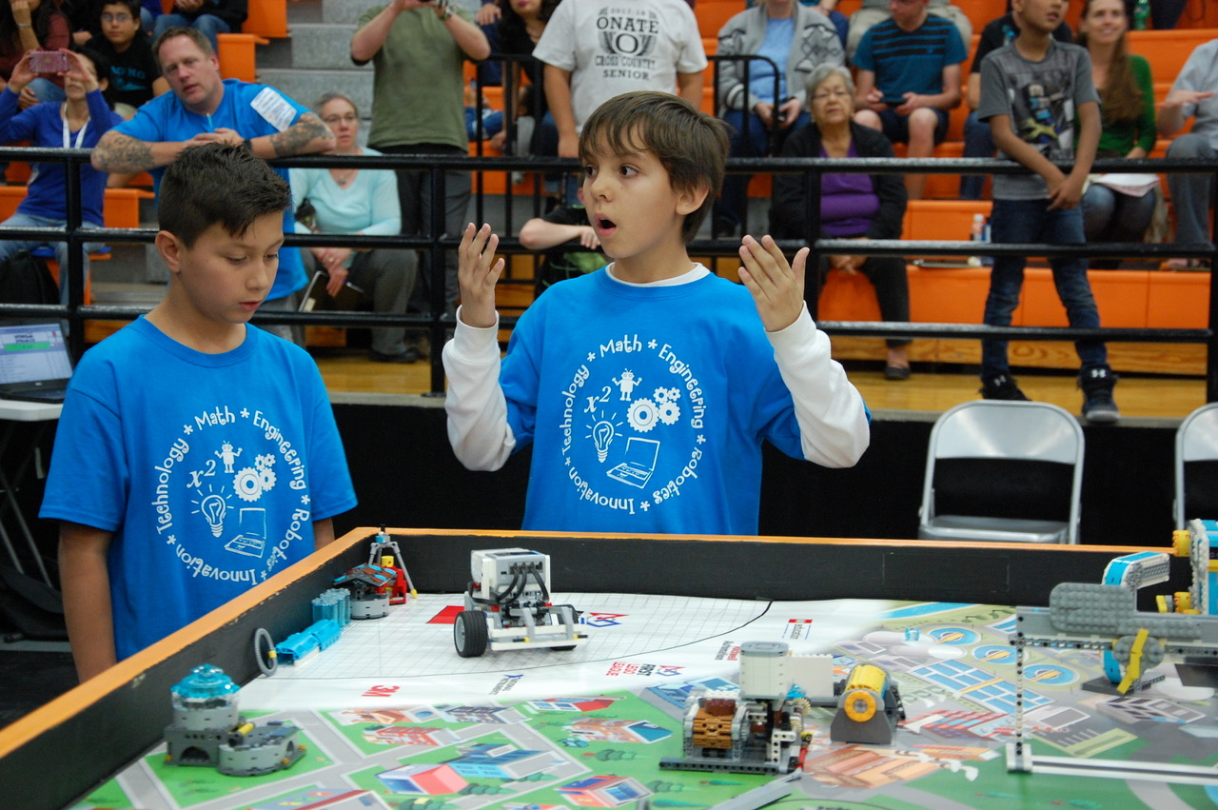
If this sounds like a challenge you are prepared to take on, please work with your parent/guardian and teachers to complete this application and return it to the Mr. Husson-Matter.

If you have any questions, please contact your FLL Teacher-Coach, Mr. Husson-Matter, at rwhm@comcast.net.
Application

Mesquite Elementary First Lego League Team, 2018 – 2019

Name _________________________________________ Age_____________________

Address _____________________________________________________________________

Home Phone___________________ School and grade_________________________________

Thank you for your interest in the Mesquite Elementary M.E.R.I.T Club 2018-2019 edition.
Selection will be based on your written responses to the following topics.

The Required Responses listed below must be completed by all applicants.
Additionally, choose at least two of the Selected Response topics below and respond to those also.
Give as much detail as possible (you may present these as the body paragraphs in a five-paragraph essay).

Required Responses:
The FLL team will work on three fronts; The Robot Game, Core Values, and the Project. Explain how your experience in these areas would enable you to contribute to the team, and which would be your area of strongest contribution.

Are you willing to work outside of class, after school and /or weekends to make sure the team is successful? Explain if there is time in your busy life to dedicate extra time to this event.

Selected Responses: (respond to at least two of the topics below)
Describe a time you were part of a team. Use details to explain how the event began, how you were part of it and include whether or not you felt it was a positive experience.

Do you consider yourself a punctual person? Give examples of how in your life you work to be on time.

Give examples of times you have needed to multi-task while working on one or more events or projects.

Give examples of times you have taken on responsibilities to work on things outside your comfort zone. Detail the circumstances and how the experiences turned out.

Where do you see yourself in a group? Are you a leader or more of a worker bee? Explain.

Explain what you feel to be the most important attributes of a good team member.

What kind of student would your teacher(s) say you are?

Application Submission Checklist

___ This Application Page
___ Written Responses (Not Required for Returning FLL Participants)
___ Signed Parent Permission Page

Parent Information

Mesquite Elementary First Lego League Team, 2018 – 2019

Special words for Parents…

With your child as part of the Mesquite Elementary FLL (http://www.firstlegoleague.org/) team, your role of support to the team is critical. There may be times that inconvenience and conflict arise with respect to meeting team needs. You are asked to be patient, supportive and encouraging as these situations arise. Throughout the FLL season, we strive to stress the FLL Core Values:

- We are a team.
- We do the work to find solutions with guidance from our coaches and mentors.
- We know our coaches and mentors don't have all the answers; we learn together.
- We honor the spirit of friendly competition.
- What we discover is more important than what we win.
- We share our experiences with others.
- We display Gracious Professionalism™ and Coopertition™ in everything we do.
- We have FUN!

In addition to being the team’s number one cheerleaders, you will have the opportunity to:
√ Assist during club meetings
√ Host the team on evenings or weekends as they work to meet deadlines
√ Assist with transportation as needed
√ Work to gain sponsorships for the team
√ Stay informed with the team’s progress and offer suggestions you feel may assist them
√ Assist with mock judging of presentations
√ Be the parent liaison between the coach/team and the other parents
√ And….. just be there when the needs arise

Parent involvement is so important that it should be thought of as “the team that helps the team.”

Please feel free to help your child understand the details of the application, particularly the Required and Selected Responses.

Be sure to review and complete the Parent Permission form as part of the application.

Parent Permission

As the parent of ____________________ I understand the commitment to the FLL Program to which my child is applying.

I realize that it is multi-day per week program, at least through December and possibly longer. Other than illness or a family emergency, I will be sure my child is there each day.

I am aware that the program will take place at our school and on the NMSU campus. I will be responsible for my child’s transportation home, and agree to pick him/her up on time.

I will provide my child with a snack each day.

As outlined in the application, I will work with the program and my child to instill the FLL Core Values

I assure that my child will be available for competitions that take place during the competition season.

I (Please Print) ________________________________voluntarily give my permission for my
child, (Please Print) _____________________________to participate in the Mesquite Elementary M.E.R.I.T. club. I have read the application packet, understand, and agree with the information, goals set forward, and the responsibilities regarding both my child and me.
Note: the level of parental support will determine the number of students on the team
I am available to volunteer with the team in the following capacity:
___ Assist on a regular basis during after-school team meetings
___ Assist occasionally during after-school team meetings
___ Host team meetings outside regular after-school meeting times
___ Assist with transportation as needed
___ other (please specify):___________________________________
Parent Signature _______________________
Cell Phone__________________
e-mail _______________________________
Please have your child include this with his/her application

Angela Silvaggio Mesquite Elementary Michael Reyes
Principal 205 NM HWY 228 Assistant Principal

Mesquite, New Mexico 88048
Ph. (575) 233-3925

Student Media Consent and Release Form

Throughout the school year, students may be highlighted in efforts to promote Mesquite Elementary School activities and achievements. For example, students may be featured in materials to train teachers and/or increase public awareness of our schools through newspapers, radio, TV, the web, DVDs, displays, brochures, and other types of media.

I, as the parent or guardian of __________________________, hereby give Mesquite Elementary School and its employees, representatives, and authorized media organizations permission to print, photograph, and record my child for use in audio, video, film, or any other electronic, digital and printed media including social media such as Twitter and Facebook.

a. This is with the understanding that neither Mesquite Elementary School nor its representatives will reproduce said photograph, interview, or likeness for any commercial value or receive monetary gain for use of any reproduction/broadcast of said photograph or likeness. I am also fully aware that I will not receive monetary compensation for my child’s participation.

b. I further release and relieve Mesquite Elementary School, GISD, its Board of Trustees, employees, and other representatives from any liabilities, known or unknown, arising out of the use of this material.

I certify that I have read the Media Consent and Release Liability statement and fully understand its terms and conditions. This consent will remain in effect until I revoke it through a written request.

Please Print
Name of child __________________________________________ Grade___________
Address _______________________________________________________________
City, State, Zip__________________________________________________________
Signature of parent or guardian ____________________________________________
Date____________________ Phone Number ________________________________

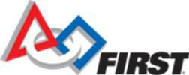
FIRST YOUTH TEAM MEMBER REGISTRATION FORM

This form is required at all FIRST events or competitions.
A parent/guardian should complete the form and return it to the Team Coach/Mentor.

Program:

Junior FIRST® LEGO® League TEAM NUMBER:
FIRST® LEGO® League TEAM NUMBER:
FIRST® Tech Challenge TEAM NUMBER:
FIRST® Robotics Competition TEAM NUMBER:

Parent/Guardian Information
FIRST NAME: LAST NAME:
ADDRESS: ADDRESS: CITY/TOWN: STATE/PROVINCE: ZIP CODE: PHONE NUMBER: PHONE TYPE: HOME WORK CELL

Child’s Information

FIRST NAME: LAST NAME:

DATE OF BIRTH: GENDER: MALE FEMALE

RACE: AFRICAN AMERICAN/BLACK ETHNICITY: HISPANIC/LATINO/LATINA
ASIAN NOT HISPANIC/LATINO/LATINA
CAUCASIAN/WHITE
NATIVE AMERICAN/ALASKAN NATIVE HAWAIIAN/PACIFIC ISLANDER

CHILD’S SCHOOL: CITY AND STATE OF SCHOOL:

GRADE IN SCHOOL (AS OF SEPT. 2018):

ELIGIBLE FOR FREE/REDUCED LUNCH AT SCHOOL? YES NO NOT SURE

HAS YOUR CHILD EVER PARTICIPATED IN: (PLEASE CHECK ALL THAT APPLY AND PROVIDE NUMBER OF YEARS):
JUNIOR FIRST LEGO LEAGUE YEARS
FIRST LEGO LEAGUE YEARS
FIRST TECH CHALLENGE YEARS
FIRST ROBOTICS COMPETITION YEARS

PLEASE RETURN THIS FORM AND A COMPLETED CONSENT AND RELEASE FORM TO YOUR TEAM COACH/MENTOR. BOTH FORMS ARE REQUIRED TO PARTICIPATE IN ALL FIRST EVENTS

UNITED STATES FOUNDATION FOR INSPIRATION AND RECOGNITION OF SCIENCE AND TECHNOLOGY (FIRST ®)

CONSENT AND RELEASE AGREEMENT
Participant Name:
If Participant is under 18 years of age, Parent/Guardian Name:
Participant Date of Birth if under 18 years of age [MM/DD/YYYY]:
Participant Address: __ Participant Email (If Participant is under 18 years of age, Parent/Guardian Email): Participant Team Number

The Participant identified above (“Participant”) desires to participate (as a team member, coach, mentor, judge, or in some other manner) in the FIRST® Robotics Competition, FIRST Tech Challenge, FIRST LEGO® League, Junior FIRST LEGO League, or another FIRST program (the “Programs”). As a condition of allowing Participant to participate in a Program, United States Foundation for Inspiration and Recognition of Science and Technology (“FIRST”) requires that the Participant (by his or her Parent/Guardian if under 18 years of age) agree to the terms of this Consent and Release Agreement.
1. Participant (and the Parent/Guardian of a Participant under 18 years of age) understands that participation in the Program will expose Participant to risks of injury including, without limitation, injury from: building, lifting, and using electrical/mechanical robots and robot components; using tools; other participants; dancing and other associated activities. Participant (and the Parent/Guardian of a Participant under 18 years of age) understands that FIRST does not select, employ, supervise or otherwise exercise authority or control over the coaches, mentors, and other participants in the Program. Participant, if 18 years of age or older, acknowledges and agrees that he/she is primarily responsible for his/her safety. The Parent/Guardian of a Participant under 18 years of age acknowledges and agrees that the Parent/Guardian is primarily responsible for the Participant’s safety and that the Parent/Guardian will monitor, as appropriate considering the age of the Participant and other factors, the Participant’s participation in the Program.
2. In consideration for FIRST allowing the Participant to participate in a Program, Participant (and the Parent/Guardian of a Participant under 18 years of age for and on behalf of the Participant and the Parent/Guardian) assumes all risk of such participation and hereby releases FIRST and (except as expressly provided below) all of FIRST’s directors, officers, employees, volunteers, and agents from any and all claims for any injury of any kind to the Participant (and the Parent/Guardian) or other damages that may occur as a result of the Participant’s participation in the Program, including without limitation any injuries or other damages that may be caused by the negligence of FIRST or negligence of any of FIRST’s directors, officers, employees, volunteers, or agents (including without limitation negligently failing to adequately investigate or screen coaches, mentors, volunteers, etc.), and agrees not to file any lawsuit or otherwise make any claim against FIRST or any of FIRST’s directors, officers, employees, volunteers, or agents for any such injury or other damages. The Participant (and the Parent/Guardian of a Participant under 18 years of age) does not hereby release any claims against any individual person who intentionally causes injury to the Participant.
3. Participant (and the Parent/Guardian of a Participant under 18 years of age) understands that photographs, videotapes, and other recordings will be made of participants in the Programs, including the Participant. Participant (and the Parent/Guardian of a Participant under 18 years of age) consents to those photographs, videotapes, and other recordings and the use thereof (i) as part of a record of the Program and (ii) to promote FIRST and the Programs.

Participant (and the Parent/Guardian of a Participant under 18 years of age) has read this document and understands that this Consent and Release Agreement includes a waiver of the right to make injury claims that is intended to be legally binding. By signing below, Participant (and the Parent/Guardian of a Participant under 18 years of age) agrees to this Consent and Release Agreement.

Signature (of Participant if 18 years of age or older or Parent/Guardian if Participant under 18)

Printed name of person signing Date

