What is vapor pressure?
Vapor pressure is the pressure of gas particles above the surface of a liquid due to its evaporation. It increases with temperature.

What is “boiling point”?
The boiling point of a substance is the temperature at which the vapor pressure of a liquid equals the pressure surrounding the liquid (atmospheric pressure) and the liquid changes into a vapor.

What is “normal boiling point”?
The normal boiling point of a substance is the temperature at which the liquid changes into a vapor at normal pressure (1 atm).

How can water boil at less than 100ºC?
By decreasing the pressure around the water, you can cause water to boil at a lower temperature.

Phase Change diagram (Pressure vs. Temperature)

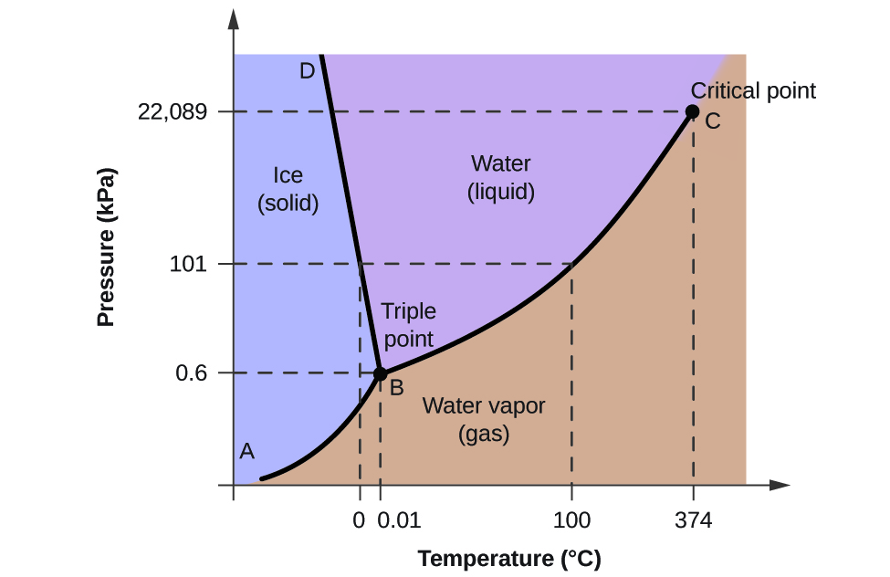
Soluble – The extent to which a substance can be dissolved in another substance.

Solution – A homogeneous mixture

Solvent – In a solution, the part that is “doing” the dissolving.

Solute - In a solution, the part that is “being” dissolved.

Suspension - A heterogeneous mixture in which the solute particles do not dissolve, but get suspended throughout the bulk of the solvent. Example: muddy water

Colloid – Similar to a suspension, but with much smaller particle sizes that are not usually detectable to the naked eye. Examples: milk, mayonnaise, gelatin

Tyndall Effect - A light scattering by particles in a colloid or in a very fine suspension. Example: headlights through fog

Electrolyte - A substance that produces an electrically conducting solution when dissolved in a polar solvent, such as water. The dissolved electrolyte separates into cations and anions, which disperse through the solvent. Example: NaCl

Non-electrolyte - A substance that does not exist in an ionic form in aqueous solution, but do dissolve. Example: Sugar

Solution equilibrium – A balance between dissolved and undissolved particles in a saturated solution.

Saturated solution - A solution in which the maximum amount of solvent has been dissolved. Any more solute added will sit as crystals on the bottom of the container.

Unsaturated solution- A solution that contains less than the maximum amount of solute that is capable of being dissolved.

Supersaturated solution- A solution that contains more than the maximum amount of solute that is capable of being dissolved at a given temperature. This can occur by allowing a warm saturated solution to slowly cool. The recrystallization of the excess dissolved solute in a supersaturated solution can be initiated by the addition of a tiny crystal of solute, called a seed crystal. This is how rock candy is made.

Solubility - The “measured” amount of a substance to dissolve in a specific amount of a solvent and form a solution. (See Concentration)

Concentration - The quantity of solute present in a given quantity of solution Concentrations are usually expressed in terms of %, ppm or Molarity.

Miscible – the ability of a liquid to mix with another. Example: alcohol and water

Immiscible - the inability of a liquid to mix with another. Example: oil and water

Hydration – The process of combining with water in order to dissolve a substance.

Solvated – The process of combining with “any liquid” in order to dissolve a substance

Heat of solution - The change in heat associated with the dissolving a solute in a solvent.

What are the 4 factors that affect the RATE of dissolving?
- Temperature
- Surface area
- Agitation or stirring
- (and if it’s a gas) the pressure

What is Henry’s law?
The amount of a given gas that dissolves in a given type and volume of liquid is directly proportional to the partial pressure of that gas. Therefore, concentration of a a gas dissolved in water is directly proportional to the amount of pressure exerted on that gas.

