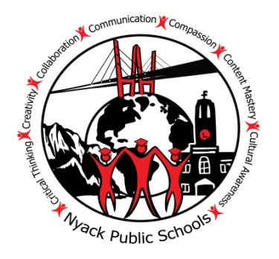
Building Bridges for today’s students to cross into tomorrow’s world with equity, innovation and optimism

Nyack Middle School • 98 South Highland Avenue • Nyack, NY 10960
Phone: (845)353-7200 • Fax: (845)353-0506 • Email: djohnson@nyackschools.org

David Johnson Lucrisha Addison-Harris Philip Kennedy

Principal Assistant Principal Dean of Students

October 2018
Dear Parents/Guardians:

In accordance with our district policy, I am required to inform you that Health Classes will be teaching a unit on Human Development and Sexuality. This unit may elicit certain questions at home that you may have to discuss. We will be covering the following topics:
- Sexually Transmitted Diseases (including HIV/AIDS)
- Transmission of Sexually Transmitted Diseases
- Prevention of Sexually Transmitted Diseases/Abstinence/ Contraception
- Role the immune system plays in preventing/combating diseases
- Puberty
- Reproductive Systems

It is recommended that all students take part in this unit. If you do not wish for your child to participate in the lesson(s) that address prevention methods he/she may be excused. Your child will then be given an alternate assignment and location with no penalty. Please sign and check off your choice below and return it. If you do not return this form, your child will participate in the class.

Please feel free to contact me if you have any questions or concerns.
Sincerely,

David Johnson
Principal
------------------------------------------------------------------------------------------------------------------------------------
Please return to Ms. Mannion by Monday, October 31, 2018:

I have read the above letter and I am aware of the information being discussed in this unit.

Student Name:__________________________________________
Parent Signature: _______________________________________ Date: ____________________

Please Check:
__________ I DO permit my child to take part in this unit.

__________ I DO NOT permit my child to take part in the lesson(s) that address prevention methods and I am aware that he/she will be receiving an alternate assignment and location.

Si ou bezwen enfòmasyon tradui an kreyòl,rele Jocelyne Abraham nan 353-7044.
Si le hace falta información traducida en español, llame a Yesenia Polanco 353-7042.

