**BLACK BUTTE HIGH SCHOOL**

**Home of the “Bears”**

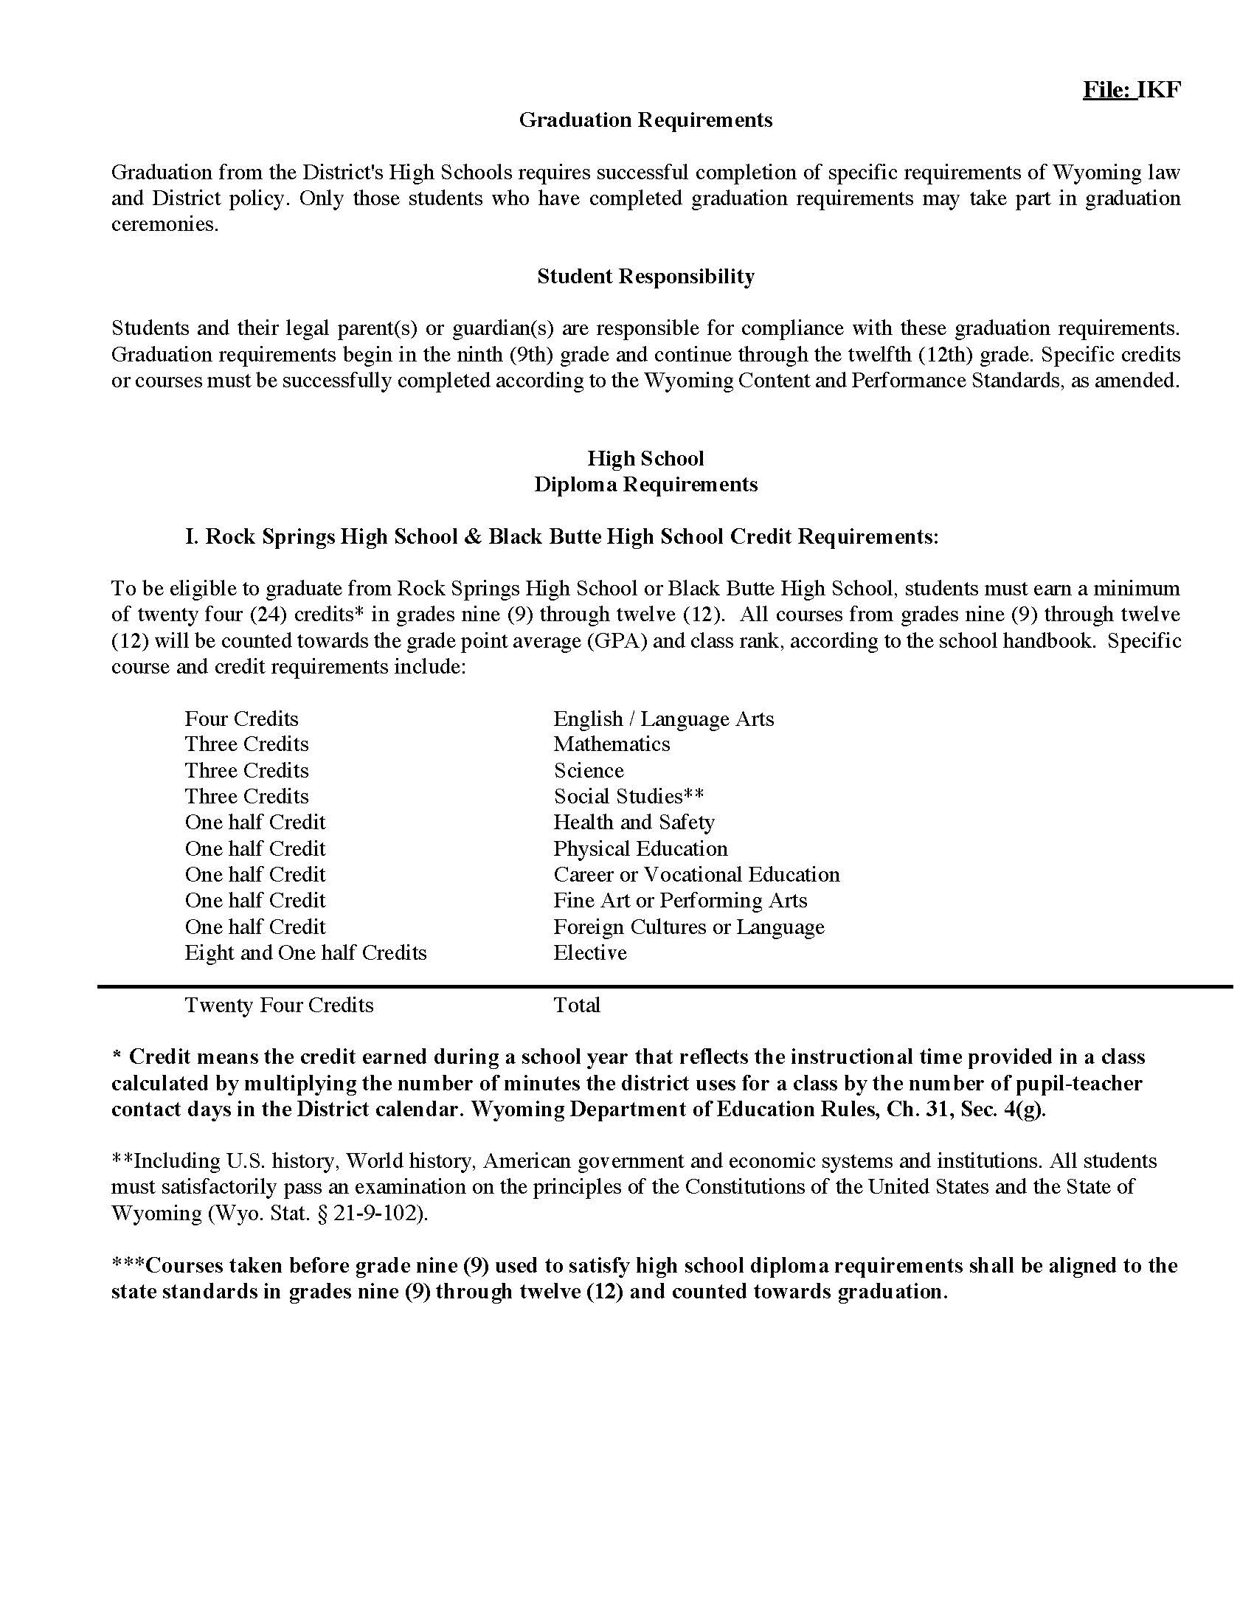

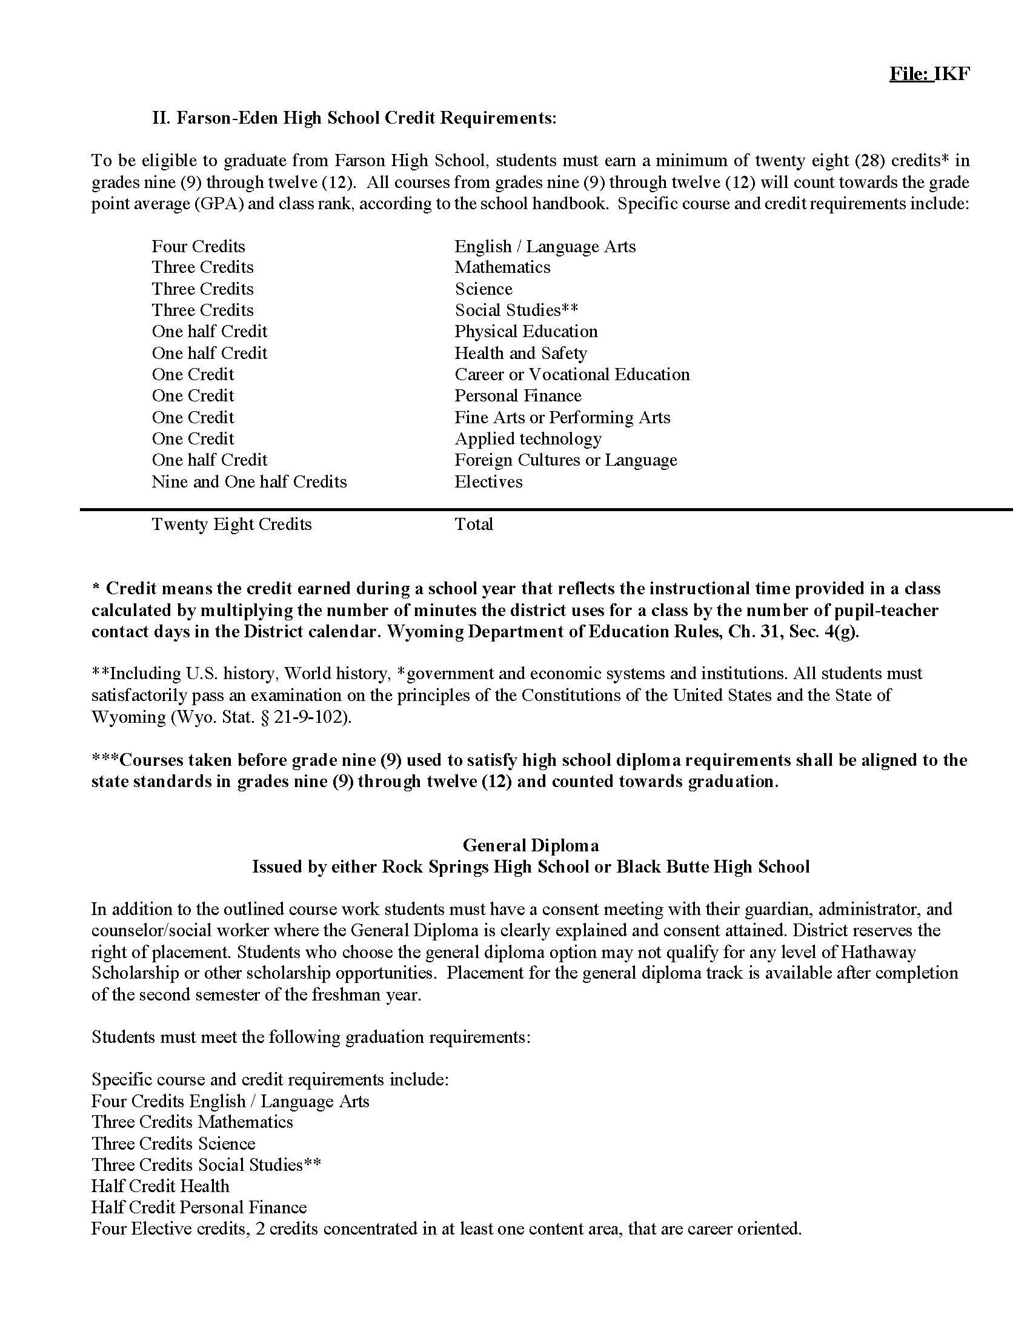

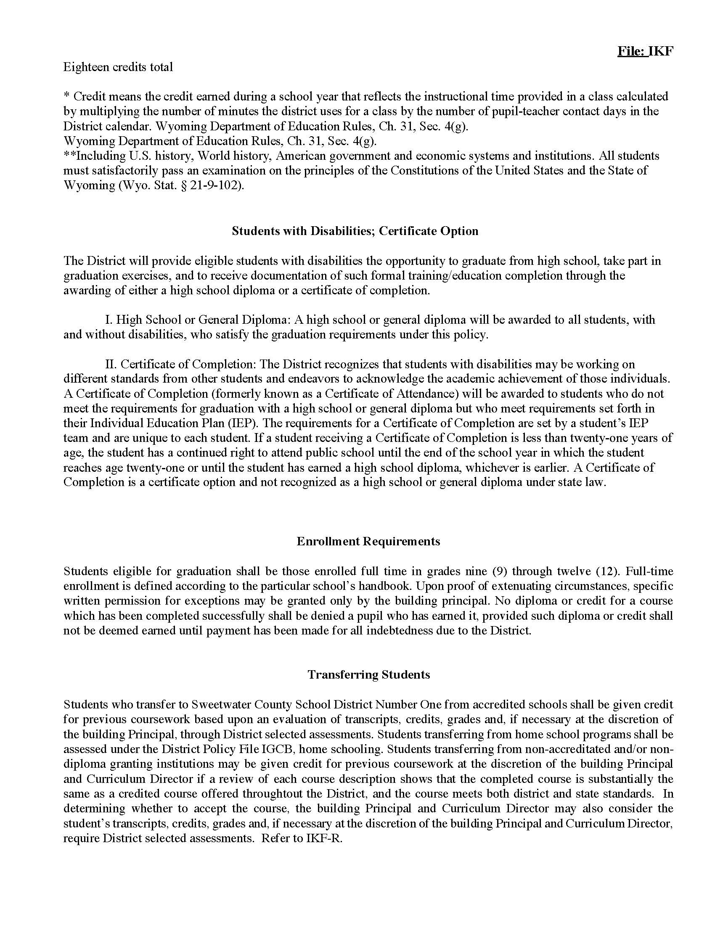

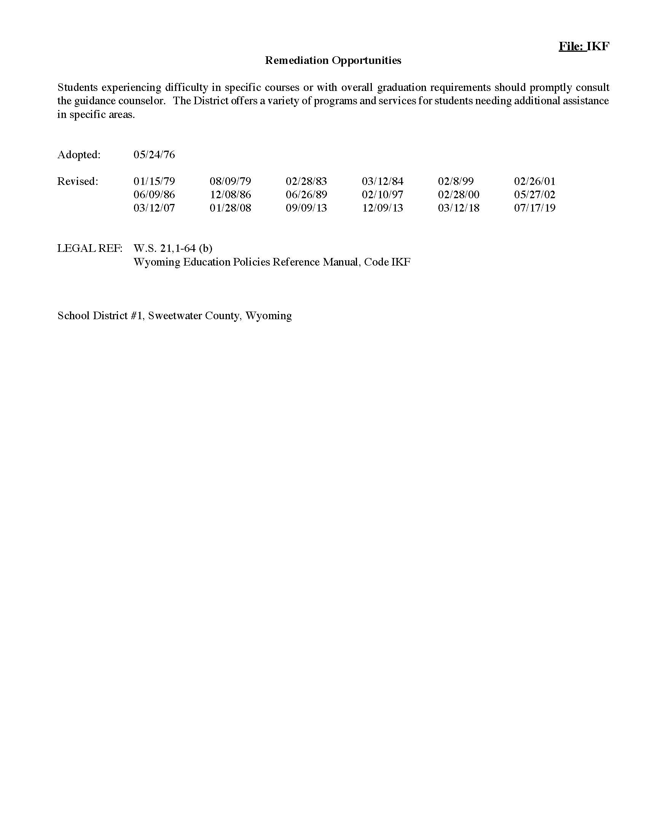

**Nondiscrimination Statement**

Sweetwater County School District Number One hereby notifies all of its employees, students and potential employees that it complies with the laws enforced by the Office of Civil Rights, including:

Title II of the American with Disabilities Act of 1990 which prohibits discrimination in all employment practices including job application procedures, hiring, firing, advancement, compensation, training and other terms, conditions and privileges of employment;

Title VI of the Civil Rights Act of 1964 which protects people from discrimination on the basis of race, color, or national origin;

Title IX of the Education Amendments of 1972 that prohibits discrimination on the basis of sex;

Section 504 of the Rehabilitation Act of 1973 prohibiting discrimination on the basis of handicap (disability); and the Age Discrimination Act of 1975 which prohibits discrimination on the basis of age.

All employees, students, and potential employees have the right to equal admission, access, treatment of employment in its educational programs and activities. Inquiries concerning Title II, Title VI, Title IX, Section 504, and the Age Discrimination Act may be referred to this District’s Superintendent of Schools, Human Resource Director, 504 Coordinator at (307)352-3400 or the Wyoming Department of Education, Office for Civil Rights Coordinator, 2nd Floor, Hathaway Building, Cheyenne, WY 82002-9950 or phone (307)777-6218. Inquiries many also be referred to the U.S. Department of Education, Office of Civil Rights, Region VIII, 244 Speer Boulevard, Suite 310, Denver, Colorado 80204-3582 or phone (303)844-3417. This publication will be provided in an alternative format upon request.

**Declaración de No Discriminación**

Por la presente, el Distrito Escolar Número Uno del Condado de Sweetwater notifica a todos sus empleados, estudiantes y empleados potenciales que cumple con las leyes impuestas por la Oficina de Derechos Civiles, que incluyen:

El Título II de la Ley de Estadounidenses con Discapacidades de 1990 que prohíbe la discriminación en todas las prácticas laborales, incluidos los procedimientos de solicitud de empleo, contratación, despido, ascenso, compensación, capacitación y otros términos, condiciones y privilegios de empleo;

El Título VI de la Ley de Derechos Civiles de 1964 que protege a las personas de la discriminación por motivos de raza, color u origen nacional;

El Título IX de las Enmiendas a la Educación de 1972 que prohíbe la discriminación por motivos de sexo;

Sección 504 de la Ley de Rehabilitación de 1973 que prohíbe la discriminación por motivos de discapacidad (incapacidad); y la Ley de Discriminación por Edad de 1975 que prohíbe la discriminación por motivos de edad.

Todos los empleados, estudiantes y empleados potenciales tienen derecho a la misma admisión, acceso y trato en el empleo en sus programas y actividades educativos. Las consultas relacionadas con el Título II, Título VI, Título IX, Sección 504 y la Ley de Discriminación por Edad se pueden remitir al Superintendente de Escuelas de este Distrito, Director de Recursos Humanos, Coordinador 504 al (307)352-3400 o al Departamento de Educación de Wyoming, Oficina para el Coordinador de Derechos Civiles, 2. ° piso, Edificio Hathaway, Cheyenne, WY 82002-9950 o por teléfono (307) 777-6218. Las consultas también pueden remitirse al Departamento de Educación de EE. UU., Oficina de Derechos Civiles, Región VIII, 244 Speer Boulevard, Suite 310, Denver, Colorado 80204-3582 o al teléfono (303) 844-3417. Esta publicación se proporcionará en un formato alternativo a pedido.

**Career and Technical Education**

Annual Public Notification of Nondiscrimination

Sweetwater School District Number One offers career and technical education programs in Construction, Design/Pre-Construction, Business Information Management, Teaching/Training, Accounting, Diagnostic Services, Restaurants & Food/Beverage Services-Management, Information Support & Services, Emergency & Fire Management Services, Pre-Engineering, Facility & Mobile Equipment Maintenance, Animal Systems, Production, Engineering & Technology, Power, Structural & Technical Systems, Banking Services. Admission to these programs is based on prerequisite standards as detailed in each course handbook.

It is the policy of Sweetwater School District Number One not to discriminate on the basis of race, color, national origin, sex or handicap in its vocational programs, services or activities as required by Title VI of the Civil Rights Act of 1964, as amended; Title IX of the Education Amendments of 1972; and Section 504 of the Rehabilitation Act of 1973, as amended.

It is the policy of Sweetwater School District Number One not to discriminate on the basis of race, color, national origin, sex, handicap, or age in its employment practices as required by Title VI of the Civil Rights Act of 1964, as amended; Title IX of the Education Amendments of 1972; the Age Discrimination Act of 1975, as amended; and Section 504 of the Rehabilitation Act of 1973, as amended. Below are links to the District non-discrimination policies:

* Policy File: AC - Nondiscrimination: <http://fmps.sw1.k12.wy.us/SuperContainer/RawData/DocuBin/2021/08/17/V-A19A9D68-7EFE-4122-A77E-81EA193EBE2B>
* Policy File: ACA - Nondiscrimination on the Basis of Sex: <http://fmps.sw1.k12.wy.us/SuperContainer/RawData/DocuBin/2021/08/17/V-EBE4B67D-4085-4AB0-B1B4-BD21C5D7542F>
* Policy File: ACA-R - Sexual Harassment: <http://fmps.sw1.k12.wy.us/SuperContainer/RawData/DocuBin/2020/08/12/V-C3CD6F89-28EB-45F1-8F50-250AFECC608D>
* Policy File: GBCH - Staff Harassment and Violence Policy: <http://fmps.sw1.k12.wy.us/SuperContainer/RawData/DocuBin/2019/06/25/V-688D2E00-8225-4525-A994-D2AA9FDCA9C2>
* Policy File: JFCB - Student Harassment and Violence Policy: <http://fmps.sw1.k12.wy.us/SuperContainer/RawData/DocuBin/2019/06/24/V-92F488A2-5230-47A4-BC0A-7A8223C7082B>

Sweetwater School District Number One will take steps to assure that lack of English language skills will not be a barrier to admission and participation in all educational and vocational programs.

For information about your rights or grievance procedures, contact the Civil Rights Compliance Coordinator at [civil.rights@sw1.k12.wy.us](mailto:civil.rights@sw1.k12.wy.us), (307)352-3400, contact the Title IX Coordinator at [title.IX@sw1.k12.wy.us](mailto:title.IX@sw1.k12.wy.us), (307)352-3400, and/or the Section 504 Coordinator at [section504@sw1.k12.wy.us](mailto:section504@sw1.k12.wy.us), (307)352-3400.

***LEA: Human Resource Director, Nicole Bolton***

***(307)352-3400 ext. 1285***

[***boltonn@sw1.k12.wy.us***](mailto:boltonn@sw1.k12.wy.us)

For further information on notice of non-discrimination, visit https://ocrcas.ed.gov/contact-ocr for the address and phone number of the office that serves your area, or call 1-800-421-3481.

[More information can be found here.](http://www2.ed.gov/about/offices/list/ocr/poloverview.html)

**Educación Técnica y Profesional**

Notificación Publica Anual de No Discriminación

El Distrito Escolar Número Uno de Sweetwater ofrece programas de educación técnica y profesional en Construcción, Diseño / Pre-Construcción, Gestión de Información Comercial, Enseñanza / Capacitación, Contabilidad, Servicios de Diagnóstico, Gestión de Servicios de Restaurantes y Alimentos / Bebidas, Soporte y Servicios de Información, Gestión de Servicios de Emergencias e Incendios, Pre-Ingeniería, Mantenimiento de Instalaciones y Equipos Móviles, Sistemas Animales, Producción, Ingeniería y Tecnología, Energía, Sistemas Estructurales y Técnicos, Servicios Bancarios. La admisión a estos programas se basa en los requisitos previos que se detallan en el manual de cada curso.

Es política del Distrito Escolar Número Uno de Sweetwater no discriminar por motivos de raza, color, origen nacional, sexo o discapacidad en sus programas, servicios o actividades vocacionales según lo requiere el Título VI de la Ley de Derechos Civiles de 1964, según enmienda; Título IX de las Enmiendas a la Educación de 1972; y la Sección 504 de la Ley de Rehabilitación de 1973, según enmienda.

Es política del Distrito Escolar Número Uno de Sweetwater no discriminar por motivos de raza, color, origen nacional, sexo, discapacidad o edad en sus prácticas laborales según lo requiere el Título VI de la Ley de Derechos Civiles de 1964, según enmienda; Título IX de las Enmiendas a la Educación de 1972; la Ley de Discriminación por Edad de 1975, según enmienda; y la Sección 504 de la Ley de Rehabilitación de 1973, según enmienda. A continuación, se encuentran los enlaces de las políticas de no discriminación del Distrito:

* Archivo de Política: AC – No Discriminación: <http://fmps.sw1.k12.wy.us/SuperContainer/RawData/DocuBin/2021/08/17/V-A19A9D68-7EFE-4122-A77E-81EA193EBE2B>
* Archivo de Política: ACA – No Discriminación por Motivos de Sexo <http://fmps.sw1.k12.wy.us/SuperContainer/RawData/DocuBin/2021/08/17/V-EBE4B67D-4085-4AB0-B1B4-BD21C5D7542F>
* Archivo de Política: ACA-R – Acoso Sexual: <http://fmps.sw1.k12.wy.us/SuperContainer/RawData/DocuBin/2020/08/12/V-C3CD6F89-28EB-45F1-8F50-250AFECC608D>
* Archivo de Política: GBCH – Acoso de Personal y Política de Violencia: <http://fmps.sw1.k12.wy.us/SuperContainer/RawData/DocuBin/2019/06/25/V-688D2E00-8225-4525-A994-D2AA9FDCA9C2>
* Archivo de Política: JFCB – Acoso Estudiantil y Política de Violencia: <http://fmps.sw1.k12.wy.us/SuperContainer/RawData/DocuBin/2019/06/24/V-92F488A2-5230-47A4-BC0A-7A8223C7082B>

El Distrito Escolar Número Uno de Sweetwater tomará medidas para asegurar que la falta de habilidades en el idioma inglés no sea una barrera para la admisión y participación en todos los programas educativos y vocacionales.

Para obtener información sobre sus derechos o procedimientos de queja, comuníquese con el Coordinador de Cumplimiento de Derechos Civiles en [civil.rights@sw1.k12.wy.us](mailto:civil.rights@sw1.k12.wy.us), (307)352-3400, comuníquese con el Coordinador de Título IX en [title.IX@sw1.k12.wy.us](mailto:title.IX@sw1.k12.wy.us), (307)352-3400, y /o el Coordinador de la Sección 504 en [section504@sw1.k12.wy.us](mailto:section504@sw1.k12.wy.us), (307)352-3400.

***LEA: Directora de Recursos Humanos, Nicole Bolton***

***(307)352-3400 ext. 1285***

[***boltonn@sw1.k12.wy.us***](mailto:boltonn@sw1.k12.wy.us)

Para obtener más información sobre el aviso de no discriminación, visite https://ocrcas.ed.gov/contact-ocr para obtener la dirección y el número de teléfono de la oficina que presta servicios en su área, o llame al 1-800-421-3481. [Puede encontrar más información aquí..](http://www2.ed.gov/about/offices/list/ocr/poloverview.html)

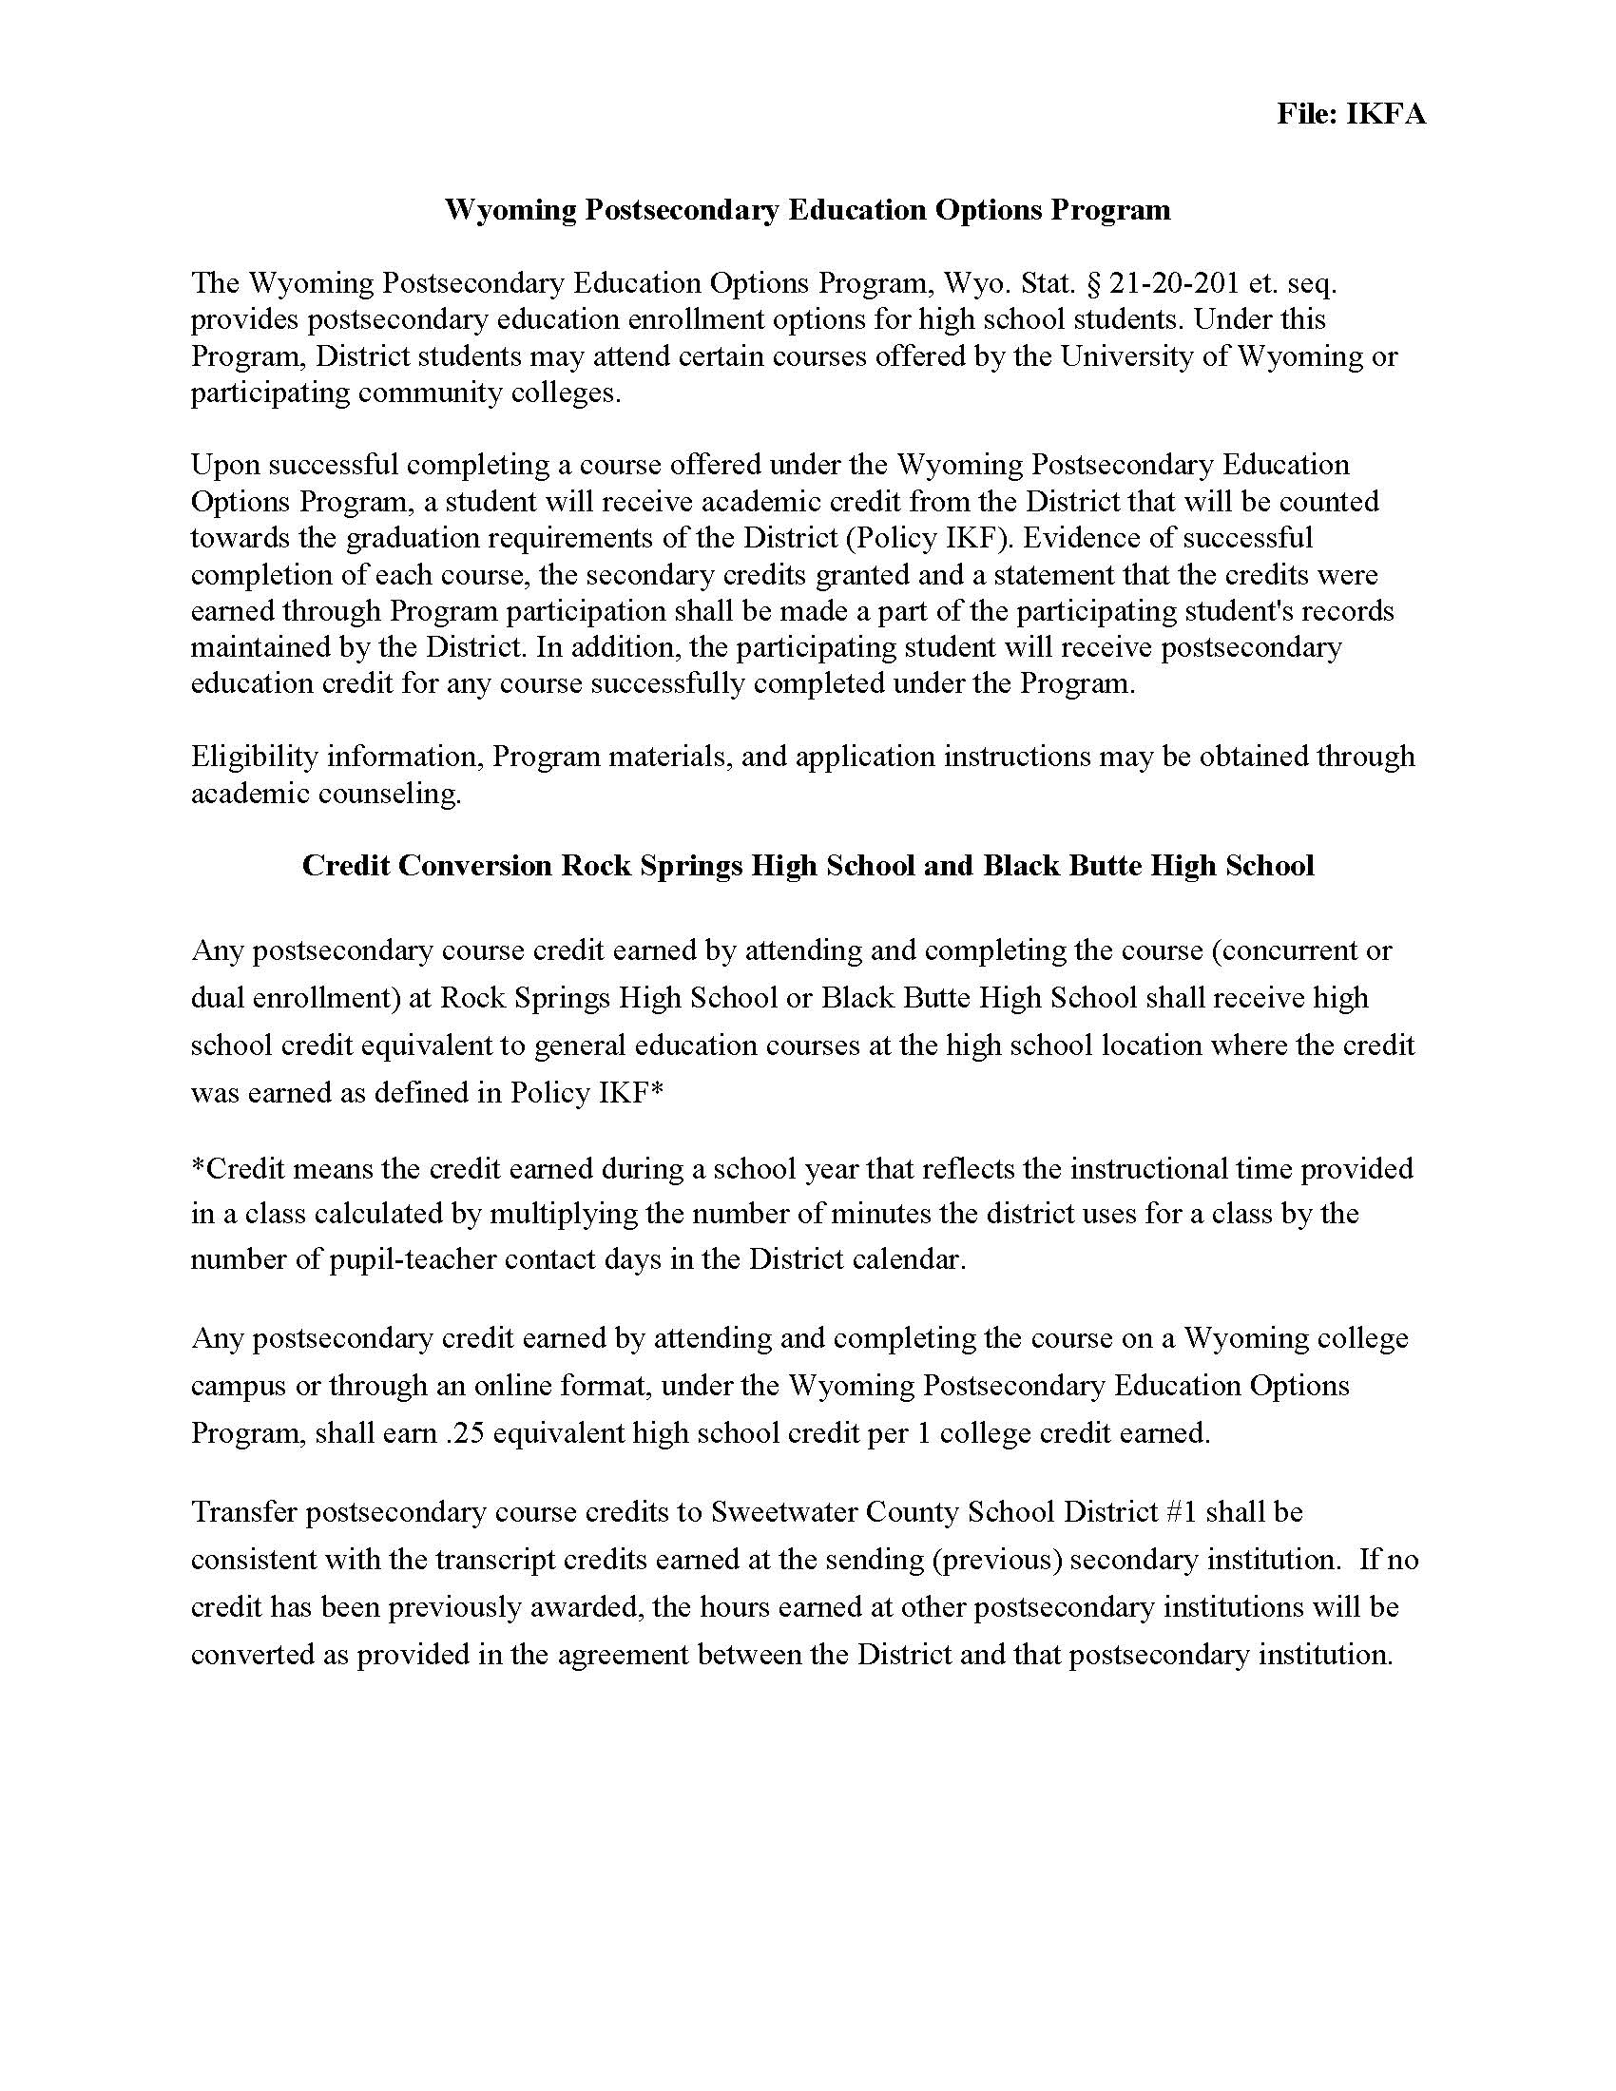

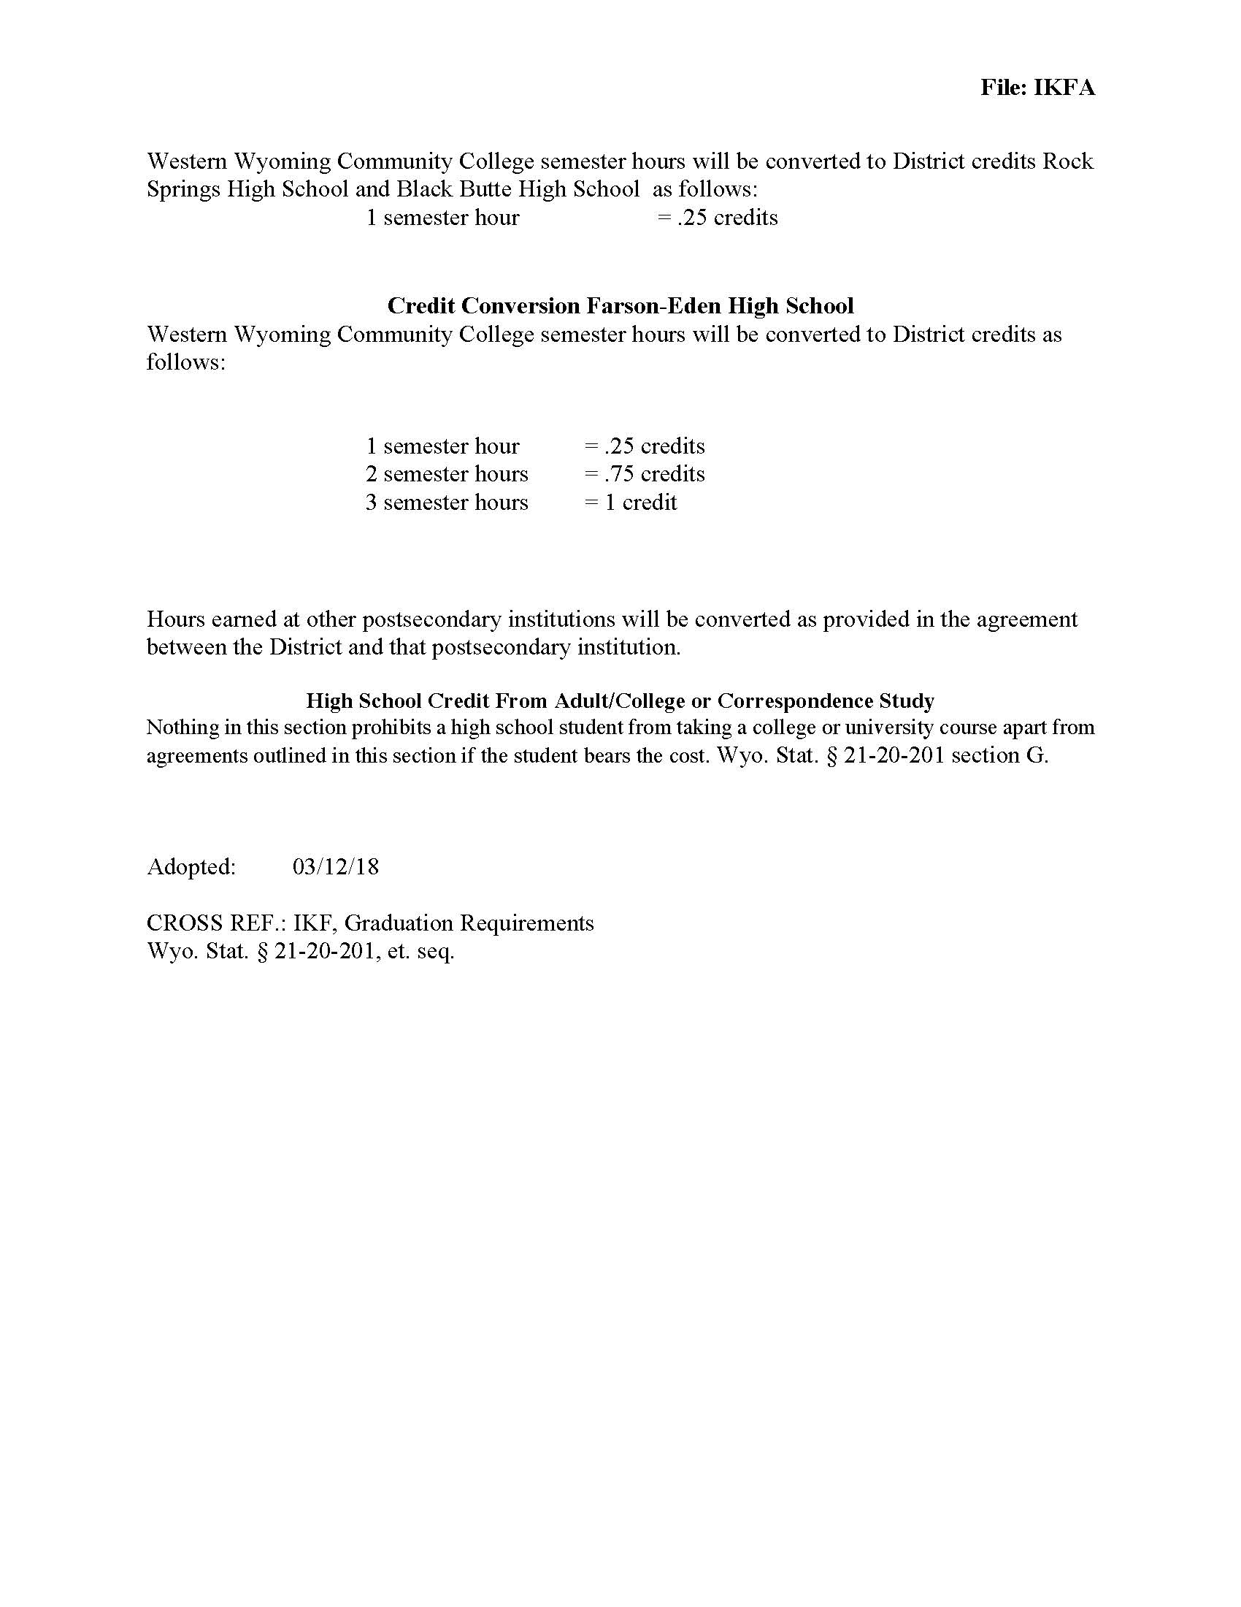

**FOUR-YEAR PLAN**

**Name:________________________________________________________________________________**

**Career Pathway:________________________________________________________________________**

***Plan Your Schedule for the Next Four Years***

|  |  |  |  |  |
| --- | --- | --- | --- | --- |
| ***Grade/Subject*** | ***9*** | ***10*** | ***11*** | ***12*** |
| **English** |  |  |  |  |
| ***Mathematics*** |  |  |  |  |
| ***Science*** |  |  |  |  |
| ***Social Studies*** |  |  |  |  |
| ***PE 1*** |  |  |  |  |
| ***Health*** |  |  |  |  |
| ***Foreign Language***  ***Cultures*** |  |  |  |  |
| ***Fine/Performing***  ***Arts*** |  |  |  |  |
| ***Career/Vocational*** |  |  |  |  |
| ***Elective*** |  |  |  |  |
| ***Elective*** |  |  |  |  |
| ***Elective*** |  |  |  |  |
| ***Total Credits*** |  |  |  |  |
|  | | | | |
| ***After graduation, I plan to:*** | | | | |

**BLACK BUTTE Course Fees**

Students may be asked to pay a charge for materials or services related to optional (elective) classes, activities, sports or projects.  Charges will be clearly listed in the course catalogs or schedule of fees.

Should financial problems become apparent for any individual student or student's family, the district will evaluate extenuating circumstances and make any appropriate adjustments to one or more fees or fines.  At the discretion of the building administrator, a portion or full amount may be waived by completing the Fees & Fines Waiver Form.  Adjustments will also be made in the tracking system. (This information will be included in the registration materials.)

REFERENCE POLICY FILE: JN and JN-R Fees and Fines

# Hathaway Requirements

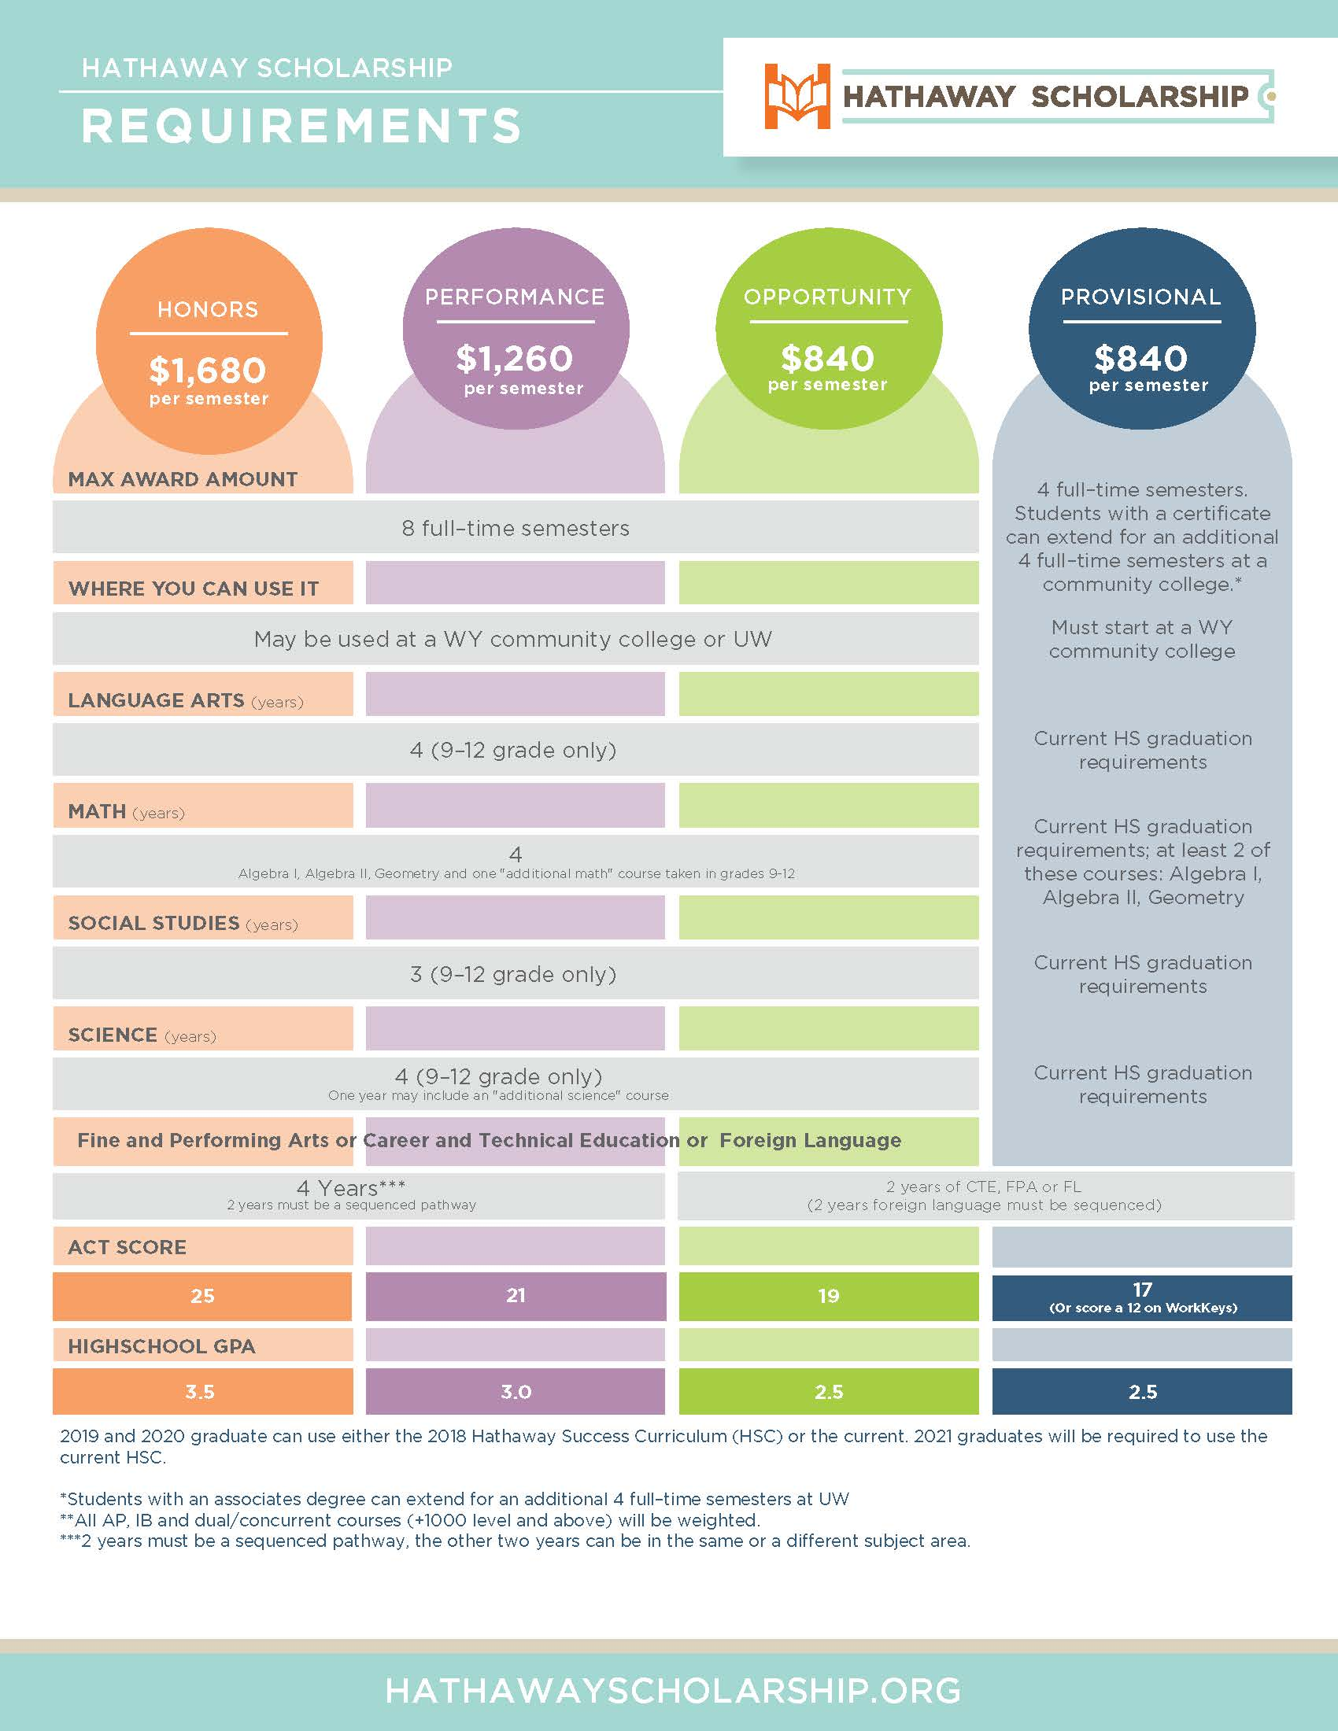

**ENGLISH LANGUAGE ARTS COURSES**

|  |  |  |  |  |  |  |
| --- | --- | --- | --- | --- | --- | --- |
| **Course Name AMERICAN LITERATURE** | | | | | | |
| GRADE: 11-12 | CREDIT: .5 | | LENGTH: | PREREQUISITE: Successful completion of Sophomore English | | |
| HATHAWAY APPROVED: Yes | | DELIVERY MODE: | | | | COLLEGE CREDIT COURSE NAME: Not Applicable |
| COURSE FEES: $0.00 | | | | |  | |
| PURPOSE STATEMENT: Students will analyze American literature from key eras and genres to evaluate the choices authors made in their compositions.  Students will compose writings in a variety of modes in order to evaluate authors in terms of their individual styles and effectiveness. | | | | | | |

|  |  |  |  |  |  |  |
| --- | --- | --- | --- | --- | --- | --- |
| **Course Name COLLEGE PREPARATION** | | | | | | |
| GRADE: 12 | CREDIT: .5 | | LENGTH: | PREREQUISITE: Junior English or English Literature or American Literature | | |
| HATHAWAY APPROVED: Yes | | DELIVERY MODE: | | | | COLLEGE CREDIT COURSE NAME: Not Applicable |
| COURSE FEES: $0.00 | | | | |  | |
| PURPOSE STATEMENT: Students will read modern literature to analyze and interpret authors’ intentions. Students will conduct inquiry-based research and also write extended analyses using MLA format with mastery of grammar and application of varied syntax. | | | | | | |

|  |  |  |  |  |  |  |
| --- | --- | --- | --- | --- | --- | --- |
| **Course Name CREATIVE WRITING** | | | | | | |
| GRADE: 12 | CREDIT: .5 | | LENGTH: | PREREQUISITE: Successful completion of junior level English | | |
| HATHAWAY APPROVED: Yes | | DELIVERY MODE: | | | | COLLEGE CREDIT COURSE NAME: Not Applicable |
| COURSE FEES: $0.00 | | | | |  | |
| PURPOSE STATEMENT: Students will explore and analyze writing styles in a diverse variety of texts, while consistently writing, editing, and publishing creative works in a multitude of genres. | | | | | | |

|  |  |  |  |  |  |  |
| --- | --- | --- | --- | --- | --- | --- |
| **Course Name ENGLISH FOR THE WORKPLACE** | | | | | | |
| GRADE: 12 | CREDIT: .5 | | LENGTH: | PREREQUISITE: Successful completion of junior level English | | |
| HATHAWAY APPROVED: Yes | | DELIVERY MODE: | | | | COLLEGE CREDIT COURSE NAME: Not Applicable |
| COURSE FEES: $0.00 | | | | |  | |
| PURPOSE STATEMENT: Students will demonstrate career ready communication and collaboration skills through the creation of a career portfolio. | | | | | | |

|  |  |  |  |  |  |  |
| --- | --- | --- | --- | --- | --- | --- |
| **Course Name ENGLISH LITERATURE** | | | | | | |
| GRADE: 11-12 | CREDIT: .5 | | LENGTH: | PREREQUISITE: Successful completion of Sophomore English | | |
| HATHAWAY APPROVED: Yes | | DELIVERY MODE: | | | | COLLEGE CREDIT COURSE NAME: Not Applicable |
| COURSE FEES: $0.00 | | | | |  | |
| PURPOSE STATEMENT: Using English iterature, students will draw conclusions and understand authors’ intentions. Students will show mastery of grammar conventions as they write in a variety of modes to present their unique analyses of texts and to create original pieces of creative writing. | | | | | | |

|  |  |  |  |  |  |  |
| --- | --- | --- | --- | --- | --- | --- |
| **Course Name JUNIOR ENGLISH** | | | | | | |
| GRADE: 11 | CREDIT: 1 | | LENGTH: 2 Semesters | PREREQUISITE: Successful completion of Sophomore English | | |
| HATHAWAY APPROVED: Yes | | DELIVERY MODE: | | | | COLLEGE CREDIT COURSE NAME: Not Applicable |
| COURSE FEES: $0.00 | | | | |  | |
| PURPOSE STATEMENT: Students will analyze literature from key eras and genres to evaluate the choices authors made in their compositions.  Students will compose writings in a variety of modes in order to evaluate authors in terms of their individual styles and effectiveness. | | | | | | |

|  |  |  |  |  |  |  |
| --- | --- | --- | --- | --- | --- | --- |
| **Course Name MYTHOLOGY** | | | | | | |
| GRADE: 12 | CREDIT: .5 | | LENGTH: | PREREQUISITE: Successful completion of junior level English | | |
| HATHAWAY APPROVED: Yes | | DELIVERY MODE: | | | | COLLEGE CREDIT COURSE NAME: Not Applicable |
| COURSE FEES: $0.00 | | | | |  | |
| PURPOSE STATEMENT: Students will analyze mythologies of early cultures to demonstrate how they have influenced modern cultures. Students will demonstrate cultural concepts through writing original narratives and analyses. | | | | | | |

|  |  |  |  |  |  |  |
| --- | --- | --- | --- | --- | --- | --- |
| **Course Name Sci-Fi Literature** | | | | | | |
| GRADE: 10-12 | CREDIT: .5 | | LENGTH: | PREREQUISITE: | | |
| HATHAWAY APPROVED: Yes | | DELIVERY MODE: | | | | COLLEGE CREDIT COURSE NAME: Not Applicable |
| COURSE FEES: $0.00 | | | | |  | |
| PURPOSE STATEMENT: Students will analyze various forms of science fiction in literature and  films to evaluate the choices authors made in their compositions. Students will compose writings in a variety of modes in order express their own ideas. Students will also evaluate authors in terms of their individual styles and effectiveness. | | | | | | |

|  |  |  |  |  |  |  |
| --- | --- | --- | --- | --- | --- | --- |
| **Course Name FRESHMAN ENGLISH** | | | | | | |
| GRADE: 9 | CREDIT: 1 | | LENGTH: | PREREQUISITE: NONE | | |
| HATHAWAY APPROVED: Yes | | DELIVERY MODE: | | | | COLLEGE CREDIT COURSE NAME: Not Applicable |
| COURSE FEES: $0.00 | | | | |  | |
| PURPOSE STATEMENT: Students will cite specific pieces of textual evidence to analyze the purpose, deeper meaning, and progression of ideas across a wide variety of texts.  Students will utilize various writing strategies to compose written works in multiple styles and formats, including inquiry-based research. Students will also investigate the language that they encounter daily, distinguishing between simple communication and more complex styles of speaking, to interpret the intended meaning behind diverse manners of expression. | | | | | | |

|  |  |  |  |  |  |  |
| --- | --- | --- | --- | --- | --- | --- |
| **Course Name SENIOR ENGLISH** | | | | | | |
| GRADE: 12 | CREDIT: 1 | | LENGTH: | PREREQUISITE: Successful completion of junior level English | | |
| HATHAWAY APPROVED: Yes | | DELIVERY MODE: | | | | COLLEGE CREDIT COURSE NAME: Not Applicable |
| COURSE FEES: $0.00 | | | | |  | |
| PURPOSE STATEMENT: Students will refine their analyses of various themes in traditional and nontraditional literature and demonstrate college and/or career ready writing skills. | | | | | | |

|  |  |  |  |  |  |  |
| --- | --- | --- | --- | --- | --- | --- |
| **Course Name SOPHOMORE ENGLISH** | | | | | | |
| GRADE: 10 | CREDIT: 1 | | LENGTH: | PREREQUISITE: Successful completion of Freshman English | | |
| HATHAWAY APPROVED: Yes | | DELIVERY MODE: | | | | COLLEGE CREDIT COURSE NAME: Not Applicable |
| COURSE FEES: $0.00 | | | | |  | |
| PURPOSE STATEMENT: Students will analyze multiple cultures, perspectives, and characters to deepen their appreciation of literature and interpret their world.  Students will produce original examples of figurative language to add creativity and connotative meaning to their writing.  Students will identify rhetorical language and incorporate it into their own writing.  Students will write accurately using various structures, paying particular attention to blending their own ideas with inquiry-based research. | | | | | | |

|  |  |  |  |  |  |  |
| --- | --- | --- | --- | --- | --- | --- |
| **Course Name VISUAL NARRATIVES** | | | | | | |
| GRADE: 10-12 | CREDIT: .5 | | LENGTH: | PREREQUISITE: Successful completion of Freshman English and Sophomore English | | |
| HATHAWAY APPROVED: Yes | | DELIVERY MODE: | | | | COLLEGE CREDIT COURSE NAME: Not Applicable |
| COURSE FEES: $0.00 | | | | |  | |
| PURPOSE STATEMENT: Students will study various storytelling devices to learn about historical eras, societal reactions to various narrative forms, expression of ideas using visuals as well as audio devices, use of imagination and innovation, as well as audience perceptions. Throughout the course, students will be required to observe, evaluate, and show critical thinking skills and analytical skills concerning art, literature, graphic novels, advertising, info-graphics, and films. | | | | | | |

|  |  |  |  |  |  |  |
| --- | --- | --- | --- | --- | --- | --- |
| **Course Name SOCIAL MEDIA** | | | | | | |
| GRADE: 9-12 | CREDIT: .5 | | LENGTH: | PREREQUISITE: NONE | | |
| HATHAWAY APPROVED: | | DELIVERY MODE: | | | | COLLEGE CREDIT COURSE NAME: Not Applicable |
| COURSE FEES: $0.00 | | | | |  | |
| PURPOSE STATEMENT: Students will investigate the origins and history of social media, examine how social media has evolved, assess how to find authenticity in an online world, and explain how a digital footprint works | | | | | | |

|  |  |  |  |  |  |  |
| --- | --- | --- | --- | --- | --- | --- |
| **Course Name THINKING AND LEARNING STRATEGIES** | | | | | | |
| GRADE: 9-10 | CREDIT: .5 | | LENGTH: | PREREQUISITE: NONE | | |
| HATHAWAY APPROVED: | | DELIVERY MODE: Classroom | | | | COLLEGE CREDIT COURSE NAME: Not Applicable |
| COURSE FEES: $0.00 | | | | |  | |
| PURPOSE STATEMENT: In this course, students will "coach" their "team" of thinking skills to meet academic challenges. Through reading, writing, and math activities, students develop critical thinking skills and test-taking strategies. Students also gain reading, writing, organization, and study strategies-- a powerful one-two punch for any student at any level! | | | | | | |

|  |  |  |  |  |  |  |
| --- | --- | --- | --- | --- | --- | --- |
| **Course Name Sports in Literature** | | | | | | |
| GRADE: 10-12 | CREDIT:.5 | | LENGTH: | PREREQUISITE: NONE | | |
| HATHAWAY APPROVED: Yes | | DELIVERY MODE: Classroom | | | | COLLEGE CREDIT COURSE NAME: Not Applicable |
| COURSE FEES: $0.00 | | | | |  | |
| PURPOSE STATEMENT: Students will examine they way the ideas thoughts, and emotions surrounding sports are expressed in writing and film, as well as various other mediums.  Sports provide a connection and outlet to the daily lives of millions around the globe.  In this course, we will aim to examine and analyze how sports took on such a large role in our society, what it has done historically to grown humankind, and why we are all so drawn in. | | | | | | |

**SCIENCE COURSES**

|  |  |  |  |  |  |  |
| --- | --- | --- | --- | --- | --- | --- |
| **Course Name BIOLOGY** | | | | | | |
| GRADE: 9-12 | CREDIT: 1 | | LENGTH: | PREREQUISITE: Physical Science | | |
| HATHAWAY APPROVED: Yes | | DELIVERY MODE: | | | | COLLEGE CREDIT COURSE NAME: Not Applicable |
| COURSE FEES: $0.00 | | | | |  | |
| PURPOSE STATEMENT: Students will explain the characteristics of life, identify and summarize hierarchical relationships and constructan explanation for how cellular organelles support life giving processes. Students will explain and summarize the ecological processes present in a balanced ecosystem, including modeling how energy flows and nutrients cycle. Students will identify the role of DNA in passing on heritable characteristics and analyze evidence in earth's historical record to explain evolution and speciation. Lastly, students will evaluate human impact on these  biological processes. | | | | | | |

|  |  |  |  |  |  |  |
| --- | --- | --- | --- | --- | --- | --- |
| **Course Name CHEMISTRY** | | | | | | |
| GRADE: 11-12 | CREDIT: 1 | | LENGTH: | PREREQUISITE: Successful Completion of Biology and Physical Science - these may be taken concurrently | | |
| HATHAWAY APPROVED: Yes | | DELIVERY MODE: | | | | COLLEGE CREDIT COURSE NAME: Not Applicable |
| COURSE FEES: $0.00 | | | | |  | |
| PURPOSE STATEMENT: Topics we will explore in the class include, but may not belimited to, structure of atoms, chemical bonding and reactions, and states of matter. Students will examine all of these both qualitatively and  quantitatively, at macroscopic and microscopic scales. | | | | | | |

|  |  |  |  |  |  |  |
| --- | --- | --- | --- | --- | --- | --- |
| **Course Name ENVIRONMENTAL SCIENCE** | | | | | | |
| GRADE: 10-12 | CREDIT: 1 | | LENGTH: | PREREQUISITE: Biology/ Physical Science | | |
| HATHAWAY APPROVED: Yes | | DELIVERY MODE: | | | | COLLEGE CREDIT COURSE NAME: Not Applicable |
| COURSE FEES: $0.00 | | | | |  | |
| PURPOSE STATEMENT: Students will analyze the fundamental physical and biological principles that govern the natural world. Students will identify and analyze environmental problems both natural and human made, to evaluate the  relative risks associated with these problems, and to examine alternative solutions for resolving and/or preventing them. | | | | | | |

|  |  |  |  |  |  |  |
| --- | --- | --- | --- | --- | --- | --- |
| **Course Name PHYSICAL SCIENCE** | | | | | | |
| GRADE: 9-12 | CREDIT: 1 | | LENGTH: | PREREQUISITE: NONE | | |
| HATHAWAY APPROVED: Yes | | DELIVERY MODE: | | | | COLLEGE CREDIT COURSE NAME: Not Applicable |
| COURSE FEES: $0.00 | | | | |  | |
| PURPOSE STATEMENT: Students will use models, evidence, and observations at the macroscopic level to explain matter and energy phenomena at an atomic level. | | | | | | |

|  |  |  |  |  |  |  |
| --- | --- | --- | --- | --- | --- | --- |
| **Course Name SCIENCE OF WYOMING** | | | | | | |
| GRADE: 10-12 | CREDIT: .5 | | LENGTH: | PREREQUISITE: Physical Science and Biology | | |
| HATHAWAY APPROVED: | | DELIVERY MODE: | | | | COLLEGE CREDIT COURSE NAME: Not Applicable |
| COURSE FEES: $0.00­­­ | | | | |  | |
| PURPOSE STATEMENT: In this unique class about the state of Wyoming, students will learn about the diversity of living things in the state, how our national parks show the geological history of the state, the contrasts between the  eastern side and western side in terms of weather and why it happens, and the ecosystems represented in the state. | | | | | | |

|  |  |  |  |  |  |  |
| --- | --- | --- | --- | --- | --- | --- |
| **Course Name CHEMISTRY OF FOOD** | | | | | | |
| GRADE: 10-12 | CREDIT: .5 | | LENGTH: | PREREQUISITE: Physical Science and Biology | | |
| HATHAWAY APPROVED: | | DELIVERY MODE: | | | | COLLEGE CREDIT COURSE NAME: Not Applicable |
| COURSE FEES: $0.00 | | | | |  | |
| PURPOSE STATEMENT: This semester long introductory chemistry course is for students who are interested in pursuing a career in the Culinary Arts. It is a basic class about food chemistry, food handling and food preparation from the perspective of safely preparing and handling food. | | | | | | |

**MATHEMATICS COURSES**

|  |  |  |  |  |  |  |
| --- | --- | --- | --- | --- | --- | --- |
| **Course Name PRE-ALGEBRA** | | | | | | |
| GRADE: 9-10 | CREDIT: 1 | | LENGTH: | PREREQUISITE: NONE | | |
| HATHAWAY APPROVED: Yes | | DELIVERY MODE: | | | | COLLEGE CREDIT COURSE NAME: Not Applicable |
| COURSE FEES: $0.00 | | | | |  | |
| PURPOSE STATEMENT: Students will fluently add, subtract, multiply, and divide fractions, integers, and decimals. Students will analyze graphs and properties of geometric figures. Students will interpret data from graphs and tables. | | | | | | |

|  |  |  |  |  |  |  |
| --- | --- | --- | --- | --- | --- | --- |
| **Course Name ALGEBRA I** | | | | | | |
| GRADE: 9-12 | CREDIT: 1 | | LENGTH: | PREREQUISITE: NONE | | |
| HATHAWAY APPROVED: Yes | | DELIVERY MODE: | | | | COLLEGE CREDIT COURSE NAME: Not Applicable |
| COURSE FEES: $0.00 | | | | |  | |
| PURPOSE STATEMENT: Students will solve linear equations and inequalities, graph linear functions, apply operations with algebraic expressions, solve systems of linear equations, simplify expressions using laws of exponents, classify polynomials and factor polynomial expressions to solve real life and mathematical problems. | | | | | | |

|  |  |  |  |  |  |  |
| --- | --- | --- | --- | --- | --- | --- |
| **Course Name ALGEBRA II** | | | | | | |
| GRADE: 9-12 | CREDIT: 1 | | LENGTH: | PREREQUISITE: Successful Completion of Algebra 1 and Geometry | | |
| HATHAWAY APPROVED: Yes | | DELIVERY MODE: | | | | COLLEGE CREDIT COURSE NAME: Not Applicable |
| COURSE FEES: $0.00 | | | | |  | |
| PURPOSE STATEMENT: Students will create and solve radical, rational, and polynomial equations within the real and complex number system. Students will also graph and analyze quadratic, exponential and logarithmic functions to broaden their mathematical understanding and problem-solving techniques | | | | | | |

|  |  |  |  |  |  |  |
| --- | --- | --- | --- | --- | --- | --- |
| **Course Name GEOMETRY** | | | | | | |
| GRADE: 9-12 | CREDIT: 1 | | LENGTH: | PREREQUISITE: Successful Completion of Algebra I | | |
| HATHAWAY APPROVED: Yes | | DELIVERY MODE: | | | | COLLEGE CREDIT COURSE NAME: Not Applicable |
| COURSE FEES: $0.00 | | | | |  | |
| PURPOSE STATEMENT: Students will apply inductive and deductive reasoning. Students will calculate lengths, areas, and volumes of plane and solid figures. Students will identify triangles and use their properties to solve equations, determine congruence and similarity. Students will apply sine, cosine and tangent ratios. Students will construct geometric shapes. Students will use all preceding skills to solve real life and mathematical problems | | | | | | |

|  |  |  |  |  |  |  |
| --- | --- | --- | --- | --- | --- | --- |
| **Course Name PRECALCULUS/TRIGONOMETRY** | | | | | | |
| GRADE: 10-12 | CREDIT: 1 | | LENGTH: | PREREQUISITE: Successful Completion of Algebra II | | |
| HATHAWAY APPROVED: Yes | | DELIVERY MODE: | | | | COLLEGE CREDIT COURSE NAME: Not Applicable |
| COURSE FEES: $0.00 | | | | |  | |
| PURPOSE STATEMENT: Pre-calculus is intended to provide the mathematical background needed for calculus. This course will provide a general introduction to functions, operations with function, inverse functions, and graphs of functions using standard graphs with transformations. It will include an extensive study of linear functions, polynomial functions (including new methods of solving polynomial equations), rational and radical functions, exponential and logarithmic functions, circular and trigonometric functions, sequences and series. The course will include extensive use of the graphing calculators. | | | | | | |

|  |  |  |  |  |  |  |
| --- | --- | --- | --- | --- | --- | --- |
| **Course Name CONSUMER/APPLIED MATH** | | | | | | |
| GRADE: 10-12 | CREDIT: 1 | | LENGTH: | PREREQUISITE: Successful Completion of Algebra I (could be taken concurrently) | | |
| HATHAWAY APPROVED: Yes | | DELIVERY MODE: | | | | COLLEGE CREDIT COURSE NAME: Not Applicable |
| COURSE FEES: $0.00 | | | | |  | |
| PURPOSE STATEMENT: Students will apply basic computational skills and mathematical concepts to essential consumer topics such as income, banking, saving, budgeting, taking out various types of loans, and expenses incurred in owning a business. Students will analyze and compare accounting and macro-economic concepts. | | | | | | |

**SOCIAL STUDIES COURSES**

|  |  |  |  |  |  |  |
| --- | --- | --- | --- | --- | --- | --- |
| **Course Name CRIMINAL JUSTICE** | | | | | | |
| GRADE: 10-12 | CREDIT: .5 | | LENGTH: | PREREQUISITE: NONE | | |
| HATHAWAY APPROVED: | | DELIVERY MODE: | | | | COLLEGE CREDIT COURSE NAME: Not Applicable |
| COURSE FEES: $0.00 | | | | |  | |
| PURPOSE STATEMENT: Students will analyze law and legal systems in the United States and will examine the extent to which the legal system affects daily life for American citizens. | | | | | | |

|  |  |  |  |  |  |  |
| --- | --- | --- | --- | --- | --- | --- |
| **Course Name AMERICAN GOVT AND ECONOMIC SYSTEMS** | | | | | | |
| GRADE: 11-12 | CREDIT: 1 | | LENGTH: | PREREQUISITE: NONE | | |
| HATHAWAY APPROVED: Yes | | DELIVERY MODE: | | | | COLLEGE CREDIT COURSE NAME: Not Applicable |
| COURSE FEES: $0.00 | | | | |  | |
| PURPOSE STATEMENT: Students will analyze the founding documents of the United States and  Wyoming and determine how they are applied to decisions made today. Students will demonstrate skills related to participation in the political process. Students will compare and contrast modern day world economic systems. | | | | | | |

|  |  |  |  |  |  |  |
| --- | --- | --- | --- | --- | --- | --- |
| **Course Name PSYCHOLOGY** | | | | | | |
| GRADE: 9-12 | CREDIT: .5 | | LENGTH: | PREREQUISITE: NONE | | |
| HATHAWAY APPROVED: Yes | | DELIVERY MODE: | | | | COLLEGE CREDIT COURSE NAME: Not Applicable |
| COURSE FEES: $0.00 | | | | |  | |
| PURPOSE STATEMENT: Students will analyze various examples of human behavior and apply psychological principles to everyday life. | | | | | | |

|  |  |  |  |  |  |  |
| --- | --- | --- | --- | --- | --- | --- |
| **Course Name INTRODUCTION TO SOCIOLOGY** | | | | | | |
| GRADE: 9-12 | CREDIT: .5 | | LENGTH: | PREREQUISITE: NONE | | |
| HATHAWAY APPROVED: Yes | | DELIVERY MODE: | | | | COLLEGE CREDIT COURSE NAME: Not Applicable |
| COURSE FEES: $0.00 | | | | |  | |
| PURPOSE STATEMENT: Students will apply Sociological principles in order to enhance their ability to examine the social world with a critical eye. Students will question assumptions, stereotypes and generalizations that underlie  conventional social interactions and beliefs about one’s world | | | | | | |

|  |  |  |  |  |  |  |
| --- | --- | --- | --- | --- | --- | --- |
| **Course Name UNITED STATES HISTORY** | | | | | | |
| GRADE: 10 | CREDIT: 1 | | LENGTH: | PREREQUISITE: NONE | | |
| HATHAWAY APPROVED: Yes | | DELIVERY MODE: | | | | COLLEGE CREDIT COURSE NAME: Not Applicable |
| COURSE FEES: $0.00 | | | | |  | |
| PURPOSE STATEMENT: Students will evaluate significant United States historical figures and events and examine how they continue to influence the modern world. Students will analyze resources from multiple perspectives in order to  interpret the impact of interrelationships, human experience, and cultural expression. | | | | | | |

|  |  |  |  |  |  |  |
| --- | --- | --- | --- | --- | --- | --- |
| **Course Name WORLD HISTORY** | | | | | | |
| GRADE: 9-12 | CREDIT: 1 | | LENGTH: | PREREQUISITE: NONE | | |
| HATHAWAY APPROVED: Yes | | DELIVERY MODE: | | | | COLLEGE CREDIT COURSE NAME: Not Applicable |
| COURSE FEES: $0.00 | | | | |  | |
| PURPOSE STATEMENT: Students will evaluate the effects of cultural diversity, debate the outcomes of global events, and analyze how and why our world has become interconnected. Students will examine how historical events  continue to influence the modern world. | | | | | | |

|  |  |  |  |  |  |  |
| --- | --- | --- | --- | --- | --- | --- |
| **Course Name GLOBAL STUDIES** | | | | | | |
| GRADE: 9-12 | CREDIT: 1 | | LENGTH: | PREREQUISITE: NONE | | |
| HATHAWAY APPROVED: Yes | | DELIVERY MODE: | | | | COLLEGE CREDIT COURSE NAME: Not Applicable |
| COURSE FEES: $0.00 | | | | |  | |
| PURPOSE STATEMENT: With more than seven billion people in the world today, there are a lot of stories out there. Human rights, the environment, global security, international economic systems, cultures, customs, and interactions around the globe are just some of the stories students will explore as they take on the role of a student reporter. | | | | | | |

|  |  |  |  |  |  |  |
| --- | --- | --- | --- | --- | --- | --- |
| **Course Name Native American Studies** | | | | | | |
| GRADE: 10-12 | CREDIT: .5 | | LENGTH: | PREREQUISITE: NONE | | |
| HATHAWAY APPROVED: | | DELIVERY MODE: | | | | COLLEGE CREDIT COURSE NAME: Not Applicable |
| COURSE FEES: $0.00 | | | | |  | |
| PURPOSE STATEMENT: Students will analyze law and legal systems in the United States and will examine the extent to which the legal system affects daily life for American citizens. | | | | | | |

**HEALTH/PE COURSES**

|  |  |  |  |  |  |  |
| --- | --- | --- | --- | --- | --- | --- |
| **Course Name HEALTH** | | | | | | |
| GRADE: 9-12 | CREDIT: .5 | | LENGTH: | PREREQUISITE: NONE | | |
| HATHAWAY APPROVED: | | DELIVERY MODE: | | | | COLLEGE CREDIT COURSE NAME: Not Applicable |
| COURSE FEES: $0.00 | | | | |  | |
| PURPOSE STATEMENT: Students will evaluate health information, products and resources; apply, analyze, and evaluate problem solving and decision-making skills. Students will demonstrate, evaluate and delineate effective communication skills and personal/social responsibility to enhance health and reduce health risks | | | | | | |

|  |  |  |  |  |  |  |
| --- | --- | --- | --- | --- | --- | --- |
| **Course Name PHYSICAL EDUCATION 1** | | | | | | |
| GRADE: 9-12 | CREDIT: .5 | | LENGTH: | PREREQUISITE: NONE | | |
| HATHAWAY APPROVED: | | DELIVERY MODE: | | | | COLLEGE CREDIT COURSE NAME: Not Applicable |
| COURSE FEES: $0.00 | | | | |  | |
| PURPOSE STATEMENT: Students will assess their individual physical fitness levels in the five health related fitness components (cardiovascular endurance, muscular strength, muscular endurance, flexibility and body composition). Students will set goals and evaluate progress related to the fitness components while participating in individual; dual, lifetime and team activities that help enhance physical fitness levels and promote self-expression and enjoyment. | | | | | | |

|  |  |  |  |  |  |  |
| --- | --- | --- | --- | --- | --- | --- |
| **Course Name PLAY FIT** | | | | | | |
| GRADE: 10-12 | CREDIT: .5 | | LENGTH: | PREREQUISITE: Successful Completion of Physical Education 1 or Physical Education 1/Swim | | |
| HATHAWAY APPROVED: | | DELIVERY MODE: | | | | COLLEGE CREDIT COURSE NAME: Not Applicable |
| COURSE FEES: $0.00 | | | | |  | |
| PURPOSE STATEMENT: Students will participate in game strategies/tactics and will demonstrate appropriate personal/social behavior while participating in a variety of dual, team and lifetime activities to enhance physical fitness levels and promote self-expression and enjoyment | | | | | | |

|  |  |  |  |  |  |  |
| --- | --- | --- | --- | --- | --- | --- |
| **Course Name PERSONAL FITNESS** | | | | | | |
| GRADE: 10-12 | CREDIT: .5 | | LENGTH: | PREREQUISITE: Successful Completion of Physical Education 1 or Physical Education 1/Swim | | |
| HATHAWAY APPROVED: | | DELIVERY MODE: | | | | COLLEGE CREDIT COURSE NAME: Not Applicable |
| COURSE FEES: $0.00 | | | | |  | |
| PURPOSE STATEMENT: In this Personal Fitness course, students are required to participate in weekly cardiovascular, flexibility and strength and endurance activities. Students who are unable to participate in such physical exercises will be unable to complete the requirements of this course. Students who have an Individualized Educational Plan (IEP) or some other physical limitation that prevents them from participating in physical activity should seek to enroll in an Adaptive Physical Education course. | | | | | | |

|  |  |  |  |  |  |  |
| --- | --- | --- | --- | --- | --- | --- |
| **Course Name LIFE MANGEMENT SKILLS** | | | | | | |
| GRADE: 9-12 | CREDIT: .5 | | LENGTH: | PREREQUISITE: NONE | | |
| HATHAWAY APPROVED: | | DELIVERY MODE: | | | | COLLEGE CREDIT COURSE NAME: Not Applicable |
| COURSE FEES: $0.00 | | | | |  | |
| PURPOSE STATEMENT: Each day hundreds of decisions are made, including important decisions that have a huge impact on personal life. Making good decisions is a whole lot easier for those who have the correct information before making those decisions. Being equipped with correct information will empower students to manage real issues, like quality nutrition, substance abuse, coping with stress, and sexual abstinence.  Good health is both mental and physical. Making good decisions starts with knowing the facts, understanding the consequences, and having the confidence to choose well. A series of signposts take students through the course, providing information, direction, and a little encouragement. Students learn to use important tools for communicating feelings and opinions. Other tools provide a foundation for becoming a savvy consumer in a world of advertising, credit cards, and focusing on earth-friendly practices that will help the environment.  This course comes with a long-term payoff. Learning to make good decisions now will set a positive direction to follow for the future. | | | | | | |

**VOCATIONAL EDUCATION COURSES**

|  |  |  |  |  |  |  |
| --- | --- | --- | --- | --- | --- | --- |
| **Course Name Business law** | | | | | | |
| GRADE: 9-12 | CREDIT: | | LENGTH: | PREREQUISITE: NONE | | |
| HATHAWAY APPROVED: Yes | | DELIVERY MODE: | | | | COLLEGE CREDIT COURSE NAME: Not Applicable |
| COURSE FEES: $0.00 | | | | |  | |
| PURPOSE STATEMENT: The students will verify their ability to compare, contrast, classify and differentiate and hypothesize basic elements, branches, factors and outcomes of business law [including but not limited to: history of law, common law, contract law,personal law, civil law, criminal law, crimes, torts, morals, ethics, equalityin law, trial procedures, equity of law and vehicles (buying, leasing, insuring, licensing)]. Students will analyze case studies of crimes, torts, contracts, buying, selling, insurance, employer-employee relations andthe legal aspects of renting and owning real estate. | | | | | | |

|  |  |  |  |  |  |  |
| --- | --- | --- | --- | --- | --- | --- |
| **Course Name COMPUTER INFORMATION SYSTEMS** | | | | | | |
| GRADE: 10-12 | CREDIT: .5 | | LENGTH: | PREREQUISITE: NONE | | |
| HATHAWAY APPROVED: Yes | | DELIVERY MODE: | | | | COLLEGE CREDIT COURSE NAME: Not Applicable |
| COURSE FEES: $0.00 | | | | |  | |
| PURPOSE STATEMENT: Provides a basic overview of current business and information systems and trends, and introduces students to fundamental skills required for today's business and academic environments. Emphasis is placed on developing proficient fundamental computer skills. The intention of this course is to prepare students to be successful both personally and professionally in an information based society. Digital Information Technology includes the exploration and use of: databases, the internet, spreadsheets, presentation applications, management of personal information and email, word processing and document manipulation, HTML, web page design, and the integration of these programs using software that meets industry standards. | | | | | | |

|  |  |  |  |  |  |  |
| --- | --- | --- | --- | --- | --- | --- |
| **Course Name COMPUTER I** | | | | | | |
| GRADE: 9-12 | CREDIT: .5 | | LENGTH: | PREREQUISITE: NONE | | |
| HATHAWAY APPROVED: Yes | | DELIVERY MODE: | | | | COLLEGE CREDIT COURSE NAME: Not Applicable |
| COURSE FEES: $0.00 | | | | |  | |
| PURPOSE STATEMENT: This course offers individualized instruction on integrated software common in the business world. Lessons start at a beginning level and build to an intermediate level using an integrated software suite, such as  Microsoft Office and the Google Suite. Applications will include: word processing, spreadsheets, database, presentations, and several lessons that integrate two or more applications. | | | | | | |

|  |  |  |  |  |  |  |
| --- | --- | --- | --- | --- | --- | --- |
| **Course Name WEB PAGE DESIGN I** | | | | | | |
| GRADE: 9-12 | CREDIT: .5 | | LENGTH: | PREREQUISITE: NONE | | |
| HATHAWAY APPROVED: Yes | | DELIVERY MODE: | | | | COLLEGE CREDIT COURSE NAME: Not Applicable |
| COURSE FEES: $0.00 | | | | |  | |
| PURPOSE STATEMENT: Students will learn some of the most important topics of a prominent web programming language, from the basics of creating web pages with graphics, links, tables, forms, controlling page layout with frames, to more advanced topics including cascading style sheets, programming objects and events, and creating a multimedia web page. | | | | | | |

|  |  |  |  |  |  |  |
| --- | --- | --- | --- | --- | --- | --- |
| **Course Name PERSONAL FINANCE/CAREERS** | | | | | | |
| GRADE: 10-12 | CREDIT: .5 | | LENGTH: | PREREQUISITE: NONE | | |
| HATHAWAY APPROVED: Yes | | DELIVERY MODE: | | | | COLLEGE CREDIT COURSE NAME: Not Applicable |
| COURSE FEES: $0.00 | | | | |  | |
| PURPOSE STATEMENT: Students will evaluate basic economic concepts related to the students’ roles as consumers, producers, and citizens. Students will demonstrate how to shape their own financial lives by developing financial skills for personal and family well-being; such as management of resources,  financial services, responsible use of credit, consumer decisions, and  consumer rights and responsibilities. | | | | | | |

|  |  |  |  |  |  |  |
| --- | --- | --- | --- | --- | --- | --- |
| **Course Name COMPUTER AIDED DRAFTING I** | | | | | | |
| GRADE: 9-12 | CREDIT: .5 | | LENGTH: | PREREQUISITE: NONE | | |
| HATHAWAY APPROVED: Yes | | DELIVERY MODE: | | | | COLLEGE CREDIT COURSE NAME: Not Applicable |
| COURSE FEES: $10 | | | | |  | |
| PURPOSE STATEMENT: Students will apply accepted drafting standards in the basic construction of 2D drawings using AutoCAD software. | | | | | | |

|  |  |  |  |  |  |  |
| --- | --- | --- | --- | --- | --- | --- |
| **Course Name COMPUTER AIDED DRAFTING II** | | | | | | |
| GRADE: 9-12 | CREDIT: .5 | | LENGTH: | PREREQUISITE: Computer Aided Drafting I | | |
| HATHAWAY APPROVED: Yes | | DELIVERY MODE: | | | | COLLEGE CREDIT COURSE NAME: Not Applicable |
| COURSE FEES: $10 | | | | |  | |
| PURPOSE STATEMENT: Students will apply accepted drafting standards in the construction of 2D mechanical sectioning  and auxiliary drawings, working drawings, technical illustration, and the geometric construction of both parallel and radial line  developments using CAD software. | | | | | | |

|  |  |  |  |  |  |  |
| --- | --- | --- | --- | --- | --- | --- |
| **Course Name WORK STUDY EXPERIENCE** | | | | | | |
| GRADE: 9-12 | CREDIT: .5 | | LENGTH: | PREREQUISITE: Must be employed | | |
| HATHAWAY APPROVED: Yes | | DELIVERY MODE: | | | | COLLEGE CREDIT COURSE NAME: Not Applicable |
| COURSE FEES: $0.00 | | | | |  | |
| PURPOSE STATEMENT: This class is designed for any BBHS student who wants to improve work readiness and employability skills to prepare for either college or work after high school. Students may use their jobs to gain valuable work skills and high school  credit. Students may earn .25 credits per quarter for successful completion of course. Students must work a minimum of 300 hours per semester and submit required paperwork to verify work hours. | | | | | | |

|  |  |  |  |  |  |  |
| --- | --- | --- | --- | --- | --- | --- |
| **Course Name EXPLORING CHILDHOOD I** | | | | | | |
| GRADE: 10-12 | CREDIT: .5 | | LENGTH: | PREREQUISITE: NONE | | |
| HATHAWAY APPROVED: Yes | | DELIVERY MODE: | | | | COLLEGE CREDIT COURSE NAME: Not Applicable |
| COURSE FEES: $0.00 | | | | |  | |
| PURPOSE STATEMENT: Students will evaluate the significant roles and responsibilities of parenting and analyze physical and emotional factors related to becoming a parent. Students will analyze factors that impact human  growth and development and the development of children from conception to preschool age. Students will apply safety and health practices when interacting with children and explore career opportunities working with children. | | | | | | |

|  |  |  |  |  |  |  |
| --- | --- | --- | --- | --- | --- | --- |
| **Course Name BBHS INTERNSHIP** | | | | | | |
| GRADE: 10-12 | CREDIT: .5 | | LENGTH: | PREREQUISITE: NONE | | |
| HATHAWAY APPROVED: Yes | | DELIVERY MODE: | | | | COLLEGE CREDIT COURSE NAME: Not Applicable |
| COURSE FEES: $0.00 | | | | |  | |
| PURPOSE STATEMENT: Black Butte High School Internship program is dedicated to helping students stand out and take control of their futures. BBHS Internship Program seeks to enhance the education of students through providing relevant field experience prior to graduation. Along with enhancing the educational experience of the student, the internship program will help students with real world skills that the job market is looking for, allowing for the creation of job experience, and providing practical knowledge of future skills required to be successful in any career. | | | | | | |

|  |  |  |  |  |  |  |
| --- | --- | --- | --- | --- | --- | --- |
| **Course Name DIGITAL INFORMATION TECHNOLOGY** | | | | | | |
| GRADE: 9-12 | CREDIT: 1 | | LENGTH: | PREREQUISITE: NONE | | |
| HATHAWAY APPROVED: Yes | | DELIVERY MODE: | | | | COLLEGE CREDIT COURSE NAME: Not Applicable |
| COURSE FEES: $0.00 | | | | |  | |
| PURPOSE STATEMENT: Students will compare computer applications, practice web design, utilize emerging technologies, operating systems, and develop skills in project management, communication methods. Students will analyze Information Technology careers and what skills they need to pursue those careers. Students will analyze how different skills relate to various career paths. | | | | | | |

|  |  |  |  |  |  |  |
| --- | --- | --- | --- | --- | --- | --- |
| **Course Name Consumer Autos** | | | | | | |
| GRADE: 9-12 | CREDIT: .5 | | LENGTH: | PREREQUISITE: NONE | | |
| HATHAWAY APPROVED: Yes | | DELIVERY MODE: | | | | COLLEGE CREDIT COURSE NAME: Not Applicable |
| COURSE FEES: $10.00 | | | | |  | |
| PURPOSE STATEMENT: Students will compare computer applications, practice web design, utilize emerging technologies, operating systems, and develop skills in project management, communication methods. Students will analyze Information Technology careers and what skills they need to pursue those careers. Students will analyze how different skills relate to various career paths. | | | | | | |

**FINE ARTS COURSES**

|  |  |  |  |  |  |  |
| --- | --- | --- | --- | --- | --- | --- |
| **Course Name ART I** | | | | | | |
| GRADE: 9-12 | CREDIT: .5 | | LENGTH: | PREREQUISITE: NONE | | |
| HATHAWAY APPROVED: Yes | | DELIVERY MODE: | | | | COLLEGE CREDIT COURSE NAME: Not Applicable |
| COURSE FEES: $0.00 | | | | |  | |
| PURPOSE STATEMENT: Students will apply basic drawing, painting, and sculpture skills and techniques to create and revise original works of art. Students will apply the elements and principles of design to their art and discuss and justify their choices | | | | | | |

|  |  |  |  |  |  |  |
| --- | --- | --- | --- | --- | --- | --- |
| **Course Name ART II** | | | | | | |
| GRADE: 9-12 | CREDIT: .5 | | LENGTH: | PREREQUISITE: Successful Completion of Art I | | |
| HATHAWAY APPROVED: Yes | | DELIVERY MODE: | | | | COLLEGE CREDIT COURSE NAME: Not Applicable |
| COURSE FEES: $0.00 | | | | |  | |
| PURPOSE STATEMENT: Students will produce original works of art by using proper drawing, painting, sculpture, and mixed media techniques and processes. Students will compose their art pieces using elements and principles of  design and a variety of compositional strategies. Students will critique reference artists and their own art using the four steps of the critique process: describe, analyze, interpret, judge. Students will research and discuss a variety of historical and contemporary artists in an effort to develop their own individual style. | | | | | | |

|  |  |  |  |  |  |  |
| --- | --- | --- | --- | --- | --- | --- |
| **Course Name COMPUTER GRAPHIC DESIGN i** | | | | | | |
| GRADE: 9-12 | CREDIT: .5 | | LENGTH: | PREREQUISITE: NONE | | |
| HATHAWAY APPROVED: Yes | | DELIVERY MODE: | | | | COLLEGE CREDIT COURSE NAME: Not Applicable |
| COURSE FEES: $0.00 | | | | |  | |
| PURPOSE STATEMENT: Students in this class will utilize computer graphics programs to begin to learn the fundamentals of visual communication through graphic design and original fine art. Art fundamentals and Elements and Principles of Design will be stressed. Software emphasizes an introduction to the Paint Shop Pro, Animation Shop, and/or Photoshop programs. Students  will be provided with opportunities to use problem solving and critical thinking skills with their original design projects. Portfolio development will be encouraged. | | | | | | |

**PERFORMING ARTS COURSES**

|  |  |  |  |  |  |  |
| --- | --- | --- | --- | --- | --- | --- |
| **Course Name INTRODUCTION TO MUSICAL INSTRUMENTS** | | | | | | |
| GRADE: 9-12 | CREDIT: .5 | | LENGTH: | PREREQUISITE: Enter Pre-requisite or NONE | | |
| HATHAWAY APPROVED: Yes | | DELIVERY MODE: | | | | COLLEGE CREDIT COURSE NAME: Enter WWCC course name or Not Applicable |
| COURSE FEES: $0.00 | | | | |  | |
| PURPOSE STATEMENT: Students in this course will have the opportunity to perform music on a wide variety of musical instruments, from bucket drums and body percussion to handbells and didgeridoos.  No previous knowledge of or participation in music is required.   Class requirements will include participation in musical exercises each day, as well as a possible performance at the end of the semester. | | | | | | |

|  |  |  |  |  |  |  |
| --- | --- | --- | --- | --- | --- | --- |
| **Course Name GUITAR I** | | | | | | |
| GRADE: 9-12 | CREDIT: .5 | | LENGTH: | PREREQUISITE: Enter Pre-requisite or NONE | | |
| HATHAWAY APPROVED: Yes | | DELIVERY MODE: | | | | COLLEGE CREDIT COURSE NAME: Enter WWCC course name or Not Applicable |
| COURSE FEES: $0.00 | | | | |  | |
| PURPOSE STATEMENT: Students will develop basic techniques on guitar including strum patterns, basic chords, melodies in first position, and major scales. Students will apply these fundamental techniques and musicianship to  ensemble playing. | | | | | | |

|  |  |  |  |  |  |  |
| --- | --- | --- | --- | --- | --- | --- |
| **Course Name GUITAR II** | | | | | | |
| GRADE: 9-12 | CREDIT: .5 | | LENGTH: | PREREQUISITE: Enter Pre-requisite or NONE | | |
| HATHAWAY APPROVED: Yes | | DELIVERY MODE: | | | | COLLEGE CREDIT COURSE NAME: Enter WWCC course name or Not Applicable |
| COURSE FEES: $0.00 | | | | |  | |
| PURPOSE STATEMENT: Students will develop basic techniques on guitar including strum patterns, basic chords, melodies in first position, and major scales. Students will apply these fundamental techniques and musicianship to  ensemble playing. | | | | | | |

|  |  |  |  |  |  |  |
| --- | --- | --- | --- | --- | --- | --- |
| **Course Name GUITAR III** | | | | | | |
| GRADE: 9-12 | CREDIT: .5 | | LENGTH: | PREREQUISITE: Enter Pre-requisite or NONE | | |
| HATHAWAY APPROVED: Yes | | DELIVERY MODE: | | | | COLLEGE CREDIT COURSE NAME: Enter WWCC course name or Not Applicable |
| COURSE FEES: $0.00 | | | | |  | |
| PURPOSE STATEMENT: Students will develop basic techniques on guitar including strum patterns, basic chords, melodies in first position, and major scales. Students will apply these fundamental techniques and musicianship to  ensemble playing. | | | | | | |

**FOREIGN LANGUAGE COURSES**

|  |  |  |  |  |  |  |
| --- | --- | --- | --- | --- | --- | --- |
| **Course Name Spanish I** | | | | | | |
| GRADE: 9-12 | CREDIT: 1 | | LENGTH: | PREREQUISITE: NONE | | |
| HATHAWAY APPROVED: Yes | | DELIVERY MODE: | | | | COLLEGE CREDIT COURSE NAME: Not Applicable |
| COURSE FEES: $0.00 | | | | |  | |
| PURPOSE STATEMENT: Students will communicate in the target language using simple sentences to ask and answer questions.  Students will focus on self, family and friends using verbs and descriptive words.  Students will compare and contrast cultures. | | | | | | |

|  |  |  |  |  |  |  |
| --- | --- | --- | --- | --- | --- | --- |
| **Course Name Spanish II** | | | | | | |
| GRADE: 10-12 | CREDIT: 1 | | LENGTH: | PREREQUISITE: Successful Completion of Spanish I | | |
| HATHAWAY APPROVED: Yes | | DELIVERY MODE: | | | | COLLEGE CREDIT COURSE NAME: Not Applicable |
| COURSE FEES: $0.00 | | | | |  | |
| PURPOSE STATEMENT: Students will communicate both orally and written in the target language asking and answering questions about a variety of real life situations, individual daily routines, and home and community life in  both present and past verb forms. Students will compare and contrast cultures while exploring regional differences in the studied topics. | | | | | | |

|  |  |  |  |  |  |  |
| --- | --- | --- | --- | --- | --- | --- |
| **Course Name WORLD CULTURES** | | | | | | |
| GRADE: 9-12 | CREDIT: .5 | | LENGTH: | PREREQUISITE: NONE | | |
| HATHAWAY APPROVED: Yes | | DELIVERY MODE: | | | | COLLEGE CREDIT COURSE NAME: Not Applicable |
| COURSE FEES: $0.00 | | | | |  | |
| PURPOSE STATEMENT: Students will investigate Spanish, German, and French speaking cultures.  Students will discuss geographical locations, governmental influences, culturally specific traditions, and cultural products.  Students will use practical phrases in the language of the target culture.  Students will use technology to access authentic culture-based research. | | | | | | |

**STUDENT AIDE COURSES**

|  |  |  |  |  |  |  |
| --- | --- | --- | --- | --- | --- | --- |
| **Course Name Guided Study Program** | | | | | | |
| GRADE: 9-12 | CREDIT: 1 | | LENGTH: | PREREQUISITE: NONE | | |
| HATHAWAY APPROVED: Yes | | DELIVERY MODE: | | | | COLLEGE CREDIT COURSE NAME: Not Applicable |
| COURSE FEES: $0.00 | | | | |  | |
| PURPOSE STATEMENT: Students will compare computer applications, practice web design, utilize emerging technologies, operating systems, and develop skills in project management, communication methods. Students will analyze Information Technology careers and what skills they need to pursue those careers. Students will analyze how different skills relate to various career paths. | | | | | | |

|  |  |  |  |  |  |  |
| --- | --- | --- | --- | --- | --- | --- |
| **Course Name Teacher Aide** | | | | | | |
| GRADE: 11-12 | CREDIT: .25 | | LENGTH:  1 Semester | PREREQUISITE: Teacher Approval | | |
| HATHAWAY APPROVED:  No | | DELIVERY MODE: Classroom | | | | COLLEGE CREDIT COURSE NAME: Not Applicable |
| COURSE FEES: $0.00 | | | | |  | |
| PURPOSE STATEMENT: Teacher instructs student on numerous tasks.  **NOTE: A Student may apply only one-half (.5) credit of aide work toward completion of the credits necessary for graduation from Black Butte High School. This credit may not be transferable to other high schools**. | | | | | | |