Vocabulary Study Cards
Directions: To help you study, cut out the cards and use to match the correct terms.
The height of a transverse wave from the center to a crest or trough | Amplitude
The distance between two corresponding parts of a wave | Wavelength
The number of complete waves that pass a give point in a certain amount of time | Frequency
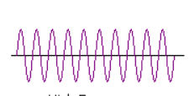 | High Pitch
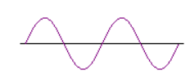 | Low Pitch
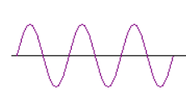 | Higher Amplitude
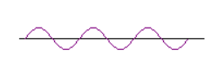 | Lower Amplitude
To show the different ampiltudes of a wave you change the _____________ of the waves. | Height
To increase the amplitude of a wave_________________________ | Hit the object with more force
To decrease the amplitude of a wave__________________ | Hit the object with less force
To increase the frequency of a wave______________________ | Hit the object more times in a given amount of time
To decrease the frequency of a wave____________________ | Hit the object less times in a given amount of time
Sound cannot travel through | Vacuum
Sound can travel through | Solids, Liquids, gases

