Name: ______________________________________ Date: ___________________

Student Activity- Equilibrium

Learning Objectives:
TRA-6.A Explain the relationship between the occurrence of a reversible chemical or physical
process, and the establishment of equilibrium, to experimental observations.
TRA-6.B Explain the relationship between the direction in which a reversible reaction proceeds
and the relative rates of the forward and reverse reactions.
TRA-7.E Identify the concentrations or partial pressures of chemical species at equilibrium
based on the initial conditions and the equilibrium constant.
TRA-7.F Represent a system undergoing a reversible reaction with a particulate model.

Science Practices:
1.A Describe the components of and quantitative information from models and representations
that illustrate particulate-level properties only.
1.B Describe the components of and quantitative information from models and representations
that illustrate both particulate-level and macroscopic-level properties.
2.F Explain how modifications to an experimental procedure will alter results.
3.B Represent chemical substances or phenomena with appropriate diagrams or models.
Most of the reactions you have been studying dealt with “forward” reactions. This means that once the reactant is used, it turns into a product and stays that way. However, some reactions are “reversible.” This means that the product can become reactants again, and the reaction keeps going back and forth.

Model 1 – Reversible Reactions

A + B C + D

1. In this reaction, which letters represent the reactants? ___________________

2. In this reaction, which letters represent the products? ___________________

3. Lets assume we start with 10 moles of A, 10 moles of B and zero moles of C and D. Why
will the concentration of A never reach zero?

_____________________________________________________________________________

_____________________________________________________________________________

_____________________________________________________________________________
We can show an equilibrium reaction mathematically with a tool called an “ICE BOX.”

A + B C + D
Initial 10.0 moles 10.0 moles 0 moles 0 moles

Change - 6.0 moles - 6.0 moles + 6.0 moles + 6.0 moles

Equilibrium 4.0 moles 4.0 moles 6.0 moles 6.0 moles

In the above reaction, 10 moles of A and 10 moles of B reacted in an equilibrium process. Only 60% of the reaction went to completion. Therefore, only 6 moles of A and B were used up, leaving 4 moles of A and 4 moles of B remaining. This resulted in the production of 6 moles of C and 6 moles of D. This is a very simple example. The stoichiometry is all one to one. But what if the reaction were not so simple? How would the results change?

Let’s try a real problem…

Example #1: Given this equation:
H₂ + I₂ ⇌ 2HI
Calculate all three equilibrium concentrations when [H₂]_{o} = [I₂]_{o} = 0.200 M and 80.0% of the [H₂] reacts. (Note the coefficients!)

 | [H₂] | [I₂] | [HI]
Initial
Change
Equilibrium

We can we represent graphically what happens to reactants and products during an equilibrium process. One of two things will occur. Either more products will be produced than reactants, or less products will be produced than reactants. Note that the dotted line represents the point when each reaction reached equilibrium.

Graph #1 Graph #2
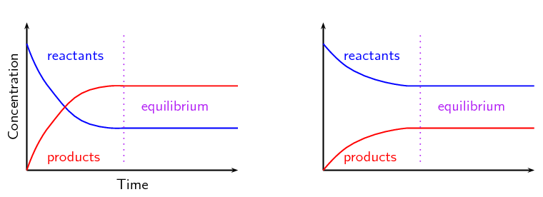
Describe what is occurring in graph #1.

_____________________________________________________________________________

_____________________________________________________________________________

_____________________________________________________________________________

_____________________________________________________________________________

Describe what is occurring in graph #2.

_____________________________________________________________________________

_____________________________________________________________________________

_____________________________________________________________________________

_____________________________________________________________________________

Equilibrium can also be affected by the addition of more reactants or products. In the reaction below, equilibrium had already been reached and is represented in the graph below. Then, more hydrogen gas is introduced to the reaction chamber. Note what happens to the reactants and the product after the addition of more hydrogen gas.

2H₂ + 3N₂ ⇌ 2NH₃
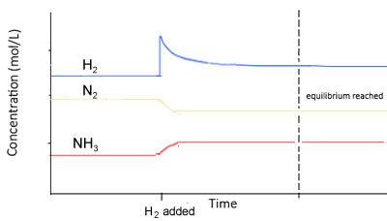

1. What information on the graph indicates that the system was initially at equilibrium?

____________________________________________________________________________

____________________________________________________________________________

2. What information on the graph shows the system was disrupted?

____________________________________________________________________________

____________________________________________________________________________

3. In terms of collision theory, explain why the concentration of H₂ (g) begins to decrease
immediately after more H₂ (g) is added to the system.

____________________________________________________________________________

____________________________________________________________________________

