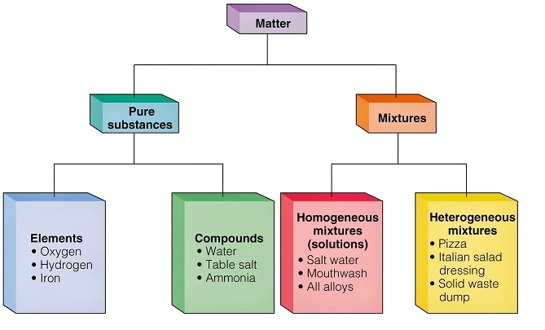

Matter – Anything that takes up space (Volume) and has Mass
Substance – Matter that is made up of only one thing, pure.
Mixture – Matter made up of multiple substances, mixed.
Element – Elements are the simplest substances. They can NOT be broken down into anything simpler.
Examples: Aluminum Al(s) Mercury Hg(l) Oxygen O₂(g)
Note – Elements can be in either solid, liquid or gas phases. Some elements are diatomic. That means that they are never found alone in nature. Instead they are found as two atoms bonded together.
Compound – Two or more different elements that are chemically combined forming a new substance with new properties.
Examples: sodium chloride NaCl(s) water H₂O(l) carbon dioxide CO₂(g)
Note that these are all Binary compounds (containing only two different elements). Some compounds have more than two elements and are not binary. Example is glucose, C₆H₁₂O₆

Atom – Atoms are the smallest unit of an element.
Molecule – Molecules are a group of atoms bonded together, representing the smallest fundamental unit of a chemical compound. However, a molecule can also be a 2 or more of the same atoms bonded together in a single element. For example, O₂ is a molecule of the element oxygen. When two of the same atoms are bonded together, we call it diatomic.
There are only seven diatomic elements in nature: H₂, N₂, O₂, F₂, Cl₂, Br₂, I₂. I have nicknamed them the -Gen Series. Elements that end in the letters, -gen are diatomic: hydrogen, nitrogen, oxygen, and the Group 17 elements which are called halogens – fluorine, chlorine, bromine and iodine.
Homogeneous Mixture – A homogeneous mixture is uniform in composition throughout (evenly mixed). It is also called a solution. Note that solutions can be found in all different phases of matter.
Examples: Bronze a solid alloy made of tin and copper Air a gaseous mixture of many different gases. Alcoholic beverages are liquid solutions of alcohol and water Salt water (NaCl(aq)) is solid sodium chloride dissolved in liquid water. Note that the symbol (aq) means aqueous. Soda is CO₂(g) dissolved in liquid water CO₂(aq)

Heterogeneous Mixture – This is a non-uniform mixture or unevenly mixed in composition. The composition varies from one region to another with clearly identifiable properties.
Examples: oil and water, sand and water, fog, a pencil, orange juice with pulp. As a general rule, if you can see different components of a mixture, or you can’t shine light completely through a mixture, it is heterogeneous. This is why fog is heterogeneous.

As a final note, remember since the smallest unit of an element is an atom, multiples of the same atom (not bonded together) make up an element.
Two or more atoms that are bonded together make up a molecule.
Multiple molecules usually form compounds unless those molecules are made of the same atoms. In that case that are molecules that make up an element.

Examples:
Many helium atoms (He) is a bottle is an element of gaseous helium, He(g).
Carbon dioxide (CO₂) is a molecule made of one carbon atom and two oxygen atoms. A bottle of carbon dioxide gas (CO₂(g)) is a compound.
A single nitrogen atom (N) does not exist in nature. Diatomic nitrogen (N₂) is a molecule. A bottle filled with gaseous nitrogen, (N₂(g)) is still an element. It is a called a diatomic element.

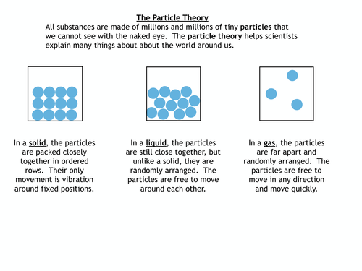
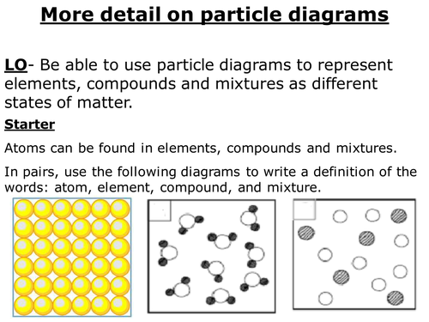
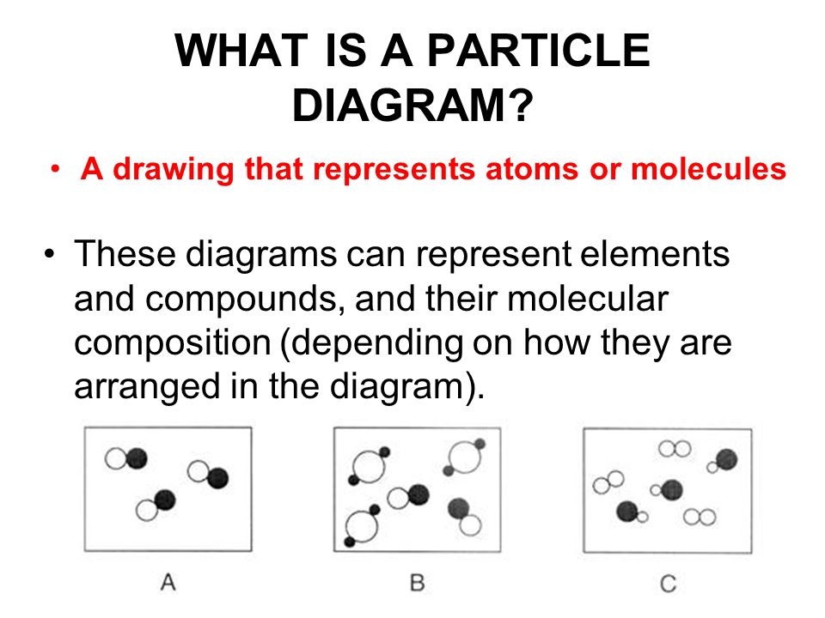

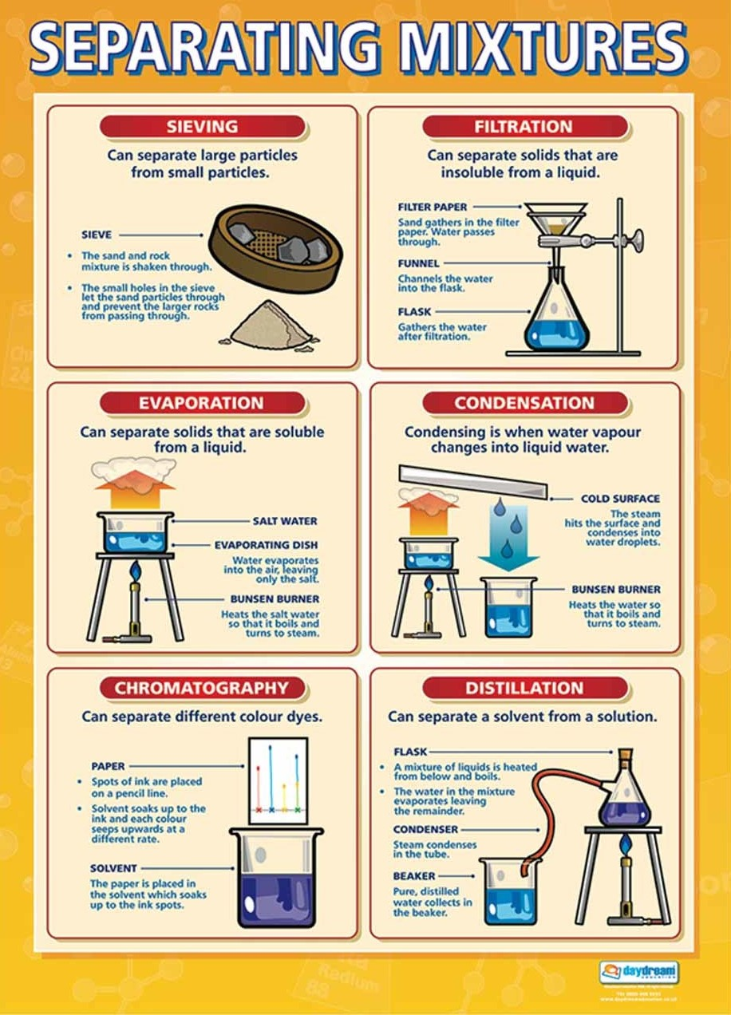
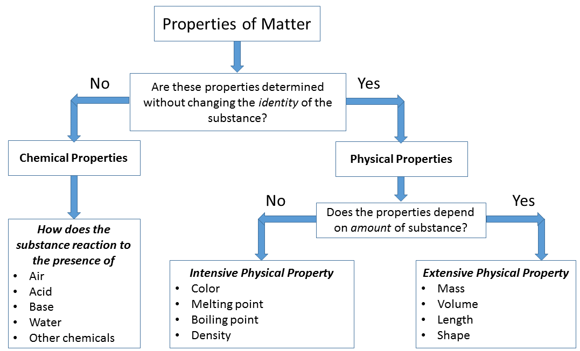
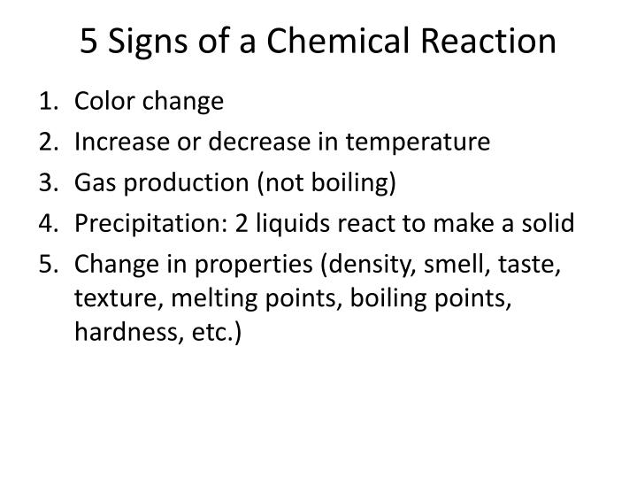
Exothermic - reaction that release energy
Endothermic - reactions that absorb energy
Heat vs. Temperature
Heat or “heat energy” is the result of the movement of tiny particles called atoms, molecules or ions in solids, liquids and gases. Heat energy can be transferred from one object to another. Heat is defined as the flow of energy between two systems. More simply put, heat energy, also called thermal energy or simply heat, is transferred from one location to another by particles bouncing into each other.
The distinction between heat and temperature is subtle but very important. Heat refers to the transfer of energy between systems (or bodies), whereas temperature is determined by the energy contained within a singular system (or body). In other words, heat is energy, while temperature is a measure of kinetic energy only. Heat may be potential or kinetic energy.
Particles have more energy at higher temperatures, and as this energy is transferred from one system to another, the fast-moving particles will collide with slower moving particles.
The SI unit for heat is a form of energy called the joule (J). Heat is frequently also measured in the calorie (cal). Temperature is the measure of how hot something is using units such as Kelvin (K) or degrees Celsius (ºC).
Heat describes the transfer of thermal energy between molecules within a system Heat measures how energy moves or flows. An object can gain heat or lose heat, but it cannot have heat. Heat is a measure of change, never a property possessed by an object or system.
Temperature describes the average kinetic energy of molecules within a material or system. It is a measurable physical property of an object.

Laws of Matter and Energy
The law of conservation of matter (mass) states that in any given system that is closed to the transfer of matter (in and out), the amount of matter in the system stays constant. A concise way of expressing this law is to say that the amount of matter in a system is conserved, or matter cannot be created or destroyed. This is demonstrated in two ways: In any reaction, that total mass of your reactants that you start with (in grams for example) must be equal to the total mass of products you make.

The law of conservation of energy states that the total energy of an isolated system remains constant; it is said to be conserved over time. This law means that energy can neither be created nor destroyed; rather, it can only be transformed or transferred from one form to another.

The law of definite proportions states that every chemical compound contains fixed and constant proportions (by mass) of its constituent elements. For example, water is 2 atoms of hydrogen and one atom of oxygen. It has a set ratio of mass (1 gram of hydrogen for every 8 grams of oxygen). This ratio can not be different for water.

The law of multiple proportions states that when two elements combine with each other to form more than one compound, the elements must combine with a fixed weight ratio. However, there may be multiple ways that these elements combine. The ratio of that atoms must be in small whole numbers. For example, carbon dioxide is CO₂ (1 carbon to 2 oxygens). But carbon monoxide is CO (1 carbon to 1 oxygen).

